Paper 1 | Paper 2
Topic 1 Core concepts in physics  Topic 2 Force and motion  Topic 3 Conservation of energy  Topic 4 Waves  Topic 5 Light and the electromagnetic spectrum  Topic 6 Radioactivity  Topic 7 Astronomy TRIPLE ONLY | Topic 1 Core concepts in physics  Topic 8 Energy, forces doing work  Topic 9 Forces and their effects  Topic 10 Electricity  Topic 11 Static electricity TRIPLE ONLY  Topic 12 Magnetism and the motor effect  Topic 13 Electromagnetic induction  Topic 14 The particle model  Topic 15 Force and matter

Checklists
Content that is for higher tier only is in bold
Topic 1 Key concepts of physics Checklist (Paper 1 & Paper 2)
After reviews
Recall and use the SI unit for physical quantities including base units: metre (m), kilogram (kg), second (s), ampere (A) and kelvin (K) and derived units: hertz (Hz), newton (N), joule (J), watt (W), pascal (Pa), coulomb (C), volt (V), ohm (Ω) and tesla (T)
Recall and use multiples and sub-multiples of units, including giga (G), mega (M), kilo (k), centi (c), milli (m), micro (µ) and nano (n)
Be able to convert between different units, including hours to seconds
Use significant figures and standard form where appropriate

Topic 2 (Motion and forces) Part 1 Checklist (Paper 1)
After reviews
Explain that a scalar quantity has magnitude (size) but no specific direction
Explain that a vector quantity has both magnitude (size) and a specific direction
Explain the difference between vector and scalar quantities
Recall vector and scalar quantities, including: a) displacement/distance b) velocity/speed c) acceleration d) force e) weight/mass f) momentum g) energy
Recall that velocity is speed in a stated direction
Recall and use the equations:
- (average) speed (metre per second, m/s) = distance (metre, m) ÷ time (s)
- distance travelled (metre, m) = average speed (metre per second, m/s) × time (s)
Recall and use the equation: acceleration (metre per second squared, m/s²) = change in velocity (metre per second, m/s) ÷ time taken (second, s)
Describe a range of laboratory methods for determining the speeds of objects such as the use of light gates
Recall some typical speeds encountered in everyday experience for wind and sound, and for walking, running, cycling and other transportation systems
Recall that the acceleration, g, in free fall is 10 m/s2 and be able to estimate the magnitudes of everyday accelerations
Recall Newton’s first law and use it in the following situations:
a) where the resultant force on a body is zero, i.e. the body is moving at a constant velocity or is at rest b) where the resultant force is not zero, i.e. the speed and/or direction of the body change(s)
Recall and use Newton’s second law as: force (newton, N) = mass (kilogram, kg) × acceleration (metre per second squared, m/s²)
Define weight, recall and use the equation: weight (newton, N) = mass (kilogram, kg) × gravitational field strength (newton per kilogram, N/kg)
Describe how weight is measured
Describe the relationship between the weight of a body and the gravitational field strength
Core Practical: Investigate the relationship between force, mass and acceleration by varying the masses added to trolleys
Explain that inertial mass is a measure of how difficult it is to change the velocity of an object (including from rest) and know that it is defined as the ratio of force over acceleration
Recall and apply Newton’s third law both to equilibrium situations and to collision interactions and relate it to the conservation of momentum in collisions
Define momentum, recall and use the equation: momentum (kilogram metre per second, kg m/s) = mass (kilogram, kg) × velocity (metre per second, m/s)
Describe examples of momentum in collisions
Use Newton’s second law as: force (newton, N) = change in momentum (kilogram metre per second, kg m/s) ÷ time (second, s)

Topic 2 (Motion and forces) Part 2 Checklist (Paper 1)
After reviews
Analyse distance/time graphs including determination of speed from the gradient
Use the equation: (final velocity)² ((metre/second)², (m/s)²) – (initial velocity)² ((metre/second)², (m/s)²) = 2 × acceleration (metre per second squared, m/s²) × distance (metre, m)
Analyse velocity/time graphs to:
a) compare acceleration from gradients qualitatively b) calculate the acceleration from the gradient (for uniform acceleration only)
c) determine the distance travelled using the area between the graph line and the time axis (for uniform acceleration only)
Explain that an object moving in a circular orbit at constant speed has a changing velocity (qualitative only)
Explain that for motion in a circle there must be a resultant force known as a centripetal force that acts towards the centre of the circle
Explain methods of measuring human reaction times and recall typical results
Recall that the stopping distance of a vehicle is made up of the sum of the thinking distance and the braking distance
Explain that the stopping distance of a vehicle is affected by a range of factors including:
a) the mass of the vehicle b) the speed of the vehicle c) the driver’s reaction time d) the state of the vehicle’s brakes e) the state of the road f) the amount of friction between the tyre and the road surface
Describe the factors affecting a driver’s reaction time including drugs and distractions
Explain the dangers caused by large decelerations and estimate the forces involved in typical situations on a public road

Topic 2 (Motion and forces) Part 3 specification points Checklist (Paper 1)
After reviews
Estimate how the distance required for a road vehicle to stop in an emergency varies over a range of typical speeds
Carry out calculations on work done to show the dependence of braking distance for a vehicle on initial velocity squared (work done to bring a vehicle to rest equals initial kinetic energy)

Topic 3 (Conservation of energy) Checklist (Paper 1)
After reviews
Recall and use the equation to calculate the change in gravitational PE when an object is raised above the ground: change in gravitational potential energy (joule, J) = mass (kilogram, kg) × gravitational field strength (newton per kilogram, N/kg) × change in vertical height (metre, m)
Recall and use the equation to calculate the amounts of energy associated with a moving object: kinetic energy (joule, J) = 1/2 × mass (kilogram, kg) × (speed)² ((metre/second)², (m/s)²)
Draw and interpret diagrams to represent energy transfers
Explain what is meant by conservation of energy
Analyse the changes involved in the way energy is stored when a system changes, including: a) an object projected upwards or up a slope b) a moving object hitting an obstacle c) an object being accelerated by a constant force d) a vehicle slowing down e) bringing water to a boil in an electric kettle
Explain that where there are energy transfers in a closed system there is no net change to the total energy in that system
Explain that mechanical processes become wasteful when they cause a rise in temperature so dissipating energy in heating the surroundings
Explain, using examples, how in all system changes energy is dissipated so that it is stored in less useful ways
Explain ways of reducing unwanted energy transfer including through lubrication, thermal insulation
Describe the effects of the thickness and thermal conductivity of the walls of a building on its rate of cooling qualitatively
Recall and use the equation: Efficiency = (useful energy transferred by the device)/(total energy supplied to the device)
Explain how efficiency can be increased
Describe the main energy sources available for use on Earth (including fossil fuels, nuclear fuel, bio-fuel, wind, hydroelectricity, the tides and the Sun), and compare the ways in which both renewable and non-renewable sources are used
Explain patterns and trends in the use of energy resources

Topic 4 (Waves) Part 1 Checklist (Paper 1)
After reviews
Recall that waves transfer energy and information without transferring matter.
Describe evidence that with water and sound waves it is the wave and not the water or air itself that travels.
Define and use the terms frequency and wavelength as applied to waves.
Use the terms amplitude, period, wave velocity and wavefront as applied to waves.
Describe the difference between longitudinal and transverse waves by referring to sound, electromagnetic, seismic and water waves.
Recall and use both the equations below for all waves:
wave speed (metre/second, m/s) = frequency (hertz, Hz) × wavelength (metre, m) v=fλ
wave speed (metre/second, m/s) = distance (metre, m) ÷ time (second, s) v = x/t
Describe how to measure the velocity of sound in air and ripples on water surfaces.
Explain how waves will be refracted at a boundary in terms of the change of direction and speed.
Recall that different substances may absorb, transmit, refract or reflect waves in ways that vary with wavelength.
Core Practical: Investigate the suitability of equipment to measure the speed, frequency and wavelength of a wave in a solid and a fluid.

Topic 4 (Waves) Part 2 Checklist (Paper 1)
After reviews
Calculate depth or distance from time and wave velocity
Describe the effects of a) reflection b) refraction
c) transmission d) absorption of waves at material interfaces
Describe the processes which convert wave disturbances between sound waves and vibrations in solids, and a) explain why such processes only work over a limited frequency range b) use this to explain the way the human ear works
Recall that sound with frequencies greater than
20 000 hertz, Hz, is known as ultrasound
Recall that sound with frequencies less than 20 hertz,
Hz, is known as infrasound
Explain uses of ultrasound and infrasound, including
a) sonar b) foetal scanning c) exploration of the Earth’s core
Describe how changes, if any, in velocity, frequency and wavelength, in the transmission of sound waves from one medium to another are inter-related

Topic 5 (Light and the electromagnetic spectrum) Part 1 Checklist (Paper 1)

After reviews

Recall that all electromagnetic waves are transverse, that they travel at the same speed in a vacuum

Explain, with examples, that all electromagnetic waves transfer energy from source to observer

Recall the main groupings of the continuous electromagnetic spectrum including (in order) radio waves, microwaves, infrared, visible (including the colours of the visible spectrum), ultraviolet, x-rays and gamma rays

Describe the electromagnetic spectrum as continuous from radio waves to gamma rays and that the radiations within it can be grouped in order of decreasing wavelength and increasing frequency

Recall that our eyes can only detect a limited range of frequencies of electromagnetic radiation

Recall that different substances may absorb, transmit, refract or reflect waves in ways that vary with wavelength

Explain the effects of differences in the velocities of electromagnetic waves in different substances

Recall that the potential danger associated with an electromagnetic wave increases with increasing frequency

Describe the harmful effects on people of excessive exposure to electromagnetic radiation, including:
a) microwaves: internal heating of body cells
b) infrared: skin burns
c) ultraviolet: damage to surface cells and eyes, leading to skin cancer and eye conditions
d) x-rays and gamma rays: mutation or damage to cells in the body
Describe some uses of electromagnetic radiation
a) radio waves: including broadcasting, communications and satellite transmissions
b) microwaves: including cooking, communications and satellite transmissions
c) infrared: including cooking, thermal imaging, short range communications, optical fibres, television remote controls and security systems
d) visible light: including vision, photography and illumination
e) ultraviolet: including security marking, fluorescent lamps, detecting forged bank notes and disinfecting water
f) x-rays: including observing the internal structure of objects, airport security scanners and medical x-rays
g) gamma rays: including sterilising food and medical equipment, and the detection of cancer and its treatment

Recall that radio waves can be produced by, or can themselves induce, oscillations in electrical circuits

Recall that changes in atoms and nuclei can a) generate radiations over a wide frequency range b) be caused by absorption of a range of radiations

Core Practical: Investigate refraction in rectangular glass blocks in terms of the interaction of electromagnetic waves with matter

Topic 5 (Light and the electromagnetic spectrum) Part 2 Checklist (Paper 1)
After reviews
Explain, with the aid of ray diagrams, reflection, refraction and total internal reflection (TIR), including the law of reflection and critical angle
Explain the difference between specular and diffuse reflection
Explain how colour of light is related to a differential absorption at surfaces b transmission of light through filters
Relate the power of a lens to its focal length and shape
Use ray diagrams to show the similarities and differences in the refraction of light by converging and diverging lenses
Explain the effects of different types of lens in producing real and virtual images
Explain that all bodies emit radiation, that the intensity and wavelength distribution of any emission depends on their temperature
Explain that for a body to be at a constant temperature it needs to radiate the same average power that it absorbs
Explain what happens to a body if the average power it radiates is less or more than the average power that it absorbs
Explain how the temperature of the Earth is affected by factors controlling the balance between incoming radiation and radiation emitted
Core Practical: Investigate how the nature of a surface affects the amount of thermal energy radiated or absorbed

Topic 6 (Radioactivity) Part 1 Checklist (Paper 1)
After reviews
Describe an atom as a positively charged nucleus, consisting of protons and neutrons, surrounded by negatively charged electrons, with the nuclear radius much smaller than that of the atom and with almost all of the mass in the nucleus.
Recall the typical size (order of magnitude) of atoms and small molecules.
Describe the structure of nuclei of isotopes using the terms atomic (proton) number and mass (nucleon) number and using symbols in the format shown here
13
6
C
Recall that the nucleus of each element has a characteristic positive charge, but that isotopes of an element differ in mass by having different numbers of neutrons.
Recall the relative masses and relative electric charges of protons, neutrons, electrons and positrons.
Recall that in an atom the number of protons equals the number of electrons and is therefore neutral.
Recall that in each atom its electrons orbit the nucleus at different set distances from the nucleus.
Explain that electrons change orbit when there is absorption or emission of electromagnetic radiation.
Explain how atoms may form positive ions by losing outer electrons.
Recall that alpha, β– (beta minus), β+ (positron), gamma rays and neutron radiation are emitted from unstable nuclei in a random process.
Recall that alpha, β– (beta minus), β+ (positron) and gamma rays are ionising radiations.
Explain what is meant by background radiation.
Describe the origins of background radiation from Earth and space.
Describe methods for measuring and detecting radioactivity limited to photographic film and a Geiger–Müller tube.
Recall that an alpha particle is equivalent to a helium nucleus, a beta particle is an electron emitted from the nucleus and a gamma ray is electromagnetic radiation.
Compare alpha, beta and gamma radiations in terms of their abilities to penetrate and ionise.

Describe how and why the atomic model has changed over time including reference to the plum pudding model and Rutherford alpha particle scattering leading to the Bohr model
Describe the process of β– decay (a neutron becomes a proton plus an electron).
Describe the process of β+ decay (a proton becomes a neutron plus a positron).
Explain the effects on the atomic (proton) number and mass (nucleon) number of radioactive decays (α, β, γ and neutron emission).
Recall that nuclei that have undergone radioactive decay often undergo nuclear rearrangement with a loss of energy as gamma radiation.
Use given data to balance nuclear equations in terms of mass and charge.
Describe how the activity of a radioactive source decreases over a period of time.
Recall that the unit of activity of a radioactive isotope is the Becquerel, Bq.
Explain that the half-life of a radioactive isotope is the time taken for half the undecayed nuclei to decay or the activity of a source to decay by half.
Explain that it cannot be predicted when a particular nucleus will decay but half-life enables the activity of a very large number of nuclei to be predicted during the decay process.
Use the concept of half-life to carry out simple calculations on the decay of a radioactive isotope, including graphical representations.
Describe the dangers of ionising radiation in terms of tissue damage and possible mutations and relate this to the precautions needed.
Explain the precautions taken to ensure the safety of people exposed to radiation, including limiting the dose for patients and the risks to medical personnel.
Describe the differences between contamination and irradiation effects and compare the hazards associated with these two.

Topic 6 (Radioactivity) Part 2 Checklist (Paper 1)
After reviews
Describe uses of radioactivity, including: a) household fire (smoke) alarms b) irradiating food c) sterilisation of equipment d) tracing and gauging thicknesses
e) diagnosis and treatment of cancer
Explain how the dangers of ionising radiation depend on half-life and relate this to the precautions needed
Compare and contrast the treatment of tumours using radiation applied internally or externally
Explain some of the uses of radioactive substances in diagnosis of medical conditions, including PET scanners and tracers
Explain why isotopes used in PET scanners have to be produced nearby
Evaluate the advantages and disadvantages of nuclear power for generating electricity, including the lack of carbon dioxide emissions, risks, public perception, waste disposal and safety issues
Recall that nuclear reactions, including fission, fusion and radioactive decay, can be a source of energy
Explain how the fission of U-235 produces two daughter nuclei and the emission of two or more neutrons, accompanied by a release of energy
Explain the principle of a controlled nuclear chain reaction
Explain how the chain reaction is controlled in a nuclear reactor, including the action of moderators and control rods
Describe how thermal (heat) energy from the chain reaction is used in the generation of electricity in a nuclear power station
Recall that the products of nuclear fission are radioactive
Describe nuclear fusion as the creation of larger nuclei resulting in a loss of mass from smaller nuclei, accompanied by a release of energy, and recognise fusion as the energy source for stars
Explain the difference between nuclear fusion and nuclear fission
Explain why nuclear fusion does not happen at low temperatures and pressures, due to electrostatic repulsion of protons
Relate the conditions for fusion to the difficulty of making a practical and economic form of power station

Topic 7 (Astronomy) Checklist (Paper 1)
After reviews
Explain how and why both the weight of any body and the value of g differ between the surface of the Earth and the surface of other bodies in space, including the Moon
Recall that our Solar System consists of the Sun (our star), eight planets and their natural satellites (such as our Moon); dwarf planets; asteroids and comets
Recall the names and order, in terms of distance from the Sun, of the eight planets
Describe how ideas about the structure of the Solar System have changed over time
Describe the orbits of moons, planets, comets and artificial satellites
Explain for circular orbits how the force of gravity can lead to changing velocity of a planet but unchanged speed
Explain how, for a stable orbit, the radius must change if orbital speed changes (qualitative only)
Compare the Steady State and Big Bang theories
Describe evidence supporting the Big Bang theory, limited to red-shift and the cosmic microwave background (CMB) radiation
Recall that as there is more evidence supporting the Big Bang theory than the Steady State theory, it is the currently accepted model for the origin of the Universe
Describe that if a wave source is moving relative to an observer there will be a change in the observed frequency and wavelength
Describe the red-shift in light received from galaxies at different distances away from the Earth
Explain why the red-shift of galaxies provides evidence for the Universe expanding
Explain how both the Big Bang and Steady State theories of the origin of the Universe both account for red-shift of galaxies
Explain how the discovery of the CMB radiation led to the Big Bang theory becoming the currently accepted model
Describe the evolution of stars of similar mass to the Sun through the following stages: a) nebula b) star (main sequence) c) red giant d) white dwarf
Explain how the balance between thermal expansion and gravity affects the life cycle of stars
Describe the evolution of stars with a mass larger than the Sun
Describe how methods of observing the Universe have changed over time including why some telescopes are located outside the Earth’s atmosphere

Topic 8 (Energy, forces doing work) Checklist (Paper 2)
After reviews
Describe the changes involved in the way energy is stored when systems change
Draw and interpret diagrams to represent energy transfers
Explain that where there are energy transfers in a closed system there is no net change to the total energy in that system
Identify the different ways that the energy of a system can be changed
a) through work done by forces
b) in electrical equipment
c) in heating
Describe how to measure the work done by a force and understand that energy transferred (joule, J) is equal to work done (joule, J)
Recall and use the equation: work done (joule, J) = force (newton, N) × distance moved in the direction of the force (metre, m)
Describe and calculate the changes in energy involved when a system is changed by work done by forces
Recall and use the equation to calculate the change in gravitational PE when an object is raised above the ground: change in gravitational potential energy (joule, J) = mass (kilogram, kg) × gravitational field strength (newton per kilogram, N/kg) × change in vertical height (metre, m)
Recall and use the equation to calculate the amounts of energy associated with a moving object: kinetic energy (joule, J) = ½ × mass (kilogram, kg) × (speed)² (metre/second)
Explain, using examples, how in all system changes energy is dissipated so that it is stored in less useful ways
Explain that mechanical processes become wasteful when they cause a rise in temperature so dissipating energy in heating the surroundings
Define power as the rate at which energy is transferred and use examples to explain this definition
Recall and use the equation: power (watt, W) = work done (joule, J) ÷ time taken (second, s)
Recall that one watt is equal to one joule per second, J/s
Recall and use the equation: efficiency = (useful energy transferred by the device) / (total energy supplied to the device)

Topic 9 (Forces and their effects) Checklist (Paper 2)
After reviews
Describe, with examples, how objects can interact
a) at a distance without contact, linking these to the gravitational, electrostatic and magnetic fields involved
b) by contact, including normal contact force and friction
c) producing pairs of forces which can be represented as vectors
Explain the difference between vector and scalar quantities using examples
Use vector diagrams to illustrate resolution of forces, a net force, and equilibrium situations (scale drawings only)
Draw and use free body force diagrams
Explain examples of the forces acting on an isolated solid object or a system where several forces lead to a resultant force on an object and the special case of balanced forces when the resultant force is zero
Describe situations where forces can cause rotation
Recall and use the equation: moment of a force (newton metre, N m) = force (newton, N) × distance normal to the direction of the force (metre, m)
Recall and use the principle of moments in situations where rotational forces are in equilibrium: the sum of clockwise moments = the sum of anti-clockwise moments for rotational forces in equilibrium
Explain how levers and gears transmit the rotational effects of forces
Explain ways of reducing unwanted energy transfer through lubrication

Topic 10 (Electricity and circuits) Part 1 Checklist (Paper 2)
After reviews
Describe the structure of the atom, limited to the position, mass and charge of protons, neutrons and electrons
Draw and use electric circuit diagrams representing them with the conventions of positive and negative terminals, and the symbols that represent cells, including batteries, switches, voltmeters, ammeters, resistors, variable resistors, lamps, motors, diodes, thermistors, LDRs and LEDs
Describe the differences between series and parallel circuits
Recall that a voltmeter is connected in parallel with a component to measure the potential difference (voltage), in volt, across it
Explain that potential difference (voltage) is the energy transferred per unit charge passed and hence that the volt is a joule per coulomb
Recall and use the equation: energy transferred (joule, J) = charge moved (coulomb, C) × potential difference (volt, V)
Recall that an ammeter is connected in series with a component to measure the current, in amp, in the component
Explain that an electric current as the rate of flow of charge and the current in metals is a flow of electrons
Recall and use the equation: charge (coulomb, C) = current (ampere, A) × time (second, s)
Describe that when a closed circuit includes a source of potential difference there will be a current in the circuit
Recall that current is conserved at a junction in a circuit
Explain how changing the resistance in a circuit changes the current and how this can be achieved using a variable resistor
Recall and use the equation: potential difference (volt, V) = current (ampere, A) × resistance (ohm, Ω)
Explain why, if two resistors are in series, the net resistance is increased, whereas with two in parallel the net resistance is decreased
Calculate the currents, potential differences and resistances in series circuits
Explain the design and construction of series circuits for testing and measuring
Core Practical: Construct electrical circuits to:
a) investigate the relationship between potential difference, current and resistance for a resistor and a filament lamp b) test series and parallel circuits using resistors and filament lamps
Explain how current varies with potential difference for the following devices and how this relates to resistance a) filament lamps b) diodes
c) fixed resistors
Describe how the resistance of a light-dependent resistor (LDR) varies with light intensity
Describe how the resistance of a thermistor varies with change of temperature (negative temperature coefficient thermistors only)
Explain how the design and use of circuits can be used to explore the variation of resistance in the following devices a) filament lamps b) diodes
c) thermistors d) LDRs
Recall that, when there is an electric current in a resistor, there is an energy transfer which heats the resistor
Explain that electrical energy is dissipated as thermal energy in the surroundings when an electrical current does work against electrical resistance
Explain the energy transfer as the result of collisions between electrons and the ions in the lattice
Explain ways of reducing unwanted energy transfer through low resistance wires
Describe the advantages and disadvantages of the heating effect of an electric current
Use the equation: energy transferred (joule, J) = current (ampere, A) × potential difference (volt, V) × time (second, s)
Topic 10 (Electricity and circuits) Part 2 Checklist (Paper 2)
After reviews
Describe power as the energy transferred per second and recall that it is measured in watt
Recall and use the equation: power (watt, W) = energy transferred (joule, J) ÷ time taken (second, s)
Explain how the power transfer in any circuit device is related to the potential difference across it and the current in it
Recall and use the equations: electrical power (watt, W) = current (ampere, A) × potential difference (volt, V) and electrical power (watt, W) = current squared (ampere², A²) × resistance (ohm, Ω)
Describe how, in different domestic devices, energy is transferred from batteries and the a.c. mains to the energy of motors and heating devices
Explain the difference between direct and alternating voltage
Describe direct current (d.c.) as movement of charge in one direction only and recall that cells and batteries supply direct current (d.c.)
Describe that in alternating current (a.c.) the movement of charge changes direction
Recall that in the UK the domestic supply is a.c., at a frequency of 50 Hz and a voltage of about 230 V
Explain the difference in function between the live and the neutral mains input wires
Explain the function of an earth wire and of fuses or circuit breakers in ensuring safety
Explain why switches and fuses should be connected in the live wire of a domestic circuit
Recall the potential differences between the live, neutral and earth mains wires
Explain the dangers of providing any connection between the live wire and earth
Describe, with examples, the relationship between the power ratings for domestic electrical appliances and the changes in stored energy when they are in use

Topic 11 (Static electricity) Checklist (Paper 2)
After reviews
Explain how an insulator can be charged by friction, through the transfer of electrons
Explain how the material gaining electrons becomes negatively charged and the material losing electrons is left with an equal positive charge
Recall that like charges repel and unlike charges attract
Explain common electrostatic phenomena in terms of movement of electrons, including a) shocks from everyday objects b) lightning c) attraction by induction such as a charged balloon attracted to a wall and a charged comb picking up small pieces of paper
Explain how earthing removes excess charge by movement of electrons
Explain some of the uses of electrostatic charges in everyday situations, including insecticide sprayers
Describe some of the dangers of sparking in everyday situations, including fuelling cars, and explain the use of earthing to prevent dangerous build-up of charge
Define an electric field as the region where an electric charge experiences a force
Describe the shape and direction of the electric field around a point charge and between parallel plates and relate the strength of the field to the concentration of lines
Explain how the concept of an electric field helps to explain the phenomena of static electricity

Topic 12 (Magnetism and the motor effect) Checklist (Paper 2)
After reviews
Recall that unlike magnetic poles attract and like magnetic poles repel
Describe the uses of permanent and temporary magnetic materials including cobalt, steel, iron and nickel
Explain the difference between permanent and induced magnets
Describe the shape and direction of the magnetic field around bar magnets and for a uniform field, and relate the strength of the field to the concentration of lines
Describe the use of plotting compasses to show the shape and direction of the field of a magnet and the Earth’s magnetic field
Explain how the behaviour of a magnetic compass is related to evidence that the core of the Earth must be magnetic
Describe how to show that a current can create a magnetic effect around a long straight conductor, describing the shape of the magnetic field produced and relating the direction of the magnetic field to the direction of the current
Recall that the strength of the field depends on the size of the current and the distance from the long straight conductor
Explain how inside a solenoid (an example of an electromagnet) the fields from individual coils a) add together to form a very strong almost uniform field along the centre of the solenoid b) cancel to give a weaker field outside the solenoid
Recall that a current carrying conductor placed near a magnet experiences a force and that an equal and opposite force acts on the magnet
Explain that magnetic forces are due to interactions between magnetic fields
Recall and use Fleming’s left-hand rule to represent the relative directions of the force, the current and the magnetic field for cases where they are mutually perpendicular
Use the equation: force on a conductor at right angles to a magnetic field carrying a current (newton, N) = magnetic flux density (tesla, T or newton per ampere metre, N/A m) × current (ampere, A) × length (metre, m) F = B×I ×l
Explain how the force on a conductor in a magnetic field is used to cause rotation in electric motors

Topic 13 (Electromagnetic induction) Checklist (Paper 2)
After reviews
Explain how to produce an electric current by the relative movement of a magnet and a conductor a) on a small scale in the laboratory b) in the large-scale generation of electrical energy
Recall the factors that affect the size and direction of an induced potential difference, and describe how the magnetic field produced opposes the original change
Explain how electromagnetic induction is used in alternators to generate current which alternates in direction (a.c.) and in dynamos to generate direct current (d.c.)
Explain the action of the microphone in converting the pressure variations in sound waves into variations in current in electrical circuits, and the reverse effect as used in loudspeakers and headphones
Explain how an alternating current in one circuit can induce a current in another circuit in a transformer
Recall that a transformer can change the size of an alternating voltage
Use the turns ratio equation for transformers to calculate either the missing voltage or the missing number of turns V_{p}/V_{s} = N_{p}/N_{s}
Explain why, in the national grid, electrical energy is transferred at high voltages from power stations, and then transferred at lower voltages in each locality for domestic uses as it improves the efficiency by reducing heat loss in transmission lines
Explain where and why step-up and step-down transformers are used in the transmission of electricity in the national grid
Use the power equation (for transformers with 100% efficiency): potential difference across primary coil (volt, V) × current in primary coil (ampere, A) = potential difference across secondary coil (volt, V) × current in secondary coil (ampere, A)
Explain the advantages of power transmission in high voltage cables, using the equations P=E/t, P=IV, P=I²R, turns ratio and V_{p} I_{p} = V_{s} I_{s}

Topic 14 (Particle model) Checklist (Paper 2)
After reviews
Use a simple kinetic theory model to explain the different states of matter (solids, liquids and gases) in terms of the movement and arrangement of particles
Recall and use the equation: density (kilogram per cubic metre, kg/m³) = mass (kilogram, kg) ÷ volume (cubic metre, m³)
Core Practical: Investigate the densities of solid and liquids
Explain the differences in density between the different states of matter in terms of the arrangements of the atoms or molecules
Describe that when substances melt, freeze, evaporate, boil, condense or sublimate mass is conserved and that these physical changes differ from some chemical changes because the material recovers its original properties if the change is reversed
Explain how heating a system will change the energy stored within the system and raise its temperature or produce changes of state
Define the terms specific heat capacity and specific latent heat and explain the differences between them
Use the equation: change in thermal energy (joule, J) = mass (kilogram, kg) × specific heat capacity (joule per kilogram degree Celsius, J/kg °C) × change in temperature (degree Celsius, °C)
Use the equation: thermal energy for a change of state (joule , J) = mass (kilogram, kg) × specific latent heat (joule per kilogram, J/kg)
Explain ways of reducing unwanted energy transfer through thermal insulation
Core Practical: Investigate the properties of water by determining the specific heat capacity of water and obtaining a temperature-time graph for melting ice
Explain the pressure of a gas in terms of the motion of its particles
Explain the effect of changing the temperature of a gas on the velocity of its particles and hence on the pressure produced by a fixed mass of gas at constant volume (qualitative only)
Describe absolute zero, −273 °C, in terms of the lack of movement of particles
Convert between the kelvin and Celsius scales
Explain that gases can be compressed or expanded by pressure changes
Explain that the pressure of a gas produces a net force at right angles to any surface
Explain the effect of changing the volume of a gas on the rate at which its particles collide with the walls of its container and hence on the pressure produced by a fixed mass of gas at constant temperature
Use the equation: P₁×V₁ =P₂ ×V₂ to calculate pressure or volume for gases of fixed mass at constant temperature
Explain why doing work on a gas can increase its temperature, including a bicycle pump

Topic 15 (Forces and matter) Checklist (Paper 2)
After reviews
Explain, using springs and other elastic objects, that stretching, bending or compressing an object requires more than one force.
Describe the difference between elastic and inelastic distortion.
Recall and use the equation for linear elastic distortion including calculating the spring constant: force exerted on a spring (newton, N) = spring constant (newton per metre, N/m) × extension (metre, m).
Use the equation to calculate the work done in stretching a spring: energy transferred in stretching (joules, J) = 0.5 × spring constant (newton per metre, N/m) × (extension (metre, m))²
Describe the difference between linear and non-linear relationships between force and extension.
Core Practical: Investigate the extension and work done when applying forces to a spring.
Explain why atmospheric pressure varies with height above the Earth’s surface with reference to a simple model of the Earth’s atmosphere.
Describe the pressure in a fluid as being due to the fluid and atmospheric pressure.
Recall that the pressure in fluids causes a force normal to any surface.
Explain how pressure is related to force and area, using appropriate examples.
Recall and use the equation: pressure (pascal, Pa) = force normal to surface (newton, N) ÷ area of surface (square metre, m²).
Describe how pressure in fluids increases with depth and density.
Explain why the pressure in liquids varies with density and depth.
Use the equation to calculate the magnitude of the pressure in liquids and calculate the differences in pressure at different depths in a liquid: pressure due to a column of liquid (pascal, Pa) = height of column (metre, m) × density of liquid (kilogram per cubic metre, kg/m³) × gravitational field strength (newton per kilogram, N/kg).
Explain why an object in a fluid is subject to an upwards force (up-thrust) and relate this to examples including objects that are fully immersed in a fluid (liquid or gas) or partially immersed in a liquid.
Recall that the up-thrust is equal to the weight of fluid displaced.
Explain how the factors (up-thrust, weight, density of fluid) influence whether an object will float or sink.

Essential Core questions for paper 1
Higher tier only in bold
 | Question | Answer | Topic
1 | What does 'give your answer to two significant figures' mean? | Round the final answer up or down so that you are only writing down two numerals, ignoring any zeros that come at the front.  (e.g. 20, 37 and 0.0054) | T1 Key concepts of Physics
2 | What does 'give your answer to an appropriate number of significant figures' mean? | Round the final answer up or down so that you are writing down the same number of numerals as the value used in your calculation that had the fewest numerals.  (e.g. 30.77 ÷ 12 = 2.6 because '12' was written to two significant figures.) | T1 Key concepts of Physics
3 | What does 'give your answer to two decimal places' mean? | Round the final answer up or down so that there are exactly two numerals written after the decimal point.  (e.g. 20.22, 37.00 and 0.01) | T1 Key concepts of Physics
4 | Put these prefixes for values smaller than 1 in order from largest to smallest:  micro (μ), milli (m), nano (n) | milli (m) is 1000x bigger than  micro (μ) which is 1000x bigger than  nano (n) | T1 Key concepts of Physics
5 | Put these prefixes for values larger than 1 in order from smallest to largest:  kilo (k), giga (G), mega (M). | kilo (k) is 1000x smaller than  mega (M) which is 1000x smaller than  giga (G) | T1 Key concepts of Physics
6 | State the phrase that describes the relationship between two variables if they make a straight line on a graph | Linear  accept constant gradient | T1 Key concepts of Physics
7 | State the phrase that describes the relationship between two variables if they make a straight line on a graph, that passes through 0,0 when plotted against each other. | Directly proportional  accept They have a doubling relationship | T1 Key concepts of Physics
8 | State the name given to the variable in an investigation that is changed or allowed to change so that its effect on another variable can be investigated. | the Independent variable | T1 Key concepts of Physics
9 | State the name given to the variable in an investigation that is measured to see if it is affected by changes in another variable. | the Dependent variable | T1 Key concepts of Physics
10 | State the name given to the variables in an investigation that are kept the same each time to make sure that they could not be causing any changes in the results. | Control variables | T1 Key concepts of Physics
11 | State the equation that shows the relationship between distance, time and speed. | s = d ÷ t  or speed = distance ÷ time | T2pt1 Forces and Motion
12 | Which measurement has the standard unit m? | distance  accept d  accept displacement or х, accept wavelength or λ, accept change in height or Δh | T2pt1 Forces and Motion
13 | Which measurement has the standard unit s? | time  accept t | T2pt1 Forces and Motion
14 | Which measurement has the standard unit m/s? | velocity  accept v or u  accept speed or s  accept wavespeed | T2pt1 Forces and Motion
15 | How many seconds (s) are in one minute (min)? | 60 seconds per minute | T2pt1 Forces and Motion
16 | How many minutes (s) are in one hour (h)? | 60 minutes per hour | T2pt1 Forces and Motion
17 | How many metres (m) are in one kilometre (km)? | 1000 metres per kilometre  accept 1 × 10³ | T2pt1 Forces and Motion
18 | What is a typical speed for a walking person? | 1.4 m/s (on average) | T2pt1 Forces and Motion
19 | What is a typical speed for a cyclist? | 6 m/s (on average) | T2pt1 Forces and Motion
20 | What is a typical speed for a car in a built up area (such as outside a school)? | 10.5 m/s (on average) | T2pt1 Forces and Motion
21 | What is a typical speed for a car on a motorway? | 31 m/s (on average) | T2pt1 Forces and Motion
22 | How is a vector quantity different from a scalar quantity? | vectors include direction as well as magnitude (scalar only has magnitude) | T2pt1 Forces and Motion
23 | What does 'magnitude' mean? | How big something is. | T2pt1 Forces and Motion
24 | How is displacement different from distance? | Displacement is a measure of the straight-line distance from a start point and end point.  Displacement is a vector (it includes direction and can be negative) | T2pt1 Forces and Motion
25 | How is velocity different from speed? | Velocity is a measure of speed relative to a stated direction.  Velocity is a vector (it includes direction and can be negative) | T2pt1 Forces and Motion
26 | Which measurement has the standard unit m/s²? | Acceleration  accept a | T2pt1 Forces and Motion
27 | What is acceleration? | Change of velocity of an object per second (in time) | T2pt1 Forces and Motion
28 | State the equation that shows the relationship between changes in velocity, time and acceleration. | a = (v - u) ÷ t  or (final velocity - initial velocity) ÷ time  or change in velocity ÷ time | T2pt1 Forces and Motion
29 | Which measurement has the standard unit N? | Force  accept F  also accept weight or W | T2pt1 Forces and Motion
30 | What does 'resultant force' mean? | A single force that describes the outcome of multiple forces acting on an object.  (e.g. 200 N acting left and 150 N acting right would mean a resultant force of 50 N acting left) | T2pt1 Forces and Motion
31 | What is the difference between mass and weight? | Mass is a scalar quantity it only has a magnitude (size). It is the amount of matter measured in kg. Weight is a vector quantity. It has both magnitude and direction. It is the force acting on a mass in a gravitational field, measured in N. | T2pt1 Forces and Motion
32 | What is a free-body diagram used to show? | The size and direction of the different forces acting on a single object. | T2pt1 Forces and Motion
33 | How do you calculate the resultant force? | You subtract the total of the forces in one direction from the total force in the opposite direction. Forces in the same direct add together. | T2pt1 Forces and Motion
34 | How must the forces acting on an object compare to cause an object to be not accelerating/moving at constant velocity? | (forces must be) balanced.  or resultant force must be zero. | T2pt1 Forces and Motion
35 | How must the forces acting on an object compare to cause an object to be accelerating/changing velocity? | (forces must be) unbalanced.  or resultant force must be larger than zero. | T2pt1 Forces and Motion
36 | What does Newton's first law of motion state | The velocity of an object will only change if a resultant force is acting on it | T2pt1 Forces and Motion
37 | State the equation that shows the relationship between gravitational field strength, mass and weight. | W = m x g  or weight = mass x gravitational field strength  accept 'gravity' in place of gravitational field strength | T2pt1 Forces and Motion
38 | State the standard unit for weight. | N  or Newtons | T2pt1 Forces and Motion
39 | Which measurement has the standard unit N/kg? | Gravitational field strength  accept g | T2pt1 Forces and Motion
40 | State the value for gravitational field strength at the surface of the Earth. | 10  N/kg or m/s² | T2pt1 Forces and Motion
41 | How many grams (g) are in one kilogram (kg)? | 1000 grams per kilogram (kg is standard unit)  accept 1 × 10³ | T2pt1 Forces and Motion
42 | State the equation that shows the relationship between mass, force and acceleration. | F = m × a  Force (N) = mass (kg) x acceleration (m/s²) | T2pt1 Forces and Motion
43 | What does Newton's second law of motion state? | The acceleration of an object increases if the resultant force on it increases, and decreases if the mass of the object increases.  accept F = m × a  accept F = (mv - mu) ÷ t | T2pt1 Forces and Motion
44 | In what situation would a scientist use a computerised method, such as a light gate, to measure time rather than a stopwatch? | If the time being measured was close to or smaller than human reaction time (roughly 0.25 s) | T2pt1 Forces and Motion
45 | In an investigation involving a trolley moving down a ramp, what is the most likely reason for tilting the ramp? | To compensate for friction.  accept So that weight balances friction.  DO NOT ACCEPT to get rid of friction. | T2pt1 Forces and Motion
46 | In an investigation involving a trolley being pulled down a ramp by hanging masses, what is the most likely reason for masses being moved from the hook to the trolley (or vice versa)? | To keep the total mass of the system constant (while changing the force pulling the trolley) | T2pt1 Forces and Motion
47 | What does Newton's third law of motion state? | Any two objects interacting will exert forces on each other that are equal in size but opposite in direction. | T2pt1 Forces and Motion
48 | State the equation that shows the relationship between mass, momentum and velocity. | p = m x v  momentum (kgm/s) = mass (kg) x velocity (m/s) | T2pt1 Forces and Motion
49 | Which measurement has the standard unit kgm/s? | Momentum  accept p | T2pt1 Forces and Motion
50 | What does the law of conservation of momentum state? | The total momentum of all objects in a collision added together before the collision is equal to the total momentum of all objects added together after the collision. | T2pt1 Forces and Motion
51 | State the equation that shows the relationship between force, time and change in momentum. | F = (mv - mu) ÷ t  or F = (m(v - u)) ÷ t  Force (N) = change in momentum (kgm/s) ÷ time (s) | T2pt1 Forces and Motion
52 | Describe the motion of an object when a distance-time graph is a straight line. | Constant velocity  accept not accelerating | T2pt2 Forces and Motion
53 | Describe the motion of an object when a distance-time graph is a flat horizontal line. | Stationary  accept constant velocity of 0 m/s | T2pt2 Forces and Motion
54 | Describe the motion of an object when a distance-time graph is a curved line. | Changing velocity  accept accelerating | T2pt2 Forces and Motion
55 | Describe how to calculate the gradient of a straight line on a graph. | • Mark two points anywhere on the line.  • Find the values on the Y (vertical axis) and X (horizontal axis) that line up with each point.  • Calculate difference between Y values of the first and second points.  • Calculate difference between X values of the first and second points.  • Gradient = change in Y values ÷ change in X values.  accept gradient = Δy ÷ Δx | T2pt2 Forces and Motion
56 | Describe how to calculate the speed of an object from its distance-time graph. | Calculate the gradient (of the line) | T2pt2 Forces and Motion
57 | Describe the motion of an object when a velocity-time graph is a straight line. | Changing velocity  accept accelerating and decelerating | T2pt2 Forces and Motion
58 | Describe the motion of an object when a distance-time graph is a flat horizontal line. | Constant velocity  accept not accelerating | T2pt2 Forces and Motion
59 | Describe how to calculate the acceleration of an object from its velocity-time graph. | Calculate the gradient (of the line) | T2pt2 Forces and Motion
60 | Describe how to calculate the distance travelled by an object from its velocity-time graph. | Calculate the area under the graph | T2pt2 Forces and Motion
61 | Describe how air bags, seat belts, crumple zones, cycle helmets, crash mats in gyms and rubber floors in playgrounds reduce the forces acting on people during accidents. | (they all) increase the time taken for a change in momentum  accept F = (mv - mu) ÷ t with bigger t | T2pt2 Forces and Motion
62 | State the equation that shows the relationship between stopping distance, thinking distance and braking distance. | Stopping distance (m) = Thinking distance (m) + Braking distance (m) | T2pt2 Forces and Motion
63 | Name at least three factors that affect the thinking distance for a car performing an emergency stop. | (any three from...)  • Velocity/speed of the car  • Alcohol/drugs  • Tiredness  • Distractions  • Illness  accept reaction time (of driver) | T2pt2 Forces and Motion
64 | Name at least three factors that affect the braking distance for a car performing an emergency stop. | (any three from...)  • Velocity/speed of the car  • Mass of the car  • Condition of car's brakes  • Condition of the road  accept Weather conditions but DO NOT ACCEPT fog | T2pt2 Forces and Motion
65 | When an object moves in a circle why is it true to say that it is accelerating even if its speed is constant? | Direction is changing, so velocity is changing and change in velocity over time is acceleration. | T2pt2 Forces and Motion
66 | When an object moves in a circle there is a force acting towards the centre of the circle. What is the name given to this force? | Centripetal force | T2pt2 Forces and Motion
67 | State the equation that shows the relationship between distance, acceleration, initial velocity and final velocity. | v² - u² = 2 × a × x  accept final velocity squared (m/s) - initial velocity squared (m/s) = 2 × acceleration (m/s²) × distance (m) | T2pt2 Forces and Motion
68 | Why does the temperature of a vehicle's brakes increase when the brakes are applied? | Work done by the frictional force between the brakes and the wheels, transfers energy from the kinetic energy store of the car to the thermal energy store of the brakes. | T2pt3 Forces and Motion
69 | How does the total stopping distance required for a vehicle to stop in an emergency vary with speed? | The faster the vehicle the further it’s stopping distance. | T2pt3 Forces and Motion
70 | How does the thinking distance required for a vehicle to stop in an emergency vary with speed? | The thinking distance increases by 3m for every 10mph increased, it is a linear relationship. | T2pt3 Forces and Motion
71 | How does the braking distance required for a vehicle to stop in an emergency vary with speed? | The braking distance increases with speed in a non-linear way. This is because the speed is squared in the kinetic energy equation and so, the braking distance increases by 4 when the speed is doubled. | T2pt3 Forces and Motion
72 | How are work done to bring an object to rest and kinetic energy transferred related? | They are the same thing. The kinetic energy transferred equals the work done (by friction) stopping the object. | T2pt3 Forces and Motion
73 | Name at least three forms of stored energy | (Any three from...)  Kinetic energy (or KE), heat (or thermal or internal), gravitational potential energy (or GPE), chemical, elastic potential, nuclear.  Also accept magnetic or electrostatic | T3 Conservation of Energy
74 | Name at least two pathways through which energy can be transferred | (Any two from...)  • Mechanical/by contact forces causing objects to move  • Radiation/by waves (such as light or infrared (thermal) radiation)  • Electrical/by electrical current (when there is a potential difference)  • Heating/by particles moving (including conduction or the results of chemical reactions or electrical currents) | T3 Conservation of Energy
75 | Which measurement has the standard unit J? | Energy  accept E  accept any named form of energy  accept work done | T3 Conservation of Energy
76 | How many Joules (J) are in one kilojoule (kJ)? | 1000 joules per kilojoule  accept 1 × 10³ | T3 Conservation of Energy
77 | How many Joules (J) are in one megajoule (MJ)? | 1 000 000 joules per megajoule  accept 1 × 10⁶ | T3 Conservation of Energy
78 | How many Joules (J) are in one gigajoule (GJ)? | 1 000 000 000 joules per gigajoule  accept 1 × 10⁹ | T3 Conservation of Energy
79 | What does the law of conservation of energy state? | The total energy before an energy transfer is equal to the total energy after.  accept Total input energy = Total output energies  accept Energy cannot be created or destroyed | T3 Conservation of Energy
80 | What word, often used to describe thermal energy transfers, means 'spread out into the surroundings'? | dissipated | T3 Conservation of Energy
81 | If 200 J of electrical energy is supplied to a lightbulb and 50 J is transferred as light energy, how much energy is wasted as thermal energy, and what happens to it? | 200 – 50 = 150 J It is dissipated to the surroundings | T3 Conservation of Energy
82 | State the equation that shows the relationship between efficiency, total energy supplied to a device and useful energy transferred by the device. | Efficiency = useful output ÷ total input | T3 Conservation of Energy
83 | Suggest how unwanted energy transfers can be reduced in a device that has lots of moving parts. | Apply oil/lubrication  (to reduce friction) | T3 Conservation of Energy
84 | A boiler’s hot water tank wastefully dissipates some of its heat energy to its surroundings. Describe how this unwanted energy transfer can be reduced. | Insulate the tank to slow down the rate at which heat is lost to the surroundings. | T3 Conservation of Energy
85 | Explain how efficiency can be increased. Give an example. | Efficiency can be increased by reducing the proportion of energy dissipated wastefully. E.g. Insulating a boiler tank reduces heat lost to surroundings, so a larger proportion of the input energy can be used to heat the water or a bicycle chain can be lubricated to reduce friction. | T3 Conservation of Energy
86 | State the three ways by which thermal energy transfers. | • Conduction (particles colliding with their neighbours);  • Convection (pockets of less dense warmer fluid floating upwards as particles get further apart);  • Radiation (as infra-red waves) | T3 Conservation of Energy
87 | Describe what affects how quickly thermal energy transfers through the walls of a house. | • Thickness (of the walls)  • (thermal conductivity of) The material the walls are made of  accept Whether there is an air gap/cavity wall/insulation inside the wall  accept Temperature difference between each side of the wall | T3 Conservation of Energy
88 | State the equation that shows the relationship between gravitational potential energy/GPE, mass, height and gravitational field strength. | ΔGPE = m × g × Δh  or (change in) gravitational potential energy (J) = mass (kg) x gravitational field strength (N/kg) x change in height (m) | T3 Conservation of Energy
89 | State the equation that shows the relationship between kinetic energy, mass and velocity. | KE = ½ × m × v²  or Kinetic energy (J) = 0.5 x mass (kg) x velocity squared (m/s) | T3 Conservation of Energy
90 | State at least two non-renewable energy sources | (Any two from...)  • Oil  • Natural gas  • Coal  • Nuclear fuel (accept nuclear fission or nuclear fusion)  accept Fossil fuels | T3 Conservation of Energy
91 | State at least three renewable energy sources | (Any three from...)  • Solar power  • Wind (turbines)  • Biofuel  • Hydroelectricity  • Geothermal  • Tidal power | T3 Conservation of Energy
92 | Which of the following can waves transfer?  Energy, Matter, Information. | Energy and information | T4pt1 Waves
93 | What do waves transfer? | Energy from the source to the observer. They transfer energy but not matter.  accept information in place of energy | T4pt1 Waves
94 | Describe how to tell that a wave is a longitudinal wave (as opposed to a transverse wave) | (in a longitudinal wave) oscillations are in the same direction as the wave's travel  accept parallel to the wave's travel  accept vibrations for oscillations | T4pt1 Waves
95 | Describe how to tell that a wave is a transvers wave (as opposed to a longitudinal wave) | (in a transverse wave) oscillations are perpendicular to the wave's travel  accept 'at right angles' to the wave's travel  accept vibrations for oscillations | T4pt1 Waves
96 | Name an example of a longitudinal wave | sound  or seismic P-waves | T4pt1 Waves
97 | What is a typical speed for a sound wave in air? | 330 m/s (in air) | T4pt1 Waves
98 | Name at least two examples of transverse waves | Surface water wave  any electromagnetic wave (gamma, xray, ultraviolet, (visible) light, infrared, microwave, radio waves)  Seismic S-waves | T4pt1 Waves
99 | What does 'wavelength (of a wave)' mean? | The distance over which the shape of a wave repeats.  accept the distance between two identical parts of a wave.  accept peak to peak or trough to trough. | T4pt1 Waves
100 | What does 'amplitude (of a wave)' mean? | The maximum distance between the top or bottom of a wave and the rest position.  accept half the distance from peak to trough.  do NOT accept the height of the wave. | T4pt1 Waves
101 | What does 'frequency (of a wave)' mean? | The number of waves passing a point each second.  accept waves per second. | T4pt1 Waves
102 | What does 'period (of a wave)' mean? | The time it takes for one complete wave to pass a point. | T4pt1 Waves
103 | Which measurement has the standard unit Hz? | Frequency  accept f | T4pt1 Waves
104 | State the equation that shows the relationship between wavespeed, distance and time. | v = x ÷ t  wavespeed (m/s) = distance (m) ÷ time (s) | T4pt1 Waves
105 | State the equation that shows the relationship between wavespeed, frequency and wavelength. | v = f x λ  wavespeed (m/s) = frequency (Hz) x wavelength (m) | T4pt1 Waves
106 | Describe how to determine the frequency of a water wave. | Start timing.  Count the number of waves passing a fixed point.  Stop timing and counting at the same time.  Divide number of waves counted by time taken. | T4pt1 Waves
107 | State the name of the phenomenon of waves changing speed and direction when they travel from one medium to another | Refraction | T4pt1 Waves
108 | State the name given to a wave travelling into the boundary between two different media (e.g. a light ray going from air into a glass block) | the Incident Ray | T4pt1 Waves
109 | State the name given to a line that is drawn at right angles to the boundary between the two different media, used for measuring angles against. | the Normal Line | T4pt1 Waves
110 | State the name given to the angle between a wave travelling into a boundary between two media and the normal line? | the Angle of Incidence | T4pt1 Waves
111 | State the name given to the angle between a wave after it has crossed a boundary between two media and the normal line? | the Angle of Refraction | T4pt1 Waves
112 | State the name given to a wave that has travelled across the boundary between two different media (e.g. a light ray that has gone from air and is now in a glass block) | the Refracted Ray | T4pt1 Waves
113 | Describe the change in direction for a wave travelling into a medium that it travels more slowly in. | (the wave is) refracted towards the normal line. | T4pt1 Waves
114 | Describe the change in direction for a wave travelling into a medium that it travels more quickly in. | (the wave is) refracted away from the normal line. | T4pt1 Waves
115 | How are pitch and frequency related? | The higher the frequency, the higher the pitch of the sound | T4pt2 Waves
116 | Where do sound waves enter the ear? | The ear canal | T4pt2 Waves
117 | What do sound waves do to the ear drum and other solid parts of the ear? | Make them vibrate | T4pt2 Waves
118 | What is the eardrum and how does it help us hear? | It is a thin membrane which is caused to vibrate by sound waves, passing on the vibrations into the inner ear | T4pt2 Waves
119 | What do the tiny bones in the ear do? | The bones (hammer, anvil and stirrup) amplify the vibrations before they are passed on to the cochlea | T4pt2 Waves
120 | What is the cochlea? | A coiled tube containing a liquid that is about 9mm in diameter. The vibrations are passed on to the liquid and then tiny hairs inside the cochlea detect these vibrations and create electrical impulses. Each hair is connected to a neurone that sends an impulse to the brain | T4pt2 Waves
121 | What connects the ear to the brain? | The auditory nerve – electrical impulses travel along neurones here | T4pt2 Waves
122 | Which parts of the ear are the vibrations occurring in a solid? | Ear drum and ear bones | T4pt2 Waves
123 | Which parts of the ear are the vibrations occurring in a liquid? | Cochlea | T4pt2 Waves
124 | Which parts of the ear are the vibrations occurring in a gas? | Ear canal | T4pt2 Waves
125 | What range of frequencies can the human ear detect? | 20 Hz to 20,000 Hz (20kHz) | T4pt2 Waves
126 | Define ultrasound | Sound with a frequency greater than 20,000 Hz (20 kHz) | T4pt2 Waves
127 | Define infrasound | Sound with a frequency less than 20 Hz | T4pt2 Waves
128 | What is echo sounding used for? | Detecting objects in deep water, measuring the depth of water | T4pt2 Waves
129 | How does echo-sounding, ultrasonic scanning and seismic wave detection allow us to investigate unobservable structures? | Vibrational waves are reflected and absorbed differently by different materials and so can give us information about structures we cannot see | T4pt2 Waves
130 | Why is ultrasound used in sonar? | This high frequency sound wave travels long distances in water (much further than light) but also does not diffract (spread out) too much and so it is reflected straight back | T4pt2 Waves
131 | Give uses of ultrasound. | Sonar, communication between animals like mice, navigation for animals like bats, medical scanning, ultrasonic cleaners, industrial imaging and in physiotherapy treatments | T4pt2 Waves
132 | Give uses of infrasound. | Communication between animals, like elephants, detection of animal movement in remote places, detection of volcanic eruptions and meteors | T4pt2 Waves
133 | What causes seismic waves? | Earthquakes or explosions | T4pt2 Waves
134 | Name 2 types of seismic wave | P-waves and S-waves (P = primary and S = secondary) | T4pt2 Waves
135 | What are the properties of P-waves? | Longitudinal waves, travel through liquids and solids | T4pt2 Waves
136 | What are the properties of S-waves? | Transverse waves, cannot travel through liquids | T4pt2 Waves
137 | What is the S-wave shadow zone? | A place where no S waves are detected. It will be on the opposite side of the Earth to the earthquake and is caused because S waves cannot travel through a liquid and so part of Earth’s core must be liquid. The outer core is liquid | T4pt2 Waves
138 | What is the P-wave shadow zone? | An area where no P waves are detected (or very few and weak P waves). There is a big change of direction between a wave that just skims the outer core and one that enters it which leaves a shadow area where none are detected because of this greater diffraction. This confirms that the outer core must be a liquid. The detection of weak P waves in this area could only happen if the inner core was solid because something solid had to reflect these waves | T4pt2 Waves
139 | State the speed of any electromagnetic wave in a vacuum? | 3.0 × 10⁸ m/s  accept 300 000 000 m/s or 300 000 km/s | T5pt1 Light and the EM Spectrum
140 | Why might different electromagnetic waves interact differently with the same object? | (the waves have) different wavelengths  accept the object absorbs/transmits/refracts/reflects different wavelengths | T5pt1 Light and the EM Spectrum
141 | State the seven colours in the spectrum of visible light in order from longest wavelength (lowest frequency) to shortest wavelength (highest frequency). | Red, Orange, Yellow, Green, Blue, Indigo, Violet | T5pt1 Light and the EM Spectrum
142 | State the seven types of electromagnetic waves in order from longest wavelength (lowest frequency) to shortest wavelength (highest frequency). | Radio waves; Microwaves; Infra-red (accept IR); Visible light; Ultraviolet (accept UV); X-rays; Gamma rays. | T5pt1 Light and the EM Spectrum
143 | Name at least two types of EM waves that are forms of ionising radiation. | (any two from)  Shorter wavelength (higher frequency) Ultraviolet (accept UV);  X-rays;  Gamma rays | T5pt1 Light and the EM Spectrum
144 | State a use for radio waves. | (long-range) communication (e.g. TV and radio broadcasts) | T5pt1 Light and the EM Spectrum
145 | State a use for microwaves. | Communication (e.g. mobile phones, WiFi, satellites)  Cooking (by heating water and fat molecules) | T5pt1 Light and the EM Spectrum
146 | State a use for infrared radiation. | Cooking (e.g. toasters)  Heating (e.g. electrical heaters)  (short-range) communication (e.g. TV remote control)  Night-vision cameras  Security sensors | T5pt1 Light and the EM Spectrum
147 | State a use for visible light. | Photography.  Vision.  Fibre optics (e.g. medical procedures like endoscopy) | T5pt1 Light and the EM Spectrum
148 | State a use for ultraviolet light. | Security marking (e.g. detecting forged bank notes)  Sterilising (e.g. disinfecting water) | T5pt1 Light and the EM Spectrum
149 | State a use for x-rays. | Medical imaging (e.g. X-ray machine to look for broken bones in 2D, CAT scan to make a 3D image of inside the body)  Security scanners (e.g. airport luggage scans)  Checking internal structures of materials (e.g. checking condition of metal rebar inside concrete) | T5pt1 Light and the EM Spectrum
150 | State a use for gamma rays. | Treating cancer (e.g. radiotherapy)  Sterilising (e.g. killing bacteria on food and medical equipment)  Medical imaging (e.g. PET scan to make a 3D image of inside the body).  Checking internal features of materials (e.g. identifying different density liquids inside sealed columns) | T5pt1 Light and the EM Spectrum
151 | How are radio waves produced? | They are produced by oscillations in electrical circuits (transmitter). The alternating current with have the same frequency as the transmitted radio waves | T5pt1 Light and the EM Spectrum
152 | What happens when radio waves are absorbed by a wire (aerial) receiver in a circuit? | Electrons in the circuit absorb the waves and oscillate, inducing an alternating current with the same frequency as the radio waves | T5pt1 Light and the EM Spectrum
153 | State how x-rays are produced. | (X-rays are emitted) When electrons suddenly lose energy (by dropping down an energy level inside an atom or suddenly slowing down after being fired at other atoms) | T5pt1 Light and the EM Spectrum
154 | State how gamma rays are produced. | Nuclei of (radioactive) atoms undergo changes and gamma waves are released at the same time. | T5pt1 Light and the EM Spectrum
155 | Describe the danger to humans from radio waves. | None | T5pt1 Light and the EM Spectrum
156 | Describe the danger to humans from microwaves. | (internal) heating of body cells | T5pt1 Light and the EM Spectrum
157 | Describe the danger to humans from infrared radiation. | Burns (to skin) | T5pt1 Light and the EM Spectrum
158 | Describe the danger to humans from visible light. | Blindness (caused by damage to retina in the eye) | T5pt1 Light and the EM Spectrum
159 | Describe the danger to humans from ultraviolet light. | Skin cancer  Eye damage  accept Damages living cells because UV is ionising. | T5pt1 Light and the EM Spectrum
160 | Describe the danger to humans from x-rays. | Cancer (caused by mutation of DNA)  accept Damages living cells because X-rays are ionising. | T5pt1 Light and the EM Spectrum
161 | Describe the danger to humans from gamma rays. | Cancer (caused by mutation of DNA)  accept Damages living cells because gamma rays are ionising. | T5pt1 Light and the EM Spectrum
162 | When drawing a ray diagram, what should you remember? | Use a ruler and add an arrow to show the direction of the light ray | T5pt2 Light and the EM Spectrum
163 | What is the law of reflection? | The angle of incident is equal to the angle of reflection | T5pt2 Light and the EM Spectrum
164 | What type of reflection do you get from rough surfaces? | Diffuse reflection where the light is scattered in all directions (but still obeys the law of reflection) | T5pt2 Light and the EM Spectrum
165 | What surfaces do you get specular reflection from? | Very smooth surfaces | T5pt2 Light and the EM Spectrum
166 | How do we see white objects? | All the wavelengths of visible light are reflected off the object together | T5pt2 Light and the EM Spectrum
167 | How do we see black objects? | All the wavelengths of visible light absorbed by the object | T5pt2 Light and the EM Spectrum
168 | How do we see yellow objects? | Only light with the wavelength of yellow light is reflected from the object, all the other wavelengths/colours of light are absorbed | T5pt2 Light and the EM Spectrum
169 | How do colour filters work? | They absorb certain wavelengths of light and transmit others | T5pt2 Light and the EM Spectrum
170 | How does a blue coloured filter affect white light? | Filters are transparent materials that only allow the wavelengths of that colour to be transmitted through and all other wavelengths are absorbed. So, a blue filter only allows through blue light, all other colours (ROYGIV) are absorbed | T5pt2 Light and the EM Spectrum
171 | What is the difference between a concave and convex lens? | Convex lenses bulge out in the middle, concave lenses are thinner in the middle than the edges | T5pt2 Light and the EM Spectrum
172 | State 2 similarities between convex and concave lenses | Both have a focal length and both work by refracting light | T5pt2 Light and the EM Spectrum
173 | What does a convex lens do to parallel rays of light? | The light converges (comes together) at the focal point. The lens will always have a positive focal length | T5pt2 Light and the EM Spectrum
174 | What does a concave lens do to parallel rays of light? | The light diverges (spreads out) so they appear to have come from the focal point. The lens will always have a negative focal length | T5pt2 Light and the EM Spectrum
175 | How is the power of a lens related to its shape? | The more curved the lens, the more powerful it is. | T5pt2 Light and the EM Spectrum
176 | How is the power of a lens related to its focal length? | The more powerful the lens, the shorter the focal length. | T5pt2 Light and the EM Spectrum
177 | What is a real image? | An image through which light rays pass, so that it can be seen on a screen placed at that point | T5pt2 Light and the EM Spectrum
178 | What is a virtual image? | An image that light rays do not pass through; they only appear to come from the image. | T5pt2 Light and the EM Spectrum
179 | What is the relationship between the temperature of an object and its emission of infrared radiation? | The higher the temperature of an object, the more infrared radiation emitted, in a given time | T5pt2 Light and the EM Spectrum
180 | What is the relationship between temperature and intensity of radiation emitted? | As temperature increases the intensity of the emitted radiation increases | T5pt2 Light and the EM Spectrum
181 | How does temperature of an object affect the peak wavelength of the emitted radiation? | As the temperature increases, the wavelength gets shorter | T5pt2 Light and the EM Spectrum
182 | How does the temperature of an object affect the peak frequency of the radiation it gives out? | The higher the temperature, the higher the peak frequency | T5pt2 Light and the EM Spectrum
183 | What can you tell about an object that absorbs and emits radiation at the same rate? | It is at a constant temperature | T5pt2 Light and the EM Spectrum
184 | How can an object get warmer? | It must radiate less power (energy per second) than it absorbs | T5pt2 Light and the EM Spectrum
185 | How can an object get cooler? | It must radiate more power (energy per second) than it absorbs | T5pt2 Light and the EM Spectrum
186 | What must happen for an object to stay at the same temperature? | It must radiate the same amount of power as it absorbs | T5pt2 Light and the EM Spectrum
187 | What is a black body? | A theoretical object that absorbs 100% of the radiation that falls on it. It does not reflect or transmit any radiation. It is also the best possible emitter. | T5pt2 Light and the EM Spectrum
188 | Which part of the electromagnetic spectrum transfers energy by heating? | Infrared radiation | T5pt2 Light and the EM Spectrum
189 | Which colour makes the best absorber of infrared radiation? | Matt black | T5pt2 Light and the EM Spectrum
190 | Which colour makes the best emitter of infrared radiation? | Matt black | T5pt2 Light and the EM Spectrum
191 | Which colour make the best reflector of infrared radiation? | Shiny white/silver | T5pt2 Light and the EM Spectrum
192 | To the nearest fraction of a metre, roughly what size is a typical atom? | 1 x 10⁻¹º m  accept 0.000 000 0001 m  accept 0.1 nm | T6pt 1 Radioactivity
193 | Describe Dalton's model of the atom. | Tiny hard speheres (that are indestructible) | T6pt 1 Radioactivity
194 | Describe JJ Thompson's model of the atom. | ('plum pudding') a spherical cloud of positive charge with negative electrons embedded inside. | T6pt 1 Radioactivity
195 | Describe how Rutherford determined the nuclear model of the atom. | • Tiny positive (alpha) particles were fired at thin gold foil  • Most particles were detected passing straight through  • Small number of particles (~1/8000) were scattered/deflected (some even reflected)  (so most of an atom must be empty space with a small, positive core - the nucleus) | T6pt 1 Radioactivity
196 | Describe the basic structure of an atom as we understand it today | Nucleus containing positive protons and neutral neutrons.  Negative electrons orbiting outside in energy levels  accept orbitals or shells for energy levels | T6pt 1 Radioactivity
197 | Describe how to use the atomic number and mass number of an atom to calculate the number of neutrons in its nucleus. | neutrons = mass number - atomic number  accept difference between the numbers | T6pt 1 Radioactivity
198 | What is being defined here: 'Atoms with the same number of protons but different numbers of neutrons' | Isotopes | T6pt 1 Radioactivity
199 | Describe what happens within an atom when it absorbs electromagnetic radiation. | Electron moves up to a higher energy level (further from the nucleus) | T6pt 1 Radioactivity
200 | Describe what happens within an atom to cause it to emit electromagnetic radiation | Electron moves down to a lower energy level (closer to the nucleus) | T6pt 1 Radioactivity
201 | What is being defined here: 'The process of an atom gaining or losing an electron or electrons' | Ionisation | T6pt 1 Radioactivity
202 | Name at least two natural sources of background radiation. | Cosmic rays, rocks in the ground, radon gas, food | T6pt 1 Radioactivity
203 | Name a man-made source of background radiation. | nuclear power, medical procedures, nuclear weapons | T6pt 1 Radioactivity
204 | Name the device that connects to a counter to detect ionising radiation. | Geiger-Müller tube  accept GM-tube | T6pt 1 Radioactivity
205 | Name a way of detecting ionising radiation that doesn't require a power source. | photographic film  or dosimeter | T6pt 1 Radioactivity
206 | Which measurement has the standard unit Bq (Bequerel)? | Radioactivity of a radioactive source  accept number of nuclear decays per second | T6pt 1 Radioactivity
207 | Describe how a scientist should use a GM-tube to record an accurate count for the radioactivity of a sample. | • record background radiation without sample present  • Hold sample in front of GM-tube and record count again  • Take background count away from sample count | T6pt 1 Radioactivity
208 | Explain why nuclear radation is dangerous to living things | It damages living cells (causing mutation/cancer)  because it is ionising.  accept high doses can cause burns/radiation sickness/death | T6pt 1 Radioactivity
209 | What is being defined here: 'Exposing an object or person to radiation' | Irradiation | T6pt 1 Radioactivity
210 | What is being defined here: '(unwanted) radioactive particles getting onto/into an object' | contamination | T6pt 1 Radioactivity
211 | Why are some isotopes radioactive when others aren't? | (radioactive isotopes) have an unstable nucleus (that can become stable by undergoing radioactibe decay/emitting radiation) | T6pt 1 Radioactivity
212 | Why is it impossible to predict when a specific radioactive nuclei will decay? | Radioactive decay is random | T6pt 1 Radioactivity
213 | Describe at least two safety precautions taken by people working with radioative material. | • limit exposure time  • use lowest effective dose  • monitor exposure (with dosimeter badges)  • shielding (such as lead-lined containers)  • wear protective clothing (such as disposable gloves) | T6pt 1 Radioactivity
214 | What is being defined here: 'The time it takes for half of the undecayed nuclei in a radioactive material to decay.' | half life | T6pt 1 Radioactivity
215 | Describe what happens to particles inside of an atom during alpha decay. | Two protons and two neutrons are ejected from the nucleus. | T6pt 1 Radioactivity
216 | Describe what happens to particles inside of an atom during beta minus decay. | A neutron becomes a proton.  A high-energy electron is ejected from the nucleus. | T6pt 1 Radioactivity
217 | Describe what happens to particles inside of an atom during beta plus decay. | A proton becomes a neutron.  A high-energy positron is ejected from the nucleus. | T6pt 1 Radioactivity
218 | What is gamma radiation? | Electromagnetic radiation emitted from an unstable nucleus. This high frequency, short wavelength transverse wave has no mass or charge. | T6pt 1 Radioactivity
219 | Put these types of nuclear radiation in order from most to least penetrating:  alpha, beta, gamma | (most penetrating first) gamma > beta > alpha. | T6pt 1 Radioactivity
220 | Put these types of nuclear radiation in order from most to least ionising:  alpha, beta, gamma | (most ionising first) alpha > beta > gamma | T6pt 1 Radioactivity
221 | How is the nucleus affected by the emission of a neutron? | The mass number (nucleon number) decreases by 1 and the atomic number (proton number) stays the same. | T6pt 1 Radioactivity
222 | What happens to the activity of a source over time? | It reduces according to its half-life but never gets to zero as it is a probability. Shown graphically as a decay curve. | T6pt 1 Radioactivity
223 | Why does the hazard from a radioactive source vary with the half-life of the radioactive material? | The shorter the half-life, the faster the activity will reduce to a safe level. | T6pt 2 Radioactivity
224 | What is nuclear fission? | The splitting of a large and unstable nucleus into 2 smaller nuclei | T6pt 2 Radioactivity
225 | How does nuclear fission occur? | An unstable nucleus absorbs a neutron, it splits into two smaller nuclei (daughter nuclei), and emits 2 or 3 neutrons plus gamma rays (lots of energy is released) | T6pt 2 Radioactivity
226 | How does a nuclear chain reaction occur? | Neutrons released from fission are absorbed by other nuclei, which become more unstable and splits. The process repeats | T6pt 2 Radioactivity
227 | What happens to the missing mass in nuclear fission? | It is converted into energy | T6pt 2 Radioactivity
228 | What are control rods? | Rods that are made from boron or cadmium and are used to absorb neutrons so that, on average, only 1 neutron from each fission reaction can carry on the chain reaction. They can be raised or lowered in the reactor core. | T6pt 2 Radioactivity
229 | What are moderator rods? | Rods that are made from graphite and are used to slow the fast-moving neutrons down, so they have more chance of being absorbed by uranium atoms for the next fission reactions. | T6pt 2 Radioactivity
230 | How is thermal energy converted into electrical energy in a nuclear power station? | Thermal energy released in the fusion reaction in the core is used to heat water to steam. The steam is used to turn a turbine (kinetic energy). The turbine turns a generator. The generator generates electrical energy. | T6pt 2 Radioactivity
231 | What is nuclear fusion? | The joining together of two small nuclei to form a larger nucleus. For example, 2 isotopes of hydrogen (tritium and deuterium) fusing to form helium (and a neutron). Energy is released | T6pt 2 Radioactivity
232 | Where does fusion happen now? | In the Sun and other stars. | T6pt 2 Radioactivity
233 | What are the conditions for fusion to occur? | High temperature, high pressure and high density. | T6pt 2 Radioactivity
234 | What 2 variables affect the gravitational field strength at the surface of a planet? | The mass of the planet and the radius of the planet. | T7 Astronomy
235 | What are the main objects in our solar system? | Sun, (eight) planets, dwarf planets, moons, asteroids (mainly between Mars and Jupiter), comets | T7 Astronomy
236 | State the names of the planets in our solar system in order from the Sun | Mercury, Venus, Earth, Mars, Jupiter, Saturn, Uranus and Neptune. | T7 Astronomy
237 | What kind of object is the Sun? | A star | T7 Astronomy
238 | What are planets? | Spherical objects that orbit the Sun (or another star) in circular or near circular orbits, in the same plane | T7 Astronomy
239 | What is a moon? | A natural object that orbits a planet in a circular orbit | T7 Astronomy
240 | How does the force of gravity make objects in orbit change their velocity but not their speed? | Gravity provides a centripetal force which keeps orbiting objects moving in a circle, they are constantly changing direction | T7 Astronomy
241 | To change the speed of an object in a stable orbit, what factor must change? | The radius of the orbit | T7 Astronomy
242 | For a stable orbit, what must happen to speed if radius is increased? | Speed must decrease to stay in a stable orbit | T7 Astronomy
243 | If the speed and radius of a satellite are not matched, what will happen? | If the satellite is too slow it will fall to Earth; if it is too fast it will fly off into space | T7 Astronomy
244 | What is a comet? | Frozen rocks that orbit the Sun in highly elliptical orbits | T7 Astronomy
245 | Which galaxy is the Solar System in? | The Milky Way | T7 Astronomy
246 | What is the difference between the geocentric and the heliocentric models of the universe? | The geocentric model had the Earth at the center of the solar system and everything else orbiting around it. Whereas the heliocentric has the Sun at the center with everything orbiting around it. | T7 Astronomy
247 | How does the use of photography improve our study of astronomy? | Images can be shared and/or enlarged to look in more detail and measurements can be taken from them. | T7 Astronomy
248 | Why don’t radio telescopes need to be in orbit but X-ray telescopes do? | The Earth’s atmosphere absorbs some types of electromagnetic radiation including X-rays and so the X-ray telescope would not receive any X-rays on Earth. However, radio waves can be transmitted through the atmosphere and so radio waves can reach radio telescopes on Earth. | T7 Astronomy
249 | What do all stars start off as? | A huge cloud of gas and dust called a nebula | T7 Astronomy
250 | Which force is responsible for forming a protostar from a nebula? | Gravity | T7 Astronomy
251 | What kind of reaction causes the expansion of a star? | Nuclear fusion | T7 Astronomy
252 | How does a main sequence star remain stable (in equilibrium)? | Fusion reactions produce outward forces which balance the gravitational forces pulling it inwards | T7 Astronomy
253 | What determines the life cycle of a star? | Mass | T7 Astronomy
254 | What is the life cycle of a star with about the same mass as the Sun? | Protostar to main sequence star to red giant to white dwarf to black dwarf | T7 Astronomy
255 | What is the life cycle of a star with much more mass than the Sun? | Protostar to main sequence star to red supergiant to supernova to neutron star or black hole (if mass is big enough) | T7 Astronomy
256 | What is red-shift? | Wavelengths of light get longer if the light source is moving away from the observer | T7 Astronomy
257 | What evidence suggests that the universe is expanding? | The light from more distant galaxies is more red-shifted, so more distance galaxies are moving away faster | T7 Astronomy
258 | What is the name of the scientific theory for the origin of the universe that suggests it started off as an extremely small, hot and dense region? | The Big Bang theory | T7 Astronomy
259 | What is the Steady State theory? | The universe has always existed and has been continuously expanding with new matter being created as it expands. | T7 Astronomy
260 | Why do most Scientists believe the Big Bang theory is correct? | Microwave radiation can be observed all over the sky, this is called Cosmic Microwave Background (CMB) radiation. Its presence can be explained by the big bang (and was predicted by it before it was discovered) but not the steady state theory. | T7 Astronomy

Essential core questions for paper 2
Higher tier only in bold
1 | What does 'give your answer to two significant figures' mean? | Round the final answer up or down so that you are only writing down two numerals, ignoring any zeros that come at the front.  (e.g. 20, 37 and 0.0054) | T1 Key concepts of Physics
2 | What does 'give your answer to an appropriate number of significant figures' mean? | Round the final answer up or down so that you are writing down the same number of numerals as the value used in your calculation that had the fewest numerals.  (e.g. 30.77 ÷ 12 = 2.6 because '12' was written to two significant figures.) | T1 Key concepts of Physics
3 | What does 'give your answer to two decimal places' mean? | Round the final answer up or down so that there are exactly two numerals written after the decimal point.  (e.g. 20.22, 37.00 and 0.01) | T1 Key concepts of Physics
4 | Put these prefixes for values smaller than 1 in order from largest to smallest:  micro (μ), milli (m), nano (n) | milli (m) is 1000x bigger than  micro (μ) which is 1000x bigger than  nano (n) | T1 Key concepts of Physics
5 | Put these prefixes for values larger than 1 in order from smallest to largest:  kilo (k), giga (G), mega (M). | kilo (k) is 1000x smaller than  mega (M) which is 1000x smaller than  giga (G) | T1 Key concepts of Physics
6 | State the phrase that describes the relationship between two variables if they make a straight line on a graph | Linear  accept constant gradient | T1 Key concepts of Physics
7 | State the phrase that describes the relationship between two variables if they make a straight line on a graph, that passes through 0,0 when plotted against each other. | Directly proportional  accept They have a doubling relationship | T1 Key concepts of Physics
8 | State the name given to the variable in an investigation that is changed or allowed to change so that its effect on another variable can be investigated. | the Independent variable | T1 Key concepts of Physics
9 | State the name given to the variable in an investigation that is measured to see if it is affected by changes in another variable. | the Dependent variable | T1 Key concepts of Physics
10 | State the name given to the variables in an investigation that are kept the same each time to make sure that they could not be causing any changes in the results. | Control variables | T1 Key concepts of Physics
11 | State the equation that shows the relationship between work done, force and distance moved in the direction of the force. | E = F × d  accept work done (J) = force (N) x distance moved in the direction of the force (m) | T8 Energy - Forces doing Work
12 | Describe the relationship between work done by a force acting on an object and energy transferred. | They are the same | T8 Energy - Forces doing Work
13 | What is being defined here: 'The rate at which energy is being transferred'? | power  acccept P | T8 Energy - Forces doing Work
14 | How can the energy in a system be changed? | Work done by forces, or by heating or in electrical equipment. | T8 Energy - Forces doing Work
15 | Why are all mechanical processes wasteful? | They cause a rise in temperature and dissipate thermal energy to the surroundings. | T8 Energy - Forces doing Work
16 | Describe some ways that objects might interact at a distance without contact. | (through interactions of fields such as...)  gravitational attraction;  electrostatic attraction/repulsion;  magnetic attraction/repulsion  accept positive and negatives for electrostatic.  accept north and south poles for magnetic. | T9 Forces and their Effects
17 | Describe how to calculate the resultant force of two forces acting at right angles to each other. | Draw a scale diagram of the forces end-to-end.  Draw a line to join the start and end points so that a triangle is formed.  Use pythagoras' theorem to calculate length of hypotenuse (c = √(a² + b²)) | T9 Forces and their Effects
18 | How can a single force, at an angle, be resolved into 2 component forces? | Draw a scale diagram of the horizontal and vertical components, which would add together to give the same effect as the single force. | T9 Forces and their Effects
19 | What is the turning effect of a force called? | A moment | T9 Forces and their Effects
20 | What can you say about clockwise and anticlockwise moments on a balanced object? | The sum of all the clockwise moments about any point will equal the sum of all the anticlockwise moments about that point. | T9 Forces and their Effects
21 | How does a lever reduce the amount of force needed to create a particular sized moment? | It increases the distance from the pivot | T9 Forces and their Effects
22 | How do levers and gears transmit the rotational effect of forces? | The applied force is at a greater distance from the pivot that the force it has to overcome. The moment with the shorter distance means the force is multiplied. | T9 Forces and their Effects
23 | Describe the basic structure of an atom. | Nucleus of positive protons and neutral neutrons.  Negative electrons in energy levels around the outside. | T10pt1 Electricity and Circuits
24 | Which measurement has the standard unit A? | Current  accept I | T10pt1 Electricity and Circuits
25 | Which measurement has the standard unit C? | Charge  accept Q | T10pt1 Electricity and Circuits
26 | What is being defined here: 'the rate of flow of charge'? | (electrical) current | T10pt1 Electricity and Circuits
27 | State the equation that shows the relationship between charge, current and time. | Q = I × t  accept charge (C) = current (A) × time (s) | T10pt1 Electricity and Circuits
28 | How many Amps (A) are in one milliamp (mA)? | 0.001 Amps per milliamp  accept 1 × 10⁻³ | T10pt1 Electricity and Circuits
29 | How is an electrical component connected in parallel different to a component connected in series? | (components in parallel are) On different loops of the circuit  accept reverse argument components in series are on the same loop of the circuit. | T10pt1 Electricity and Circuits
30 | State the name of the device used to measure current in an electrical circuit. | Ammeter | T10pt1 Electricity and Circuits
31 | Describe how an ammeter must be connected in an electrical circuit. | In series  accept in the same loop (as the component being measured) | T10pt1 Electricity and Circuits
32 | Describe how current behaves in parallel circuits. | Current splits/rejoins at junctions.  accept total current is conserved before and after junctions. | T10pt1 Electricity and Circuits
33 | Describe how current behaves in series circuits. | Current is the same everywhere in a series circuit. | T10pt1 Electricity and Circuits
34 | Which measurement has the standard unit V? | Potential difference  accept V  accept supply voltage | T10pt1 Electricity and Circuits
35 | What is being defined here: 'one joule of energy per coulomb of charge'? | (one) Volt | T10pt1 Electricity and Circuits
36 | State the equation that shows the relationship between charge, energy and potential difference. | E = Q × V  accept Energy (J) = charge (C) × potential difference (V) | T10pt1 Electricity and Circuits
37 | What is being defined here: 'the energy transferred per unit of charge'? | Potential difference  accept V  accept voltage | T10pt1 Electricity and Circuits
38 | State the name of the device used to measure current in an electrical circuit. | Voltmeter | T10pt1 Electricity and Circuits
39 | Describe how a voltmeter must be connected in an electrical circuit. | in parallel (across the component being measured)  accept connected before and after the component | T10pt1 Electricity and Circuits
40 | What happens to potential difference (voltage) in series? | Total potential difference is split across the components | T10pt1 Electricity and Circuits
41 | What happens to potential difference (voltage) in parallel? | Stays the same | T10pt1 Electricity and Circuits
42 | What is being defined here: 'opposition to the flow of charge in an electrical circuit'? | (electrical) Resistance | T10pt1 Electricity and Circuits
43 | Which measurement has the standard unit Ω? | Resistance  accept R | T10pt1 Electricity and Circuits
44 | State the equation that shows the relationship between resistance, current and potential difference. | V = I × R  accept potential difference (V) = current (A) x resistance (Ω) | T10pt1 Electricity and Circuits
45 | What happens to resistance in series? | Total resistance is the sum of the resistances of all the components | T10pt1 Electricity and Circuits
46 | What happens to resistance in parallel? | Total resistance is lower than the resistance of the component with the smallest resistance | T10pt1 Electricity and Circuits
47 | What is a diode and what does it do in a circuit? | A semiconducting component that only allows a current to flow in one direction. They can be used to protect other components in a circuit and be connected together to form bridge rectifiers to convert AC to DC | T10pt1 Electricity and Circuits
48 | How does current vary with potential difference for a fixed resistor (or fixed piece of wire)? | I and V are directly proportional for a constant temperature. As the potential difference increases the current increases in step. If the potential difference doubles, the current will double | T10pt1 Electricity and Circuits
49 | Give an example of an appliance that uses the heating effect of a current. | Kettle, iron, toaster etc.. | T10pt1 Electricity and Circuits
50 | Give an example of a disadvantage that can result from overheating by an electric current. | Wasted energy dissipated to the surrounding reduced efficiency, potential fire hazard, damage to the appliance/wires etc.. | T10pt1 Electricity and Circuits
51 | What causes the temperature of a wire to increase as current flowing through it increases (the heating effect)? | (as current increases there are) more collisions between (free flowing) electrons  and (lattice) ions (and other electrons).  Causing ions to vibrate faster.  (so electrical energy → thermal energy) | T10pt1 Electricity and Circuits
52 | Suggest at least two methods of reducing the resistance of a wire in a circuit. | (any two from...)  Shorter wire;  Thicker/larger diameter wire;  Cool the wire;  Use a lower-resistance material/better conductor. | T10pt1 Electricity and Circuits
53 | Describe what happens to the resistance of a thermistor as the thermistor's temperature increases. | (resistance) decreases (as temperature increases) | T10pt1 Electricity and Circuits
54 | Describe what happens to the resistance of an LDR (light-dependent resistor) as the intensity of light shining on the LDR increases. | (resistance) decreases (as light intensity increases) | T10pt1 Electricity and Circuits
55 | State the equation that shows the relationship between energy, time, current and potential difference. | E = I × V × t  accept energy (J) = current (A) x potential difference (V) x time (s) | T10pt2 Electricity and Circuits
56 | State the equation that shows the relationship between power, energy and time. | P = E ÷ t  accept power (W) = energy (J) ÷ time (s) | T10pt2 Electricity and Circuits
57 | Which measurement has the standard unit W? | power  acccept P | T10pt2 Electricity and Circuits
58 | State the equation that shows the relationship between power, current and potential difference. | P = I × V  accept power (W) = current (A) × potential difference (V) | T10pt2 Electricity and Circuits
59 | State the equation that shows the relationship between power, current and resistance. | P = I² × R  accept power (W) = current² (A) x resistance (Ω) | T10pt2 Electricity and Circuits
60 | Describe the difference between direct current (DC) and alternating current (AC). | In direct current charge moves continuously in one direction.  In alternating current charge oscillates/continually changes direction. | T10pt2 Electricity and Circuits
61 | Do cells, batteries and solar panels supply direct current or alternating current? | Direct current | T10pt2 Electricity and Circuits
62 | Describe at least two of the three features of UK mains electricity. | (any two from...)  Alternating current/AC;  (potential difference of) 230 V;  (frequency of) 50 Hz | T10pt2 Electricity and Circuits
63 | Inside a three-core electrical cable in the UK there is a yellow/green wire, a brown wire and a blue wire. State the names for each of these wires. | yellow/green is Earth;  brown is live;  blue is neutral. | T10pt2 Electricity and Circuits
64 | In a 3 core cable, what are the features of the live wire? | Alternates its potential difference from maximum +230V to -230V, 50 times a second. This wire carries current to the plug | T10pt2 Electricity and Circuits
65 | In a 3 core cable, what are the features of the neutral wire? | Potential difference = 0V This wire completes the circuit between the appliance and the local substation | T10pt2 Electricity and Circuits
66 | In a 3 core cable, what are the features of the earth wire? | Potential difference = 0V This wire only carries current in the event of a fault. This prevents danger from short circuits | T10pt2 Electricity and Circuits
67 | Describe how the Earth wire can prevent someone getting electrocuted if there is a fault with an electrical appliance. | (Earth wire) provides a lower-resistance pathway for current to flow through (than a human) | T10pt2 Electricity and Circuits
68 | Describe how a fuse works. | When current exceeds a pre-determined magnitude the heating effect will melt the fuse wire, disconnecting the live wire. | T10pt2 Electricity and Circuits
69 | Circuit breakers perform a similar function to fuses. Describe the ways in which circuit breakers are better than fuses. | (Circuit breakers) act quickly enough that they can prevent people getting electrocuted.  (Circuit breakers) do not need to replaced once they have performed their function. | T10pt2 Electricity and Circuits
70 | How can an insulator be charged? | By rubbing the insulator so that force of friction causes electrons to be transferred. | T11 Static electricity
71 | How is static electricity generated by rubbing surfaces? | Electrons are transferred from one surface to the other | T11 Static electricity
72 | What is an electric field? | The space around a charged object where another charged object experiences an electrostatic force | T11 Static electricity
73 | Describe an experiment to show the force between two objects with opposite charge | Suspend the two charged objects (for example, by string) and bring them together: they will move towards each other due to the attractive force between them. | T11 Static electricity
74 | Describe the direction and shape of the electric field around a point charge. | The field radiates out in all directions from the point charge. The direction is away, or out of, a positive charge and into, or towards, a negative charge. | T11 Static electricity
75 | Why does the electrostatic force between two charged objects get stronger when the distance between them decreases? | The field is stronger, closer to the object | T11 Static electricity
76 | Is the electrostatic force contact or non-contact? | Non-contact | T11 Static electricity
77 | How is the strength of an electric field shown using field lines? | The stronger the electric field, the closer the field lines will be. | T11 Static electricity
78 | How does the idea of electric charge explain static attraction and repulsion? | Charges will be forced to follow the lines of force by being pushed or pulled. | T11 Static electricity
79 | Describe the direction and shape of the electric field between parallel plates. | There is a uniform electric field in the direction of positive to negative. | T11 Static electricity
80 | Why does the transfer of electrons lead to electrostatic effects? | Electrons have a negative charge, so a build-up of electrons on a surface gives it a negative charge. A loss of electrons from a surface gives it a positive charge. | T11 Static electricity
81 | When an object is charged by induction, do any charges get transferred? | No. The surface charges just rearrange within the same atoms. | T11 Static electricity
82 | What is the difference between a conductor and an insulator? | A conductor has electrons that are free to move (free electrons) and so it allows a flow of electrons – an electric current – through it. An insulator does not have electrons that are free to move (free electrons) and so, cannot allow the flow of an electric current through it. | T11 Static electricity
83 | What unit do we measure charge in? | Coulombs (C). | T11 Static electricity
84 | How does earthing a charged object (with a conductor) remove the excess charge and make the object neutral? | If the object is negative, the excess electrons will be able to travel through the conductor to earth. If the object is positive, electrons will be able to travel through the conductor from the earth to the object until the overall charge is zero. | T11 Static electricity
85 | How might an aircraft get charged as it flies? | The air rubs against the aircraft causing a transfer of electrons. | T11 Static electricity
86 | Name the four most common magnetic metals. | Iron, steel, nickel and cobalt  accept Fe, Ni and Co for the elemental metals. | T12 Magnetism and the Motor Effect
87 | Describe how a permanent magnet is different from an induced magnet. | Permanent magnet creates its own magnetic field.  Induced magnet only has a magnetic field due to being in the magnetic field of another magnet (e.g. a paper clip hanging from a bar magnet) | T12 Magnetism and the Motor Effect
88 | Describe how like magnetic poles interact (N + N or S + S) | repel | T12 Magnetism and the Motor Effect
89 | Describe how opposite magnetic poles interact (N + S) | attract | T12 Magnetism and the Motor Effect
90 | What is being defined here: 'The region of space around a magnet where magnetic materials (and wires with currently flowing through them) experience a force'? | magnetic field | T12 Magnetism and the Motor Effect
91 | Describe the direction that magnetic field lines always point in. | North to south | T12 Magnetism and the Motor Effect
92 | What is the relationship between the strength of a magnetic field and the magnetic field lines drawn to represent it? | the stronger the magnetic field, the close the magnetic field lines are to each other. | T12 Magnetism and the Motor Effect
93 | What is being defined here: 'The type of magnetic field where all of the magnetic field lines are equally spaced apart and parallel to each other'? | uniform magnetic field | T12 Magnetism and the Motor Effect
94 | Describe how to use plotting compasses to show the shape of the magnetic field around a bar magnet. | • place magnet on paper, draw around it, label north and south pole.  • place plotting compass at corner and mark where each end of the arrow points.  • move plotting compass so start of arrows lines up with further point and mark the new furthest point  • repeat until points go off the paper or back to the magnet  • draw a line going through all points with arrows pointing form north to south  • repeat several times but with plotting compass at different starting points | T12 Magnetism and the Motor Effect
95 | Describe how to work out the direction of the magnetic field around a wire with a current flowing through it using just your hand. | (right hand grip rule)  • Curl fingers of right hand as if holding a pole and stick thumb up.  • Point thumb in direction of current.  • Fingers show (circular) direction of magnetic field. | T12 Magnetism and the Motor Effect
96 | Which variables affect the strength of the magnetic field around a wire with a current flowing through it? | size/magnitude of current;  distance from the wire | T12 Magnetism and the Motor Effect
97 | What is being defined here: 'A coil of wire (usually used to make an electromagnet by passing a current through the wire)'? | solenoid | T12 Magnetism and the Motor Effect
98 | Where is the magnetic field in a solenoid strongest and why? | Inside, where magnetic field lines are uniform and add together.  (outside some field lines cancel each other out so it is weaker) | T12 Magnetism and the Motor Effect
99 | Describe how to work out the relative directions of the movement of a current-carrying wire in a magnetic field, the direction of the current in the wire and the direction of the magnetic field lines using just your hand. | (Fleming's left hand rule)  • thumb up to represent movement  • first finger pointing straight to represent magnetic field  • second finger bent at 90° to first to represent current direction. | T12 Magnetism and the Motor Effect
100 | State the equation that shows the relationship between magnetic flux density, force on a current-carrying conductor at right angles to the magnetic field, length of the conductor and size of the current. | F = B × I × l  accept force (N) = magnetic flux density (T) x current (A) x length (m) | T12 Magnetism and the Motor Effect
101 | Which measurement has the standard unit T (tesla)? | magnetic flux density  accept B | T12 Magnetism and the Motor Effect
102 | Explain why a current carrying conductor placed near a magnet will move. | The magnetic field from the current interacts with the magnetic field from the magnet and forces the conductor. This is called the motor effect | T12 Magnetism and the Motor Effect
103 | What is true about the force on the wire and the force on the magnet for the current carrying conductor between the poles of a magnet? | They are equal in size (magnitude) and opposite in direction | T12 Magnetism and the Motor Effect
104 | What causes magnetic forces? | The interaction between magnetic fields | T12 Magnetism and the Motor Effect
105 | When is the force on a current carrying wire, in a magnetic field, strongest? | When the direction of the current is at right angles to the direction of the magnetic field | T12 Magnetism and the Motor Effect
106 | Why does the coil in a simple d.c. motor start to turn? | The current flows one way down one side of the coil and the opposite way down the other side of the coil, each side creating a magnetic field. The magnetic field from each side of the coil, interacts with the magnetic field from the permanent magnets, forcing one side of the coil upwards and the other side of the coil downwards | T12 Magnetism and the Motor Effect
107 | How does the split ring commutator keep the coil spinning in a simple d.c. motor? | It switches the current to keep it flowing in the correct direction so that the forces on the coil keep it spinning in one direction | T12 Magnetism and the Motor Effect
108 | How can an electric current be induced? | By moving the either the conducting wire or the magnetic field, relative to one another or by changing the magnetic field | T13 Electromagnetic Induction
109 | How can a larger current be induced? | By moving the magnet or wire faster, by using a bigger coil of wire (to have more length in the magnetic field) or by using a stronger magnet | T13 Electromagnetic Induction
110 | How can the direction of an induced current be reversed? | Reverse the movement of the wire or magnet or reverse the polarity of the magnet | T13 Electromagnetic Induction
111 | Explain how an electric current can be produced on a small scale in the laboratory /how does a simple generator work? | A simple generator consists of a coil of wire, with the ends connected to slip rings. The coil is rotated inside a magnetic field and as it turns, a current is induced. Carbon brushes are used to connect the slip rings to an external circuit | T13 Electromagnetic Induction
112 | How does an alternator work? | A rectangular coil is made to spin in a uniform magnetic field, causing an AC to be induced in the coil | T13 Electromagnetic Induction
113 | Explain how an electric current can be produced on a large scale (for example, at a power station) | A large rotating electromagnet that is surrounded by coils. The electromagnet is turned by the steam driven turbines and this induces a current in the coil. The coil is connected to an external circuit. The induced current is AC | T13 Electromagnetic Induction
114 | Explain how a dynamo works | A split-ring commutator is used with an alternator to reverse the connection of the coil every half-turn, causing the output to be DC | T13 Electromagnetic Induction
115 | What type of current is generated with a dynamo? | Direct current (DC) | T13 Electromagnetic Induction
116 | What type of current is generated with an alternator? | Alternating current (AC) | T13 Electromagnetic Induction
117 | Explain how a loudspeaker works | Variations in electrical current are converted into sound waves using a coil in a magnetic field. As the varying current flows through the coil, the force exerted on the coil causes it to move back and forth. The coil is connected to a diaphragm which also moves and produces sound waves | T13 Electromagnetic Induction
118 | Explain how a microphone works | Pressure variations in sound waves are converted into variations in electrical current. As the sound waves cause the diaphragm to vibrate back and forth, it moves a coil of wire backwards and forwards within a magnetic field. This induces a varying electrical signal | T13 Electromagnetic Induction
119 | What is being defined here: 'A device that changes the magnitude of the potential difference of an AC power supply'? | Transformer | T13 Electromagnetic Induction
120 | Describe how a transformer works. | • AC current flows into primary coil, creating a magnetic field.  • This magnetic field induces an AC current in the secondary coil. | T13 Electromagnetic Induction
121 | What material is typically used for the core of a transformer and why? | Iron  because it is easily magnetised and demagnetised. | T13 Electromagnetic Induction
122 | Why is electrical energy transferred through the national grid at very high voltages? | Reduces energy lost through heating effect (in transmission lines)  by allowing the same power output for a lower current (because P = I² × R) | T13 Electromagnetic Induction
123 | What is the function of a step-up transformer? | Increases potential difference (while maintaining the same power so also decreasing current) | T13 Electromagnetic Induction
124 | Where would you find step-up transformers in the national grid? | At power stations (to boost potential difference up really high to transmit it power long distances without losing too much energy) | T13 Electromagnetic Induction
125 | What is the function of a step-down transformer? | Decreases potential difference (while maintaining the same power so also increasing current) | T13 Electromagnetic Induction
126 | Where would you find step-down transformers in the national grid? | In sub-stations and houses (to lower potential difference back to safe, usable levels) | T13 Electromagnetic Induction
127 | State the equation that shows the relationship between the potential differences across the coils in a transformer and the current flowing through the coils. | V₁ × I₁ = V₂ × I₂  accept potential difference across primary coil x current through primary coil = potential difference across secondary coil x current through secondary coil. | T13 Electromagnetic Induction
128 | How does the power compare in the primary and secondary coils of a transformer? | It is the same. | T13 Electromagnetic Induction
129 | What are the hazards of transmitting electricity? | High potential differences could cause electrocution. | T13 Electromagnetic Induction
130 | What is the efficiency of a transformer if the power output from the secondary coil is the same as the power input to the primary coil? | 100% | T13 Electromagnetic Induction
131 | What does the ratio of potential difference in a transformer depend on? | The ratio of the number of turns on the primary and secondary coil | T13 Electromagnetic Induction
132 | Describe how the particles are arranged in a solid substance. | touching; regular order | T14 Particle Model
133 | Describe how the particles are moving in a solid substance. | vibrating | T14 Particle Model
134 | Describe how the particles are arranged in a liquid substance. | touching; random order | T14 Particle Model
135 | Describe how the particles are moving in a liquid substance. | sliding past each other | T14 Particle Model
136 | Describe how the particles are arranged in a gaseous substance. | not touching; random order | T14 Particle Model
137 | Describe how the particles are moving in a gaseous substance. | moving freely in all directions | T14 Particle Model
138 | What is the change in the size and mass of particles when a substance melts? | there is no change in size or mass | T14 Particle Model
139 | What is being defined here: 'The average kinetic energy per particle in a substance'? | Temperature | T14 Particle Model
140 | What is being defined here: 'The total energy of the system also called heat' ? | Thermal energy | T14 Particle Model
141 | What, in °C, is the coldest temperature that any object can get to? | -273 °C | T14 Particle Model
142 | Convert 0 K (Kelvin) in to °C (degrees Celsius). | -273 °C | T14 Particle Model
143 | Describe how the movement of particles changes as a solid cools down. | Vibrating/moving more slowly or lower kinetic energy | T14 Particle Model
144 | Describe how the movement of particles in a solid change as the solid is heated. | vibrating faster | T14 Particle Model
145 | If heat is transferred into a substance that is changing state, why does the temperature of the substance not rise until it has finished changing state completely? | Energy is being used to overcome forces of attraction between particles (rather than increasing the particles kinetic energy) | T14 Particle Model
146 | Describe how the energy stored in a substance changes as it heat up. | (kinetic/thermal) energy stored increases. | T14 Particle Model
147 | On a heating or cooling curve (a graph of heat energy applied vs temperature) for a pure substance, what do the flat parts (plateaus) of the graph indicate? | a change of state (such as melting or boiling) | T14 Particle Model
148 | What is being defined here: 'The amount of energy required to increase the temperature of one kilogram of a substance by one degree'? | (specific) heat capacity | T14 Particle Model
149 | State the equation that shows the relationship between specific heat capacity, change in thermal energy, mass and temperature. | ΔQ = m x c x Δθ  accept change in thermal energy (J) = mass (kg) x specific heat capacity (J/kg°C) x change in temperature (°C) | T14 Particle Model
150 | Which measurement has the standard unit J/kg°C? | (specific) heat capacity  accept c | T14 Particle Model
151 | What is being defined here: 'The amount of energy required to melt one kilogram of a substance'? (the same as the amount of energy transferred to the surrounding when one kilogram of the substance freezes) | Latent heat of fusion | T14 Particle Model
152 | What is being defined here: 'The amount of energy required to boil one kilogram of a substance'? (the same as the amount of energy transferred to the surrounding when one kilogram of the substance condenses) | Latent heat of vaporisation | T14 Particle Model
153 | Which measurement has the standard unit J/kg? | Latent heat (of fusion or of vaporisation)  accept L | T14 Particle Model
154 | State the equation that shows the relationship between latent heat, change in thermal energy and mass. | ΔQ = m x L  accept change in thermal energy (J) = mass (kg) x latent heat (of fusion or vaporisation) (J/kg) | T14 Particle Model
155 | State the equation that shows the relationship between density, volume and mass. | ρ = m ÷ V  accept density (kg/m³) = mass (kg) ÷ volume (m³)  accept density (g/cm³) = mass (g) ÷ volume (cm³) | T14 Particle Model
156 | How do you convert an area from cm² to m² ? | 1m = 100 cm 1 m² = 100 x 100 = 10000 cm² So you would divide by 10000 | T14 Particle Model
157 | How do you convert a volume from cm³ to m³ ? | 1m = 100 cm 1 m³ = 100 x 100 x 100 = 1000000 cm³ So you would divide by 1000000 | T14 Particle Model
158 | Which measurement has the standard unit kg/m³? | density  accept ρ | T14 Particle Model
159 | Describe how you could record the density of an irregularly-shaped object. | • Record mass (using a top pan balance)  • Record volume of liquid object displaces when submerged (in a measuring cylinder/density can/eureka can)  • Divide mass by volume. | T14 Particle Model
160 | What causes the pressure of a gas on a surface? | the force of the gas particles colliding with the surface. | T14 Particle Model
161 | What is being defined here: 'The temperature at which particles of substance have no movement energy' | absolute zero  accept 0 K  accept -273(.15) °C | T14 Particle Model
162 | For a fixed volume of gas, how does the pressure change if the temperature in Kelvin doubles? | Pressure also doubles  accept pressure is directly proportional to temperature (in Kelvin)  accept there is a doubling relationship | T14 Particle Model
163 | What is the standard unit for temperature? | Kelvin K (though it is often measured in degrees Celsius ˚C for convenience) | T14 Particle Model
164 | What is the relationship between the temperature of a gas, in kelvin, and the kinetic energy store? | The variables of temperature (in K) and kinetic energy (in J) are directly proportional. | T14 Particle Model
165 | What causes the pressure of a gas on a surface? | The force of the particles colliding with that surface (net force at 90˚ to surface) | T14 Particle Model
166 | Give two reasons why the pressure of a fixed mass of gas in a sealed container, of fixed volume, increases if its temperature increases. | The particles move faster and so, they collide with the surfaces with greater force on the same areas. The rate collisions increases and so, the total force is greater, on the same area. | T14 Particle Model
167 | What is the angle of the net force on a surface, from gas particle collisions? | Right angles (90˚ or perpendicular or normal to) | T14 Particle Model
168 | How does a gas' pressure affect its volume at constant temperature? | If the pressure is increased, volume will increase (expansion). If the pressure is decreased, volume will decrease (compression). | T14 Particle Model
169 | If temperature and mass are kept constant, but volume is increased, what will happen to a gas' pressure? | It will decrease. | T14 Particle Model
170 | If temperature and mass are kept constant, but volume is decreased, what will happen to a gas' pressure? | It will increase. | T14 Particle Model
171 | How can doing work on a gas increase its temperature? (HT only) | Work done to overcome the force caused by the pressure of the gas - energy is transferred to the gas' internal energy store (KE), raising its temperature. | T14 Particle Model
172 | Give two reasons why the temperature of a gas increases if it is compressed quickly (HT only) | The force applied to compress the gas results in work being done to the gas, and the energy gained by the gas is not transferred quickly enough to the surroundings. | T14 Particle Model
173 | Describe the differences between plastic (inelastic) and elastic distortion | Elastic distortion means materials return to their original shape when the force that changed their shape is no longer being applied. Plastic/inelastic do not return to their original shape. | T15 Forces and Matter
174 | What is the minimum number of forces that must be applied to an object to stretch, bend or compress it? | Two | T15 Forces and Matter
175 | What is being defined here: 'The stiffness of a spring. Measured by recording how many Newtons of force are required to stretch the spring per metre'? | Spring constant  accept k | T15 Forces and Matter
176 | State the equation that shows the relationship between the extension of a spring, its spring constant and the force applied to the spring. | F = k × x  accept force (N) = spring constant (N/m) x extension (m) | T15 Forces and Matter
177 | Which measurement has the standard unit N/m? | Spring constant  accept k | T15 Forces and Matter
178 | Describe how to calculate the extension of a spring when a force/load is applied to it. | • Measure length of spring with no force applied  • Measure length of spring with force applied  • extension = length of stretched spring - length of unstretched spring | T15 Forces and Matter
179 | Describe how the extension of an elastic material changes when the force applied to it is doubled. | Extension also doubles  accept extension is directly proportional to force applied/linear  accept there is a doubling relationship | T15 Forces and Matter
180 | What do we name the point where F = k × x no longer applies for a material (where a graph of force vs extension stops being a straight line) | the elastic limit | T15 Forces and Matter
181 | State the equation that shows the relationship between the extension of a spring, its spring constant and the work done in stretching the spring. | E = ½ × k × x²  accept work done (J) = ½ × spring constant (N/m) × extension² (m) | T15 Forces and Matter
182 | Describe how to use a graph of force vs extension to determine the work down in stretching a spring. | (work done is) area under the graph | T15 Forces and Matter
183 | How would you calculate the spring constant from a graph of force (y axis) and extension (x axis)? | Spring constant (N/m) = Force (N) / extension (m) and so the gradient of the graph will be the value of the spring constant | T15 Forces and Matter
184 | In what circumstances can you use the equation F = k × x when stretching materials? | Only for elastic materials before the elastic limit, where the relationship between force and extension is linear. | T15 Forces and Matter
185 | Do stiffer springs have a higher or lower spring constant? | Higher because you would need to apply more force to get the same extension. | T15 Forces and Matter
186 | What is the magnitude of atmospheric pressure at sea level? | 100 000 Pa | T15 Forces and Matter
187 | Explain why the atmosphere exerts a pressure on you | The atmosphere is made up from air molecules. These molecules collide with you, causing a net force at right angles to your surface | T15 Forces and Matter
188 | Why does atmospheric pressure decrease with increased altitude? | The density of the air decreases, there are fewer air molecules, in the same volume, as you go higher. This means that there is less weight of air above a surface and so less pressure as you go higher in the atmosphere | T15 Forces and Matter
189 | Explain what causes the pressure on a deep-sea diver | The ocean is made up from water molecules. These molecules collide with you, causing a net force at right angles to your surface. It is important to remember that the atmosphere is also exerting its maximum pressure from above the ocean, down on the diver too. | T15 Forces and Matter
190 | Describe the force on surface caused by the pressure in a fluid | Normal (at right angles) to the surface. It can be calculated using: Pressure (Pascals, Pa) = Force normal to the surface (newtons, N)/ area of the surface (metres squared, m²) | T15 Forces and Matter
191 | Footballers wear boots with studs on the bottom. Explain why football boots help the player grip the pitch. | The area of each stud is much smaller than the area of the boots, so the pressure under the stud is greater from the same weight of the player. The greater pressure causes the player to sink into the muddy pitch providing better grip | T15 Forces and Matter
192 | What is a fluid? | A substance that can flow (liquid or gas) | T15 Forces and Matter
193 | What is upthrust? | The upward resultant force created by a pressure difference above and below an object submerged in a fluid. It is measured in newtons (N) | T15 Forces and Matter
194 | In which direction do the forces acts in fluids? | Forces acts normal to the surface (at 90˚or at right angles) in all directions. | T15 Forces and Matter
195 | How does the pressure in a liquid increase with depth? | The deeper you go, the greater the pressure. The pressure at any point is due to the weight of the liquid above that point | T15 Forces and Matter
196 | Why does pressure in a liquid depend on the density of the liquid? | The greater the density of the liquid, the greater the pressure. This is because denser liquids have more particles packed into the same volume and so more force (weight of the particles) on the same area. | T15 Forces and Matter
197 | What will an object placed in a fluid do if its weight is equal to the upthrust? | Float | T15 Forces and Matter
198 | What will an object placed in a fluid do if its weight is greater than the upthrust? | Sink | T15 Forces and Matter
199 | Why does an object that is less dense than a fluid float, if it is placed in the fluid? | The weight of the object is less than, or equal to, the weight of the fluid displaced, so the weight of the object is less than, or in magnitude to, the upthrust | T15 Forces and Matter
200 | Why does an object that is more dense than a fluid sink, if it is placed in the fluid? | The weight of the object is greater than the weight of the fluid displaced, so the weight of the object is greater than the upthrust | T15 Forces and Matter
201 | If an object is partially submerged in a fluid, is the pressure greater on its top or bottom surface? | Bottom | T15 Forces and Matter
202 | If you dive 10m underwater, what is the effect on the pressure on you compared with the surface? | The pressure on you would double, compared with at the surface. This is because water is over 800 times denser than the air at sea level. The total pressure on you will be from both the water and the air above the water | T15 Forces and Matter
203 | What does the weight of fluid displaced by an object equal? | Upthrust (measured in newtons, N) | T15 Forces and Matter
204 | Describe the forces acting on a floating object | The weight of the object (downwards) is balanced by the upthrust (upwards) and so there is no resultant force. | T15 Forces and Matter
205 | Why do heavier objects float deeper into a liquid than lighter objects? | They need a greater pressure beneath them to balance their weight and so need to sink to a lower depth (where the pressure is greater) before the forces of weight and upthrust balance. | T15 Forces and Matter
206 | Explain why some objects do not float. | The upthrust is less than the weight of the object and so there is a resultant force downwards. | T15 Forces and Matter

Additional revision questions for Paper 1
Higher tier only in bold
 | Question | Answer | Topic
1 | State the phrase that describes the relationship between two variables if they make a curved line on a graph | Non-linear  accept changing gradient | T1 Key concepts of Physics
2 | State the phrase that describes the relationship between a variable and the reciprocal of another variable (1/variable) if they make a straight line on a graph, that passes through 0,0 when plotted against each other. | Inversely proportional  accept As one variable doubles the other variable halves | T1 Key concepts of Physics
3 | What do we mean by standard form? | Standard form is a way of writing down very large or very small numbers more easily and without using lots of zeros. For example, 0.001 can be written as 1x10⁻³ and 3000 can be written as 3x10³. | T1 Key concepts of Physics
4 | What is the decimal (and standard form) of giga (G)? | 1,000,000,000 (10⁹) | T1 Key concepts of Physics
5 | What is the decimal (and standard form) of mega (M)? | 1,000,000 (1 x 10⁶) | T1 Key concepts of Physics
6 | What is the decimal (and standard form) of kilo (k)? | 1000 (1 x 10³) | T1 Key concepts of Physics
7 | What is the decimal (and standard form) of centi (c)? | 0.01 (1 x 10⁻²) | T1 Key concepts of Physics
8 | What is the decimal (and standard form) of milli (m)? | 0.001 (1 x 10⁻³) | T1 Key concepts of Physics
9 | What is the decimal (and standard form) of micro (µ)? | 0.000001 (1 x 10⁻⁶) | T1 Key concepts of Physics
10 | What is the decimal (and standard form) of nano (n)? | 0.000000001 (1 x 10⁻⁹) | T1 Key concepts of Physics
11 | How many metres are there in 1 cm? | 1 cm is 1 x 10⁻² m (100cm = 1m) So, 1cm = 0.01 m (1/100 ) | T1 Key concepts of Physics
12 | How do you convert an area from cm² to m² ? | 1m = 100 cm 1 m² = 100 x 100 = 10000 cm² So you would divide by 10000 | T1 Key concepts of Physics
13 | How do you convert a volume from cm³ to m³ ? | 1m = 100 cm 1 m³ = 100 x 100 x 100 = 1000000 cm³ So you would divide by 1000000 | T1 Key concepts of Physics
14 | Convert 1 hour into seconds | 60 s in 1 min and 60 min in 1 hour and so, 60 x 60 = 3600 s in 1 hour | T1 Key concepts of Physics
15 | What steps help you secure all the marks in mathematical application questions? | HEIST - Highlight, equation, insert values, solve, top off (with units) | T1 Key concepts of Physics
16 | What is the equation for calculating distance using time and speed? | d = s x t  or distance = speed x time | T2pt1 Forces and Motion
17 | A skydiver has a weight of 800 N pulling her towards the Earth. Describe the force, if any, that the Earth experiences as a result of the skydiver. | -800 N  accept 800 N  accept equal size but opposite direction | T2pt1 Forces and Motion
18 | Is force a vector or scalar quantity? | Vector | T2pt1 Forces and Motion
19 | Is acceleration a vector or a scalar? | Vector | T2pt1 Forces and Motion
20 | Is energy a vector or a scalar? | Scalar | T2pt1 Forces and Motion
21 | Is momentum a vector or a scalar? | Vector | T2pt1 Forces and Motion
22 | What is average speed? | A measure of the total distance travelled in the total time taken. Measured in m/s. You can find the average speed of an object using a stopwatch and a ruler. Measure the distance (in m) and time how long the object takes to travel that distance (in s) and the calculate speed using distance ÷ time. This is not very accurate over small distances or for fast speeds | T2pt1 Forces and Motion
23 | What is instantaneous speed? | The speed at one specific instant. Measured in m/s and often measured in the laboratory using light gates | T2pt1 Forces and Motion
24 | How do light gates work? | First attach a thin strip of card, of a known width, to cut the infra-red light beam as the object passes. Input the know this distance (width) into the computer. As the object moves past the light gate, the time it takes for the width card to pass through is recorded (as it is the time the beam is cut out). The computer then calculates the speed accurately using distance ÷ time. | T2pt1 Forces and Motion
25 | What is a typical speed for sound travelling in air? | 330 m/s | T2pt1 Forces and Motion
26 | How can you experimentally measure the acceleration due to gravity, in the laboratory? | Using 2 light gates, it is possible to record the instantaneous speed in more than one place and so, calculate the rate of change of velocity or acceleration. By recording the speed at each light gate as the object falls, and the time taken to travel between the 2 light gates, the acceleration can be calculated using v-u/t. | T2pt1 Forces and Motion
27 | How can an object be accelerating even if it is travelling at a constant (steady) speed? | If it is changing direction | T2pt1 Forces and Motion
28 | What are the characteristics of speed and velocity in a circular orbit? | Constant speed, changing velocity | T2pt1 Forces and Motion
29 | What is happening to an object if it has a negative acceleration? | It is slowing down (decelerating) | T2pt1 Forces and Motion
30 | What do we mean by inertia? | The tendency of an object to remain in a steady state (at rest or moving in a straight line at a constant speed) | T2pt1 Forces and Motion
31 | What is the inertial mass of an object? | How difficult it is to change an object’s velocity. It is the ratio of resultant force over acceleration | T2pt1 Forces and Motion
32 | What is the resultant force on a stationary object? | Zero | T2pt1 Forces and Motion
33 | According to Newton’s Second law, what is the acceleration of an object proportional to? | The resultant force acting on it | T2pt1 Forces and Motion
34 | According to Newton’s Second law, what is the acceleration of an object inversely proportional to? | The mass of the object | T2pt1 Forces and Motion
35 | What is the same about the interaction pair of forces when 2 objects interact with each other? | The forces are the same size (magnitude) | T2pt1 Forces and Motion
36 | What is the difference about interaction pair of forces when 2 objects interact with each other? | Forces are in opposite directions | T2pt1 Forces and Motion
37 | What equipment can be used to measure the weight of an object? | Newtonmeter (calibrated spring balance) | T2pt1 Forces and Motion
38 | What safety features work by increasing the time taken for the change of momentum in a collision (to reduce the force on the person/object stopping? | Air bags, seat belts, crumple zones in cars. Cycle helmets, crash mats in gyms, cushioned surfaces on children’s playgrounds. | T2pt1 Forces and Motion
39 | How can an object be accelerating even if it is travelling at a constant (steady) speed? | If it is changing direction | T2pt2 Forces and Motion
40 | What direction is the centripetal force in? | Towards the centre of the circle. | T2pt2 Forces and Motion
41 | What is the name for the constant (steady) speed a falling object reaches when the resistive force is equal to its weight? | Terminal velocity | T2pt2 Forces and Motion
42 | What is the general name for the frictional forces an object experiences when moving through a fluid (liquid or a gas)? | Drag | T2pt2 Forces and Motion
43 | In which direction does the drag on an object always act? | In the opposite direction to which it is moving | T2pt2 Forces and Motion
44 | What happens to the drag on an object as its speed increases? | It increases | T2pt2 Forces and Motion
45 | What is thinking distance? | The distance the vehicle travels during the driver’s reaction time | T2pt2 Forces and Motion
46 | What is braking distance? | The distance the vehicle travels once the brakes have been applied | T2pt2 Forces and Motion
47 | Which distance is proportional to the speed of the vehicle? | Thinking distance | T2pt2 Forces and Motion
48 | Which distance increases by an increasing amount as speed increases? | Braking distance | T2pt2 Forces and Motion
49 | What is a typical human reaction time? | 0.25s | T2pt2 Forces and Motion
50 | Describe a way to measure human reaction time | Dropping a ruler and catching it or compuerised tests involving pressing a button in response to seeing something on a screen, time. | T2pt2 Forces and Motion
51 | Estimate the forces involved in a squash ball hitting a wall, a car hitting a wall and 2 cars hitting each other. | A squash ball hitting a wall 30N, a car hitting a wall 200 000N and 2 cars hitting each other 300 000N. | T2pt2 Forces and Motion
52 | Describe a way to measure human reaction time | Dropping a ruler and catching it or computerised tests involving pressing a button in response to seeing something on a screen, time. | T2pt2 Forces and Motion
53 | Convert 20 kJ to J. | 20 000 | T3 Conservation of Energy
54 | Convert 20 J to kJ. | 0.02 kJ | T3 Conservation of Energy
55 | Describe the shift between energy stores that happens when an object is is falling towards the Earth. | GPE → KE  or gravitational potential energy is transferred to a store of kinetic energy  ignore kinetic energy stored in the object is shifted to a store of thermal energy in the air particles they collide with. | T3 Conservation of Energy
56 | Describe the shift between energy stores that happens when fuel is burning. | Chemical → thermal  or chemical energy is transferred to a store of thermal energy in the fuel and the surroundings  ignore thermal energy is dissipated to the surroundings | T3 Conservation of Energy
57 | Describe the shift between energy stores that happens when a spring is being stretched. | KE → Elastic potential  or kinetic energy is transferred to a store of elastic potential energy  ignore kinetic energy stored is shifted to a store of thermal energy in the spring | T3 Conservation of Energy
58 | Describe the shift between energy stores that happens when a car's brakes are activated. | KE → Thermal  or Kinetic energy stored in the moving car is transferred to a store of thermal energy in the brake disks/pads/brakes  ignore thermal energy is dissipated to the surroundings | T3 Conservation of Energy
59 | Describe the shift between energy stores that happens when a moving object collides with an obstacle. | KE → Thermal (+ sound)  or Kinetic energy stored in the moving object is transferred to a store of thermal energy in the faster moving particles of the object and obstacle  ignore thermal energy is dissipated to the surroundings | T3 Conservation of Energy
60 | Describe the shift between energy stores that is happening while a sky diver is falling towards the Earth. | Gravitational potential energy stored in the skydiver is shifted to a store of kinetic energy in the skydiver.  accept GPE → KE  accept kinetic energy stored in skydiver is shifted to a store of thermal energy in the air particles they collide with. | T3 Conservation of Energy
61 | Describe the shift between energy stores that is happening while a lit candle is burning. | Chemical energy stored in the candle is shifted to a store of thermal energy in the candle and the surroundings.  accept Chemical → Thermal | T3 Conservation of Energy
62 | Describe the shift between energy stores that is happening while the string of a bow is being pulled back to get it ready to shoot an arrow. | Kinetic energy stored in the moving bow is shifted to a store of elastic potential energy in the bow.  accept Kinetic → Elastic potential | T3 Conservation of Energy
63 | Describe the shift between energy stores that causes a car to slow down when the brake pads are pressed to the brake disks on the car's wheels. | Kinetic energy stored in the moving car is shifted to a store of thermal energy in the brakes (and dissipated to the surroundings).  accept Kinetic → Thermal | T3 Conservation of Energy
64 | How can the energy in a system be changed? | Work done by forces, or by heating or in electrical equipment. | T3 Conservation of Energy
65 | Why are all mechanical processes wasteful? | Frictional forces cause a rise in temperature and dissipate thermal energy to the surroundings. | T3 Conservation of Energy
66 | Why are all electrical processes wasteful? | Electrical resistance causes a rise in temperature and dissipates thermal energy to the surroundings. | T3 Conservation of Energy
67 | What are the useful energy changes when an object is projected upwards or moves up a slope? | Kinetic energy is transferred to gravitational potential energy. | T3 Conservation of Energy
68 | What are the energy changes when a moving object hits an obstacle? | The kinetic energy will be transferred into elastic potential energy, thermal energy and sound. | T3 Conservation of Energy
69 | Describe the energy transfer when an electric kettle is used to heat water | The electric current in the kettle transfers to the heating element’s thermal energy store. Energy is then transferred by heating from the heating element’s thermal store to the thermal store of the water. | T3 Conservation of Energy
70 | What are the useful energy changes in a solar battery charger? | Light energy is transferred into electrical energy which is transferred into chemical energy | T3 Conservation of Energy
71 | Describe the energy transfer when an elastic band is fired across the room | Energy is transferred mechanically from the elastic potential energy store of the elastic band to the kinetic energy store of the elastic band. Some energy is dissipated to the thermal store of the surroundings | T3 Conservation of Energy
72 | Describe the energy transfer when a battery powered toy car is used | Energy is transferred from the chemical energy store of the battery to the kinetic store of the toy car. Some energy is dissipated to the thermal store of the surroundings | T3 Conservation of Energy
73 | Describe the energy transfer when a falling apple hits the ground | Gravitational potential energy is transferred to the kinetic energy store of the apple. Some energy is dissipated to the thermal store of the surroundings and as sound waves on the collision with the ground | T3 Conservation of Energy
74 | If the thickness of a buildings walls increase, what will happen to its rate of cooling? | Rate of cooling will decrease | T3 Conservation of Energy
75 | If a building is made of materials that have a decreased thermal conductivity, what will happen to its rate of cooling? | Rate of cooling will decrease | T3 Conservation of Energy
76 | Why are many countries trying to reduce the amount of fossil fuels they use? | To reduce pollution, so contributing less to climate change, and to make remaining supplies last longer. | T3 Conservation of Energy
77 | Give one reason why is it currently impractical to use renewable resources and nothing else? | Many renewable resources take up a lot of space. Some renewables (e.g. solar) are not always available or reliable. Renewables can be expensive to set up. | T3 Conservation of Energy
78 | Name 3 greenhouse gases | Water vapour, carbon dioxide and methane | T3 Conservation of Energy
79 | Why do greenhouse gases increase the Earth’s temperature? | Earth’s surface absorbs and re-emits infrared radiation from the Sun, which greenhouse gases absorb. The greenhouse gases re-emit this infrared radiation back towards the Earth’s surface | T3 Conservation of Energy
80 | What are the main advantages to using fossil fuels like coal to generate electricity? | Easily to transport and store. Reliable. Relatively low cost | T3 Conservation of Energy
81 | What are the main disadvantages to using fossils fuels like coal to generate electricity? | Produces large amounts of Carbon Dioxide and some Sulphur Dioxide which contribute to climate change. | T3 Conservation of Energy
82 | What are the main advantages to using nuclear fuel to generate electricity? | Energy dense (lots for little fuel). Reliable. No CO₂ emissions from fission | T3 Conservation of Energy
83 | What are the main disadvantages to using nuclear fuel to generate electricity? | Expensive to construct, run and decommission. Produces dangerous radioactive waste with long half-lives. Risk of nuclear accident. | T3 Conservation of Energy
84 | What are the main advantages to using biofuels to generate electricity? | Low cost. Readily available. Carbon neutral. | T3 Conservation of Energy
85 | What are the main disadvantages to using biofuels to generate electricity? | Large scale land use requiring lots of water. Destruction of habitat to grow crops. | T3 Conservation of Energy
86 | What are the main advantages to using wind turbines to generate electricity? | No fuel costs. No polluting gases. Can be put out at sea | T3 Conservation of Energy
87 | What are the main disadvantages to using wind turbines to generate electricity? | Not always reliable. Noisy. Some think they are ugly (eyesore). Expensive to set up. | T3 Conservation of Energy
88 | What are the main advantages to using hydroelectricity to generate electricity? | No fuel costs. Reliable. Easily controlled. | T3 Conservation of Energy
89 | What are the main disadvantages to using hydroelectricity to generate electricity? | Requires flooding land to build so, habitats can be destroyed. Water needs to be stored in a reservoir. | T3 Conservation of Energy
90 | What are the main advantages to using tidal power to generate electricity? | No fuel costs. No polluting gases. Reliable at predictable times. | T3 Conservation of Energy
91 | What are the main disadvantages to using tidal power to generate electricity? | Can damage marine ecosystems. Not everywhere is near water. Not available all the time. | T3 Conservation of Energy
92 | What are the main advantages to using solar cells to generate electricity? | No fuel costs. No polluting gases. | T3 Conservation of Energy
93 | What are the main disadvantages to using solar cells to generate electricity? | Expensive to set up. Less reliable and does not work at night. | T3 Conservation of Energy
94 | What evidence is there that water waves transfer energy but do not transfer matter? | A float on the surface of the water will move only up and down, not across the water, when a wave travels across the water | T4pt1 Waves
95 | What evidence is there that sound waves transfer energy but do not transfer matter? | Each air particle will vibrate back and forth, not travel across the room, when the sound wave travels across the room | T4pt1 Waves
96 | What property of a wave always stays the same when it travels from one medium to another? | Frequency | T4pt1 Waves
97 | As the speed of a wave increases, what happens to the wavelength of the wave? (Assuming that the frequency is constant). | The wavelength would get longer | T4pt1 Waves
98 | As the wavelength of a wave increases, how is its frequency changed? (Assuming that it is travelling at a constant speed). | The frequency would decrease | T4pt1 Waves
99 | What 2 variables affect the speed of a wave? | The kind of wave it is and what the wave is moving through | T4pt1 Waves
100 | What happens to the speed of sound as you move from gas to liquid to solid? | It increases. This is because there are more particles to pass on the vibrations | T4pt1 Waves
101 | What is the speed of sound in a vacuum? | 0 m/s. Sound cannot travel through a vacuum as there are no particles to pass on the vibrations/energy | T4pt1 Waves
102 | Why are electromagnetic waves not mechanical waves? | They can travel through a vacuum because they do not need a substance to travel through | T4pt1 Waves
103 | If light is allowed the travel into a glass block and out of the other side again, what would you notice about the incident ray and the emergent ray? | They will be parallel to each other. You might also notice the incident ray is slightly brighter than the emergent ray, as some energy may have been absorbed by the glass as the wave is transmitted through. | T4pt1 Waves
104 | If a wave travels 90 ͦ to the surface (along the normal line) of a material what will not change and what will change? | Direction will not change but speed still will. This means that the wavelength will change for a constant frequency, but the direction of the wave will continue in a straight line and not bend | T4pt1 Waves
105 | What happens to a water wave as it travels from shallow water to deeper water? | It will speed up in deeper water. This will cause the wavelength to increase (for a fixed frequency) and if the waves arrive at the deep water at any angle other than 90 ͦ , they will change direction | T4pt1 Waves
106 | What four things can happen when a wave hits an object? | It can be transmitted, absorbed, reflected and/or refracted. What happens will depend on the wavelength of the wave and the material the object is made from | T4pt1 Waves
107 | What happens when waves are transmitted at a boundary between two substances? | They carry on moving, but at a different speed and, if entering the second substance at an angle to the normal line, direction | T4pt1 Waves
108 | What happens when waves are absorbed by a substance? | The energy of the wave is transferred to energy stores of the substance | T4pt1 Waves
109 | What happens when a wave is refracted? | The wave changes speed and direction as it crosses the boundary from one substance to another due to its change in velocity | T4pt1 Waves
110 | What happens when a wave is reflected? | The wave will bounce back towards the source obeying the rule: angle of incidence = angle of reflection | T4pt1 Waves
111 | Why is it better to measure the time taken for 10 waves and then divide by 10 to find the period rather than timing 1 wave experimentally? | More accurate because 1 wave might be too fast to time and human reaction times will be more significant over a shorter time | T4pt1 Waves
112 | Describe how to measure the speed of sound in a gas like air. | Use a signal generator to produce a sound of known frequency. Connect 2 microphones to an oscilloscope to detect the sound waves in front of the speaker. Move 1 microphone away until the waveforms are aligned. Measure the distance between the microphones as this is the wavelength of the sound wave. The speed (in m/s) will be frequency (Hz) x wavelength (m) | T4pt1 Waves
113 | How can you work out the speed of sound in air during a storm? | Lightning and thunder are produced at the same time from the same place. From a long distance away, you would have a delay in time between seeing the lightning and hearing the thunder. This is because light travels so much quicker (3x10⁸ m/s) than sound (330m/s). Time, in s, how long it takes between seeing the lightning and hearing the thunder. Then, calculate the distance by multiplying the speed (330m/s) and the time to find the distance in m. | T4pt1 Waves
114 | Describe how to measure the speed of a wave in a liquid like water. | Use a ripple tank to create water waves. Method 1 – Accurately measure the distance across 10 waves and divide by 10 to find the wavelength in m. Accurately count the number of waves passing a point in 10s and divide by 10 to find the frequency in Hz. Multiply the wavelength and frequency to find the speed of the water wave in m/s. Method 2 – Mark 2 points as far apart as possible and measure the distance between them in m. Time how long it takes 1 wave to travel between them in s. Divide the distance by the time to find the speed of the water wave in m/s. | T4pt1 Waves
115 | Describe how to measure the speed of sound in a solid like steel. | Hit a suspended rod and use a frequency app (or an oscilloscope and a microphone) to record the peak frequency. Measure the length of the rod in m. λ=2L Calculate the wavelength of the sound wave by multiplying the length of the rod by 2. Multiply the calculated wavelength and frequency to find the speed of the sound wave in m/s. | T4pt1 Waves
116 | Why are sound waves mechanical? | They need a substance to travel through | T4pt2 Waves
117 | If sound travels from a less dense material (like air) into a denser material (like glass), what happens and why? | The sound changes direction, it is refracted away the normal line because one side of the sound wave speed up before the other at the interface. (Some sound may also be reflected) | T4pt2 Waves
118 | If sound travels along the normal line from glass to air what happens? | The sound slows down but does not change direction as both sides of the sound wave reach the interface together | T4pt2 Waves
119 | The pitch of a sound is not affected as the sound wave travels from one material to another but what must change? | The velocity of the wave changes in different materials and so (c=fλ) the wavelength must also change | T4pt2 Waves
120 | Why is the human ear limited to hearing a range of frequencies between 20 Hz and 20,000 Hz? | The membrane that the cochlea is made from differs in thickness and stiffness, so the part of the membrane that vibrates depends on the frequency of the sound. Different thicknesses of membrane vibrate best at different frequencies. The base is thickest and stiffest and so it detects high frequencies but only up to 20,000 Hz. The apex is thinnest and most flexible, detecting low frequencies but only as low as 20 Hz | T4pt2 Waves
121 | How do mice, use ultrasound? | To communicate with each other | T4pt2 Waves
122 | How do bats use ultrasound? | To detect objects around them using the reflection of ultrasonic waves | T4pt2 Waves
123 | What is sonar? | Sonar equipment can be used on boats and submarines to find the depth of the sea, or detect fish by sending out an ultrasonic pulse and timing how long it takes to receive the echo (reflected wave) back to the detector (microphone) | T4pt2 Waves
124 | Which equation can be used to calculate the depth or distance from time and wave velocity (for example when using sonar equipment)? | Distance (or depth) in m = speed in m/s x time in s. It is important to remember that the distance calculated is there and back | T4pt2 Waves
125 | Where is ultrasound used in diagnosis? | Scanning during pregnancy and to locate kidney stones, cysts etc. in internal organs | T4pt2 Waves
126 | Why is a gel used in ultrasound scanning? | To help prevent the sound waves just being reflected off the skin | T4pt2 Waves
127 | How does ultrasound show a picture of a developing foetus? | A probe emits the ultrasound and then receives the echoes (reflections) which occur at each interface (i.e. between bone and fat) and uses the calculated time and intensity to build a picture as the ultrasound as it is reflected back differently from different types of tissue | T4pt2 Waves
128 | Where is ultrasound used in treatment? | To break up kidney stones and in treating muscle problems | T4pt2 Waves
129 | Why is it difficult to predict earthquakes? | The earth’s tectonic plates are constantly moving and there are never two occasions when the amount of energy needed to move the surface is the same | T4pt2 Waves
130 | What causes seismic waves to reflect and refract? | Both waves move through the center of the Earth which is made of different materials. When these waves reach a boundary, they can be reflected or refracted | T4pt2 Waves
131 | What is a seismometer? | A piece of equipment that can be used to detect seismic waves | T4pt2 Waves
132 | How can the epicentre of an earthquake be found? | We know that P waves travel faster than S waves. Both are produced at the same time so by measuring the time difference between their arrival at the seismometer, we can work out how far away the epicentre is from the monitoring station. If there are at least 3 monitoring stations the epicentre can then be triangulated | T4pt2 Waves
133 | How do seismic waves help us understand the structure of the Earth? | Infrasound can travel a long way, the whole diameter of the Earth. Using information about the time that the seismic waves arrive in different places around the world and the speed of the waves in different rocks, scientists have been able to model the paths taken by the waves through the Earth as they are reflected and refracted in the same patterns wherever the earthquake occurs | T4pt2 Waves
134 | Which observation suggests that the outer core of Earth must be liquid? | S-waves are not detected on the opposite side of Earth | T4pt2 Waves
135 | Why do the earths tectonic plates move? | There are convection currents in the earth’s Mantle (Hot liquid rock underneath the earth’s crust) that force liquid rock up between plate boundaries forcing the plates to move apart | T4pt2 Waves
136 | What can P-waves travel through? | P-waves can travel through solid and liquid at speeds of about 10km/s. So, these waves can travel from one side of earth through to the opposite point | T4pt2 Waves
137 | What can S-waves travel through? | S-waves can travel through solids but NOT liquids at speeds of about 6km/s. So, these waves cannot travel through the liquid outer core of the earth and cannot be detected at the opposite point on the earth | T4pt2 Waves
138 | What causes an earthquake? | At plate boundaries, tectonic plates slide past one another | T4pt2 Waves
139 | What is the electromagnetic spectrum? | A continuous spectrum from radio waves to gamma rays where types of waves are grouped by decreasing wavelength (increasing frequency) with some overlap between groups | T5pt1 Light and the EM Spectrum
140 | Which part of the electromagnetic spectrum can humans see? | Visible light | T5pt1 Light and the EM Spectrum
141 | What type of substances absorb EM waves? | Electromagnetic waves are absorbed by black materials or dark surfaces. | T5pt1 Light and the EM Spectrum
142 | What type of substances reflect EM waves? | Mirrors and shiny surfaces reflect electromagnetic waves. | T5pt1 Light and the EM Spectrum
143 | What type of substances transmit EM waves? | Clear materials like glass and plastic transmit electromagnetic waves. | T5pt1 Light and the EM Spectrum
144 | What happens to the speed of an electromagnetic wave as it travels from a vacuum into a gas, then liquid and then solid material? | In a vacuum, all electromagnetic waves travel at the fastest possible speed (3x10⁸m/s). If EM waves travel through gas, liquid and then solid, the speed will decrease more with each change of state | T5pt1 Light and the EM Spectrum
145 | What can happen to an atom if it is exposed to harmful electromagnetic waves? | The atom may gain enough energy to have an electron removed. This leaves it charged and so it becomes an ion. Or, electrons may be excited to higher energy levels, without leaving the atom, and then emit energy (EM wave) as they fall back down to lower energy levels. | T5pt1 Light and the EM Spectrum
146 | How are microwaves produced? | They can be produced by a magnetron in a microwave oven. As they are basically extremely high frequency radio waves, they can also be produced by a transmitter. In a mobile phone, they are produced by a transmitter chip and an antenna | T5pt1 Light and the EM Spectrum
147 | How can the visible spectrum be observed from a ray of white light? | The ray of light can be dispersed into the visible spectrum using a prism or a spectrometer | T5pt1 Light and the EM Spectrum
148 | What is a spectrometer? | A device that can split up the different wavelengths of light. (It splits light into its different colours) | T5pt1 Light and the EM Spectrum
149 | How do you see luminous objects? | They give out light which enters your eyes | T5pt2 Light and the EM Spectrum
150 | How do you see non-luminous objects? | They reflect light into your eyes | T5pt2 Light and the EM Spectrum
151 | What words describe an object that transmits visible light? | Transparent or translucent | T5pt2 Light and the EM Spectrum
152 | Why does an object appear opaque? | It does not transmit visible light, it absorbs or reflects it | T5pt2 Light and the EM Spectrum
153 | What is white light? | A mixture of different wavelengths of visible light (ROYGBIV are the colours associated with each wavelength, red with the longest wavelength and violet with the shortest) | T5pt2 Light and the EM Spectrum
154 | A red rose has a green stem. If white light is passed through a green filter to light up the rose, how will it appear? | The stem will look green and the flower head will look black. Only green light will be transmitted by the filter (ROYBIV will all be absorbed) and so the stem can reflect the green light, looking green but the red rose head will absorb the green light and reflect no light, appearing black | T5pt2 Light and the EM Spectrum
155 | Describe the image formed by a diverging lens | Virtual image, the right way up and diminished. | T5pt2 Light and the EM Spectrum
156 | Describe the image formed by a converging lens if the object is more the 2 focal lengths away | Real image, inverted and diminished. | T5pt2 Light and the EM Spectrum
157 | Describe the image formed by a converging lens if the object is between 1 and 2 focal lengths away | Real image, inverted and magnified. | T5pt2 Light and the EM Spectrum
158 | Describe the image formed by a converging lens if the object is less than 1 focal length away | Virtual image, the right way up and magnified. | T5pt2 Light and the EM Spectrum
159 | Where does the Earth absorb energy from? | The Sun | T5pt2 Light and the EM Spectrum
160 | What do the atmosphere, clouds and surface of Earth all do? | Reflect some energy away and absorb some energy and re-radiate energy back into space | T5pt2 Light and the EM Spectrum
161 | What human activities increase levels of greenhouse gases released? | Deforestation, burning fossils fuels and livestock farming are all example activities | T5pt2 Light and the EM Spectrum
162 | How small is the nucleus compared to the whole atom? | Around 100 000 times smaller. | T6pt 1 Radioactivity
163 | Why do atoms have no overall charge? | They have equal numbers of positive protons and negative electrons. | T6pt 1 Radioactivity
164 | What is formed if an atom loses an electron? | A positive ion. | T6pt 1 Radioactivity
165 | How does an atom become a negative ion? | The atom gains one or more electrons. | T6pt 1 Radioactivity
166 | Why did scientists change their ideas about radioactivity over time? | Scientific knowledge changed over time as more observations and data were collected. | T6pt 1 Radioactivity
167 | In what ways can an unstable nucleus become more stable? | By emitting ionizing radiation for example, an alpha particle, beta particle (including both beta minus and beta plus), gamma ray or a neutron particle. | T6pt 1 Radioactivity
168 | Which materials can stop alpha, beta and gamma radiation? | A sheet of paper (alpha), thin aluminum (beta minus) and thick lead/concrete (gamma). Note, Beta plus does not travel far before meeting an electron and annihilating. | T6pt 1 Radioactivity
169 | What is the difference between activity and count rate? | Acitvity is the rate at which a source of unstable nuclei decays(measured in Bq). The count rate is the number of decays recorded each second (by a detector, e.g., Geiger-Muller tube). | T6pt 1 Radioactivity
170 | How is half-life related to the random nature of radioactive decay? | The radioactive nuclei in a sample, exist in huge numbers. Predictions can be made about the probability of overall activity even though individual decays are unpredictable and random. | T6pt 1 Radioactivity
171 | Why is americium-241 used in smoke alarms? | It is an alpha emitter with a long half-life. It ionises the air in the gap in the circuit, all the while there is no smoke. It does not need to be replaced as it will emit alpha particles for a long time. | T6pt 2 Radioactivity
172 | What happens when smoke enters a smoke alarm? | The smoke particles cause the current flowing across the air gap to be decreased. When the current drops below a certain level, the alarm sounds. | T6pt 2 Radioactivity
173 | How is radioactivity used in gauging thickness? | A suitable source is used on one side of the material being measured. A detector is on the other side. If the material is too thick, the count rate decreases, and the rollers are moved closer together. If the material is too thin, the count rate increases, and the rollers are moved further apart. | T6pt 2 Radioactivity
174 | Explain why food is irradiated with gamma rays. | The microorganisms in food, decompose the food. By using gamma rays to irradiate the food, these bacteria can be killed. The food is therefore preserved for longer, without the food becoming radioactive from the process. | T6pt 2 Radioactivity
175 | Explain why surgical equipment, that is sterilised using gamma rays, is sealed into bags before irradiation. | The gamma rays can easily pass through the bag, sterilising any equipment in the bag. New microorganisms are kept away from the equipment, to keep it sterile, until it is needed. | T6pt 2 Radioactivity
176 | How can a gamma source be used to help find a leak in a water pipe? | A source of gamma radiation is put into the water. The gamma source is being used as a tracer. Where the water leaks into the ground, there will be more radiation given off. A Geiger-Müller tube is used to locate the point where the radiation is highest. | T6pt 2 Radioactivity
177 | How are gamma rays used in radiotherapy? | Radiotherapy is an external treatment. High energy gamma radiation or X-rays are used over a period of time to target and destroys cancerous cells using a multiple beam approach to limit the damage to healthy cells by reducing the intensity of the radiation through them while maintaining the higher intensity needed at the site. | T6pt 2 Radioactivity
178 | How are radioactive implants used to treat cancer in brachytherapy ? | Brachytherapy is an internal treatment. A permanent implant (wire or seeds) containing a gamma or beta source is placed inside the patient’s body and destroys cancer cells. It can require surgery. | T6pt 2 Radioactivity
179 | How does a radioactive tracer in medicine work? | The patient drinks or is injected with a solution containing a gamma source. Radiation detectors are placed next to the body and monitor how the fluid moves through the body. | T6pt 2 Radioactivity
180 | What is a PET scan? | Positron emission tomography can be used to detect small changes in cells and identify rapidly growing cells, such as cancer cells. Fluorine-18 is used because it decays by positron emission. When the emitted positrons collide with electrons the two particles are annihilated releasing two gamma rays in opposite directions. A ring of gamma detectors detect the gamma rays, and can calculate the point they were emitted from in the body. PET images and CT images can be combined to provide a very useful diagnostic tool. | T6pt 2 Radioactivity
181 | Why is F-18 used in PET scanning? | Fluorine-18 is used because it decays by positron emission. The radioisotope needs to have a short half-life, F-18 has a half-life of 110 minutes. This is short enough to make sure the patient does not remain radioactive for long after the PET scan but is long enough to ensure the full investigation can be performed. The F-18 is tagged to glucose to form the radiopharmaceutical FDG. | T6pt 2 Radioactivity
182 | Why do radioactive sources used in PET scanners need to be produced near to the scanner? | The half-life of the source needs to be short so that the patient is not still emitting radiation after the scan and so, it needs to be produced nearby and relatively near to the time of the scan so that it remains radioactive for the duration of the scan. F-18 has a half-life of 110 minutes. | T6pt 2 Radioactivity
183 | How does gamma photography of internal organs work? | The patient is injected with a solution containing a gamma source, which is then absorbed by the organ. A gamma camera is placed next to the patient and receives the transmitted gamma rays which are used to build up an image of the organ | T6pt 2 Radioactivity
184 | What are the advantages of using nuclear power to generate electricity? | No carbon dioxide emissions (greenhouse gas), no air pollutants like carbon monoxide or sulphur dioxide, low fuel costs, jobs created for local community, small quantity of waste produced. | T6pt 2 Radioactivity
185 | What are the disadvantages of using nuclear power to generate electricity? | Risk of accident and public perception of the risks. The waste is radioactive and needs storage. Expensive to build and maintain, security threat, not nice to look at, wildlife habitats destroyed for building, carbon dioxide released in extraction of fuel and more traffic in area, so noise and air pollution caused. | T6pt 2 Radioactivity
186 | What are the levels of radioactive waste? | High level waste – for example spent fuel rods from the reactor core. Medium level waste – for example cladding around the fuel rods in the core of the reactor. Low level waste – for example protective clothing. | T6pt 2 Radioactivity
187 | How is energy transferred in nuclear fission? | Energy is transferred by gamma radiation emitted by the fissioning nucleus and is also transferred to the thermal store of the fission neutrons and daughter nuclei | T6pt 2 Radioactivity
188 | How is radioactive decay different from fission? | Radioactive decay is a natural process (where the unstable nucleus breaks down), fission is a process that can be controlled. Both release energy. | T6pt 2 Radioactivity
189 | What happens to U-235 in fission? | A slow-moving neutron collides with the uranium-235 nucleus and is absorbed. This makes the nucleus even more unstable and so it splits to form 2 daughter nuclei, 2 (or more) fast moving neutrons and gamma radiation. Lots of energy is released | T6pt 2 Radioactivity
190 | What is a controlled chain reaction? | The neutrons produced in fission are allowed to go on and cause more fission reactions but this is controlled by using control rods (made from boron or cadmium) to absorb neutrons so that, on average, only 1 can carry on the chain reaction from each fission. | T6pt 2 Radioactivity
191 | Why do nuclear power stations have the disadvantage of producing nuclear waste? | When uranium undergoes fission, daughter nuclei are produced (for example barium and krypton). The daughter nuclei are radioactive isotopes and will break down to release radioactive particles over long periods of time until they have become new stable products. In addition to this, the materials in the core that absorb neutrons become radioactive too. | T6pt 2 Radioactivity
192 | Why are the conditions required for fusion to occur? | There is an electrostatic repulsion between the isotopes of hydrogen because both nuclei have a positive +1 charge (tritium is 2 neutrons and 1 proton and deuterium is 1 neutron and 1 proton). Same charges repel and this force needs to be overcome. | T6pt 2 Radioactivity
193 | What radiation is emitted by nuclear fusion? | Gamma radiation | T6pt 2 Radioactivity
194 | Why is it difficult to make a fusion reactor that is economically viable? | Because we cannot create the densities and pressures needed to create and sustain the temperatures required for fusion, we need to put more energy into the reactor than we get from it. | T6pt 2 Radioactivity
195 | As the mass of planets increases, what happens to the gravity of planets? | g increases. | T7 Astronomy
196 | As the radii of planets increases, what happens to the gravity of planets? | g decreases. | T7 Astronomy
197 | Why does the gravity of an object differ between the surface of Earth and the surface of other places in the Solar System, for example the moon? | Different planets have different masses and radii (they are different sizes). Both variables affect the value of g at their surface. | T7 Astronomy
198 | Why does the weight of an object differ between the surface of Earth and the surface of other places in the Solar System, for example the moon, but the mass of the object does not? | Weight is a force and can be calculated by multiplying the mass by the gravitational field strength (w = mg). On Earth g = 9.81 N/kg which we round up to 10. As the value of g changes, in different places in the Solar system, the weight of a fixed mass would also change, even though there was the same amount of matter. | T7 Astronomy
199 | What is an artificial satellite? | An artificial object that orbits a planet, usually in a circular orbit. Satellites can be at different heights, depending on their uses. Some orbits are tilted, and some are elliptical | T7 Astronomy
200 | What is special about the orbit of a geostationary satellite? | The height of the orbit, means that the speed of the orbit (3070 m/s), keeps the satellite moving relative to Earth at the same point above the surface. These are very useful in broadcasting. | T7 Astronomy
201 | Why did Scientists change their opinion on the model of the solar system from the geocentric to the heliocentric? | Originally scientists thought the Earth was at the center of everything, from observations by the naked eye, but by using telescopes to observe and plot the movements of other planets this was found to be incorrect. | T7 Astronomy
202 | Describe how Galileo’s observations of Jupiter provided evidence in favour of the heliocentric model of the solar system in place of the geocentric model. | Using a telescope, Galileo plotted the movements of Jupiter’s 4 moons around Jupiter thus proving not everything orbits the Earth. He also studied the phases of Venus. | T7 Astronomy
203 | How do Scientists observe the solar system and the milky way today? | Relatively close luminous objects in the solar system give out visible light that can be observed using telescopes on the Earth or in orbit. Objects further away in the Milky way may give out only small amounts of visible light and so are better observed using other types of telescopes that pick up other electromagnetic waves. | T7 Astronomy
204 | What other regions of the electromagnetic spectrum, other than visible light, are used by modern telescopes? | Most objects that astronomers observe give out energy in all parts of the electromagnetic spectrum and modern telescopes can detect almost all of it. Gamma rays, X-rays, ultra-violet, Infra-red, microwaves and radio waves are all commonly detected as well as visible light. | T7 Astronomy
205 | What methods are used to search for life beyond earth? | Space probes orbit other planets like Mars photographing the surface so scientists can decide where water might have been. Some space probes fly by. The scientists can then use Landers to do soil experiments and look for life in the most promising spots. Rovers are also used to move around collecting data. | T7 Astronomy
206 | What is the advantage of the Hubble space telescope? | As it is situated above the atmosphere so that light from distant objects enters it without being refracted or reflected from our atmosphere which creates clearer images. There are also not the problems of light pollution in orbit. | T7 Astronomy
207 | How are naturally occurring elements formed? | From nuclear fusion during the life cycle of stars | T7 Astronomy
208 | Which elements are only produced in supernova? | Elements that are heavier than iron | T7 Astronomy
209 | How are elements distributed throughout the universe? | Massive stars going supernova (exploding) | T7 Astronomy
210 | Why do we hear the Doppler effect when an aircraft flies over us? | The aircraft is moving relative to us and so, it will have higher frequency sound waves in front of it (because the waves are compressed) and lower frequency waves behind (because the waves are stretched). As the aircraft passes us and moves away, the pitch of the sound will decrease. | T7 Astronomy
211 | Both theories believe the universe is expanding, why is this? | When light from far away stars is split using a spectrometer the absorption lines in the spectrum appear to have shift towards the red end of the spectrum. The wavelength is longer and the frequency is lower than we would expect. This is called red shift and can be explained if the source that is emitting the light is moving away from us. | T7 Astronomy

Additional revision questions for paper 2
Higher tier only in bold
1 | State the phrase that describes the relationship between two variables if they make a curved line on a graph | Non-linear  accept changing gradient | T1 Key concepts of Physics
2 | State the phrase that describes the relationship between a variable and the reciprocal of another variable (1/variable) if they make a straight line on a graph, that passes through 0,0 when plotted against each other. | Inversely proportional  accept As one variable doubles the other variable halves | T1 Key concepts of Physics
3 | What do we mean by standard form? | Standard form is a way of writing down very large or very small numbers more easily and without using lots of zeros. For example, 0.001 can be written as 1x10⁻³ and 3000 can be written as 3x10³. | T1 Key concepts of Physics
4 | What is the decimal (and standard form) of giga (G)? | 1,000,000,000 (10⁹) | T1 Key concepts of Physics
5 | What is the decimal (and standard form) of mega (M)? | 1,000,000 (1 x 10⁶) | T1 Key concepts of Physics
6 | What is the decimal (and standard form) of kilo (k)? | 1000 (1 x 10³) | T1 Key concepts of Physics
7 | What is the decimal (and standard form) of centi (c)? | 0.01 (1 x 10⁻²) | T1 Key concepts of Physics
8 | What is the decimal (and standard form) of milli (m)? | 0.001 (1 x 10⁻³) | T1 Key concepts of Physics
9 | What is the decimal (and standard form) of micro (µ)? | 0.000001 (1 x 10⁻⁶) | T1 Key concepts of Physics
10 | What is the decimal (and standard form) of nano (n)? | 0.000000001 (1 x 10⁻⁹) | T1 Key concepts of Physics
11 | How many metres are there in 1 cm? | 1 cm is 1 x 10⁻² m (100cm = 1m) So, 1cm = 0.01 m (1/100 ) | T1 Key concepts of Physics
12 | Convert 1 hour into seconds | 60 s in 1 min and 60 min in 1 hour and so, 60 x 60 = 3600 s in 1 hour | T1 Key concepts of Physics
13 | What steps help you secure all the marks in mathematical application questions? | HEIST - Highlight, equation, insert values, solve, top off (with units) | T1 Key concepts of Physics
14 | What happens to the moment of a force when a small gear drives a large gear? | The moment is increased. | T9 Forces and their Effects
15 | In mechanical systems, how can the unwanted energy transfers be reduced? | Smoothing surfaces to reduce friction, for example by using oil as a lubricant. | T9 Forces and their Effects
16 | How do we measure and calculate resistance? | With an ammeter in series and a voltmeter in parallel to record the current and voltage (potential difference). Resistance = voltage (p.d.) ÷ current. | T10pt1 Electricity and Circuits
17 | How does a variable resistor control the current in a circuit? | By moving the contact point in the variable resistor, the length of wire increases (or decreases) and the resistance increases (or decreases). As resistance increases, (for the same potential difference) the current decreases. If the resistance decreases, current increases. | T10pt1 Electricity and Circuits
18 | How does the overall resistance of identical resistors compare when they are connected in series with when they are connected in parallel? | (overall resistance is) lowest for resistors connected in parallel  accept reverse argument for resistors in series | T10pt1 Electricity and Circuits
19 | Why does resistance increase in series but decrease in parallel? | Resistors in series must have the total potential difference shared between them, so current through each is lower. Adding more resistors in parallel draws more current as each has the same potential difference across it. | T10pt1 Electricity and Circuits
20 | What is 1W equivalent to? | 1W = 1J/s | T10pt2 Electricity and Circuits
21 | How do we measure the power of a component? | With an ammeter in series and a voltmeter in parallel to record the current and voltage (potential difference). Power = current x voltage | T10pt2 Electricity and Circuits
22 | Why is transferring electrical power at very high potential difference across long distances (in the National grid) an efficient method? | Because power loses due to heating us proportional to current², a higher potential difference means a lower current (for the same power) and therefore less heating effect from current and less power loses | T10pt2 Electricity and Circuits
23 | What energy store does a battery have? | Chemical energy store | T10pt2 Electricity and Circuits
24 | What current is supplied by cells (including solar cells) and batteries? | DC (direct current) | T10pt2 Electricity and Circuits
25 | In a current – time graph (or a potential difference – time graph) what is the key difference between AC and DC? | AC the line will cut the x axis but DC the line will stay one side of the x axis | T10pt2 Electricity and Circuits
26 | Why is the live wire dangerous even when the switch in a mains circuit is open? | It is at very high potential difference compared to earth. If a person touched it, they would be electrocuted as current flows through them to earth | T10pt2 Electricity and Circuits
27 | What is a fuse preventing? | Fuses prevent appliances from overheating and causing fires | T10pt2 Electricity and Circuits
28 | What 2 things does energy transfer to an appliance depend on? | Power of the appliance and the time it is switched on for | T10pt2 Electricity and Circuits
29 | In a circuit, electric current does work against resistance, what does this mean and where does the energy end up? | When electrons flow (current) through a wire or component, they collide with the positive ions of the lattice (resistance) and these collisions transfer energy (work done) into the thermal energy store of the wire or component. The wire or component heats up and the thermal energy is eventually dissipated to the surroundings | T10pt2 Electricity and Circuits
30 | How can the amount of energy transferred be calculated in a circuit? | With an ammeter in series and a voltmeter in parallel to record the current and voltage (potential difference) multiply them together to calculate the energy transferred every second (power). For the total energy transfer, you need to then multiply by the time the current flows for. P = VxI and P= E/t therefore, E= P x t or E= VxIxt (this version of the 2 power equations together is provided in the exam) | T10pt2 Electricity and Circuits
31 | Describe an experiment to show the force between two objects with the same charge | Suspend the two charged objects (for example, by string) and bring them together: they will move apart due to the repulsive force between them. | T11 Static electricity
32 | Explain why pieces of paper jump and stick to plastic comb when it has been rubbed and held near. | When the comb is rubbed, electrons are transferred. The comb becomes charged. As the charged comb gets near to the pieces of paper, the paper is charged by induction. | T11 Static electricity
33 | Explain why a balloon sticks to wall when it has been rubbed and held near. | When the balloon is rubbed, electrons are transferred. The balloon becomes charged. As the charged balloon gets near to the wall, the surface of the wall is charged by induction. | T11 Static electricity
34 | Explain why lightning occurs. | Charge builds up in the clouds, due to friction between particles of ice or water moved by air currents. This excess charge can jump between the clouds and the ground. The rapid heating of the air by this electric current, causes the sound and energy is released, as the air recombines with electrons, in the form of light. | T11 Static electricity
35 | How is sparking caused by rubbing surfaces? | If the electric field between two oppositely charged objects is strong enough, electrons are pulled out of air molecules by the electric field. These electrons hit other air molecules, knocking electrons out of them, causing a sudden flow of electrons between the two charged objects. | T11 Static electricity
36 | Explain why you might feel a shock after trampolining wearing socks. | As your socked feet rub against the elastic, of the trampoline, you gain a charge. As you climb down and touch the metal frame, or another person, the excess charge flows to Earth and you feel the shock as it does. | T11 Static electricity
37 | Explain why aircraft need a bonding line when fuelling. | As the fuel flows through the fuel pipe it is charged. The excess charges could lead to a spark. This spark could cause an explosion of the fuel. To prevent the charge building up, the fuel tank is connected to earth by a conductor called the bonding line. | T11 Static electricity
38 | When fuelling a car, how is excess charge in the tanks, pipes, hoses, car and person filling up, prevented from building up and causing a spark? | In filling stations, the tanks, pipes and hoses are earthed. The car is earthed through its tyres (because they are made of carbon) and the person filling up is earthed when they touch the metal car or the fuel pump. | T11 Static electricity
39 | Explain how static electricity is useful in paint spraying. | The nozzle is charged causing the droplets of paint also gain the same charge, as they move through it. Because all the droplets have the same charge, they repel each other, The paint spreads out into a fine mist. The object that is being painted can be given the opposite charge to that given to the paint. This means that the paint is attracted to the object and prevents paint from being wasted. | T11 Static electricity
40 | Compare the use of insecticide sprayers with paint sprayers. | The nozzle is charged causing the droplets of insecticide also gain the same charge as they move through it. Because all the droplets have the same charge, they repel each other. The insecticide spreads out into a fine mist. The insecticide is attracted to all parts of the crops by induction. | T11 Static electricity
41 | Name a use for permanent magnets | Compasses, electric motors, generators, loudspeakers, door latches etc | T12 Magnetism and the Motor Effect
42 | How do magnetic compasses provide evidence that the Earth’s core must be magnetic? | The compass needle always points North, indicating that it is aligning itself with a magnetic field from the Earth. | T12 Magnetism and the Motor Effect
43 | What is produced around a wire when electric current flows through it? | A magnetic field | T12 Magnetism and the Motor Effect
44 | What is the magnetic field like around a current-carrying wire? | Circular around the wire | T12 Magnetism and the Motor Effect
45 | Which factors affect the magnetic force? | Size of the current (larger current = bigger force), strength of the magnetic field (greater magnetic flux density = bigger force) and length of wire in the magnetic field (longer wire, more turns on coil = bigger force). | T12 Magnetism and the Motor Effect
46 | 1 N/Am is equivalent to what? | 1 Tesla (1T) | T12 Magnetism and the Motor Effect
47 | What is the difference between an alternator and a dynamo in design? | An alternator has slip rings. A dynamo has a split-ring commutator to make the ends of the coil swap contacts with the circuit every half turn | T13 Electromagnetic Induction
48 | Why can’t transformers work on DC supplies? | A direct current flowing into the primary coil would make a constant magnetic field in the coil. This would cause a spike of current in the secondary coil, when it is first switched on because it would be like pushing the magnet into the secondary coil. There would also be a spike in current (in the opposite direction) when you turn it off (because it would like pulling the magnet out of the coil) but once on, it would be like the magnet is stationary in the secondary coil and so there would be no movement of the coil or magnetic field and no current would be induced in the secondary coil. | T13 Electromagnetic Induction
49 | What is a step-up transformer? | To increase the potential difference, less coils of wire on the primary coil of the iron core are needed (and more on the secondary coil). A step-up transformer, will increase the potential difference and to maintain the same power, decrease the current. | T13 Electromagnetic Induction
50 | What is a step-down transformer? | To decrease the potential difference, less coils of wire on the secondary coil of the iron core are needed (and more on the primary coil). A step-down transformer, will decrease the potential difference and to maintain the same power, increase the current. | T13 Electromagnetic Induction
51 | Why are changes of state physical changes? | No new substances are produced and the substance will have the same properties as before if the change is reversed. | T14 Particle Model
52 | What happens to the mass of a substance when it changes state? | It is conserved. The total mass stays the same. The number of particles does not change. | T14 Particle Model
53 | What is there between the particles, in the spaces? | Nothing at all. | T14 Particle Model
54 | What two things need to be measured to calculate the density of a substance? | The mass and the volume of the substance. | T14 Particle Model
55 | Explain the differences in density between solids, liquids and gases | Solids have the highest density (in general) because the particles are closely packed and have little space between them. Gases are the least dense as there is a lot of space between particles. | T14 Particle Model
56 | Density is constant for a particular material when which other variables are fixed? | Temperature, pressure and no impurities are added. | T14 Particle Model
57 | Which piece of equipment do you need to find the mass of a substance? | Top pan balance/electronic scale. | T14 Particle Model
58 | Which piece of equipment do you need to find the volume of a regular shaped solid? | A ruler. | T14 Particle Model
59 | Which pieces of equipment do you need to find the volume of an irregular shaped solid? | A displacement can and a measuring cylinder. | T14 Particle Model
60 | Which piece of equipment do you need to find the volume of a liquid? | A measuring cylinder. | T14 Particle Model
61 | What 3 variables affect the amount of thermal energy that is stored by a substance? | Temperature, mass and what the substance is. | T14 Particle Model
62 | Which equation will you choose to use for a question where the substance stays in the same state? | Specific heat capacity | T14 Particle Model
63 | Which equation will you choose to use for a question where the substance changes state? | Specific latent heat | T14 Particle Model
64 | State 2 factors that affect the rate of thermal energy transfer? | Thickness of the material and thermal conductivity of the material. The temperature difference is another factor. | T14 Particle Model
65 | How do you convert from ˚C into K? | Add 273 | T14 Particle Model
66 | Explain why the pressure of a fixed mass of gas decreases if the volume is increased and kept at a constant temperature | The distance the particles travel between each collision with a wall of the container is greater, so the number of collisions per second decreases, so the net (total) force of the collisions also decreases. | T14 Particle Model
67 | Describe the relationship between the length of a spring and the force applied to it before it reaches its elastic limit | The force and length have a linear relationship. The graph would be a straight line. The line would cut the Y-axis above 0 | T15 Forces and Matter
68 | Describe the relationship between the extension of a spring and the force applied to it before it reaches its elastic limit | The force and extension have a linear relationship. They are directly proportional to each other. This means the graph will not only be a straight line, it will pass through (0,0) because as the force doubles, the extension will double as well | T15 Forces and Matter
69 | Describe the relationship between the extension of a spring and the force applied to it after it reaches its elastic limit | The force and extension would have a non-linear relationship. The graph would be a curved line | T15 Forces and Matter
70 | How would you measure the extension of a spring? | Measure the length with no force applied. Measure the length with the force applied. Find extension from stretched length – original length | T15 Forces and Matter
71 | Explain why a sealed balloon would inflate more as it moves higher in the atmosphere (assume temperature does not change). | When the balloon was filled and sealed, the pressure inside and outside is balanced. As the balloon rises, the atmospheric pressure will decrease outside the balloon but the pressure inside the balloon would remain the same. Therefore, the pressure inside the balloon will push it outwards. | T15 Forces and Matter
72 | Explain why a hot air balloon can float in air | The pressure on top of the balloon is less than the pressure underneath it. This pressure difference causes an upthrust. Because the air in the balloon is heated, it is less dense than than the gas in the surrounding atmosphere and the weight of the atmosphere displaced by the balloon is equal to the total weight of the balloon. The upthrust balances the weight. | T15 Forces and Matter

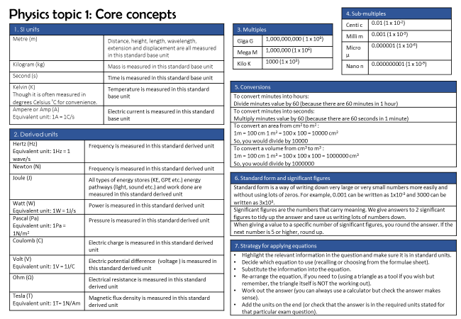
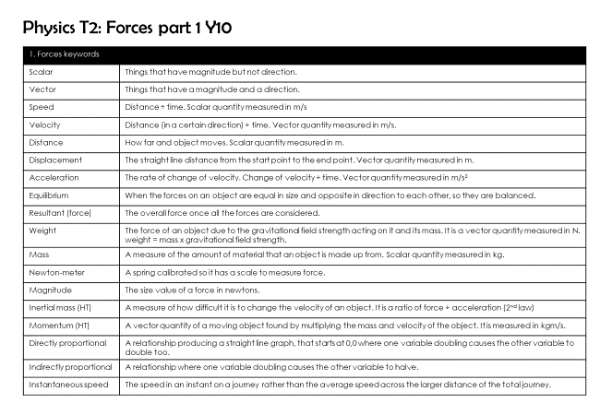
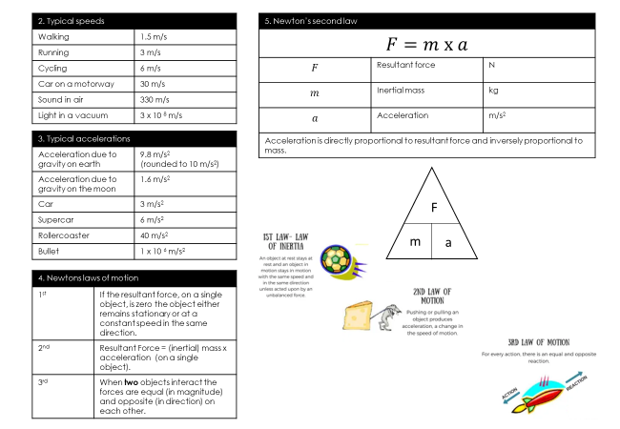
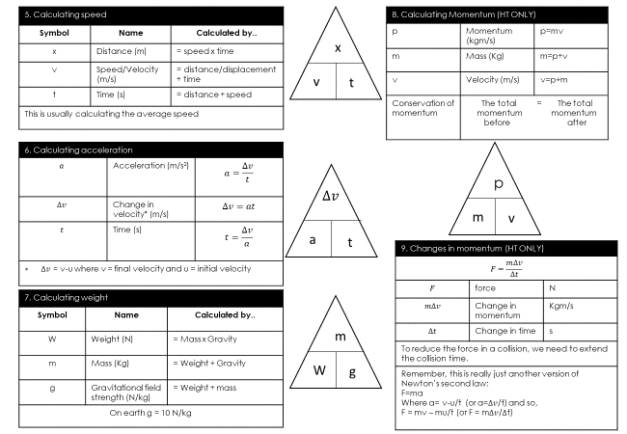
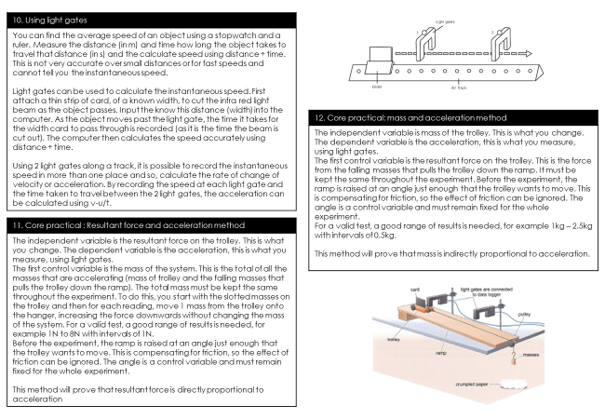
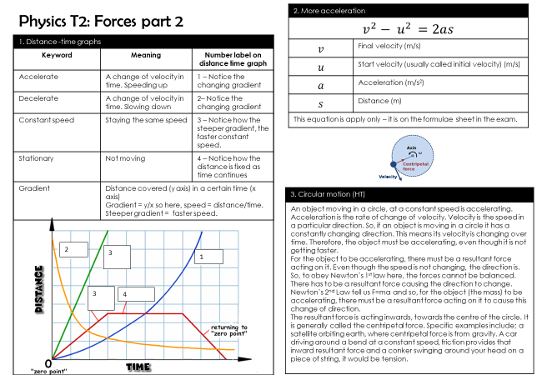
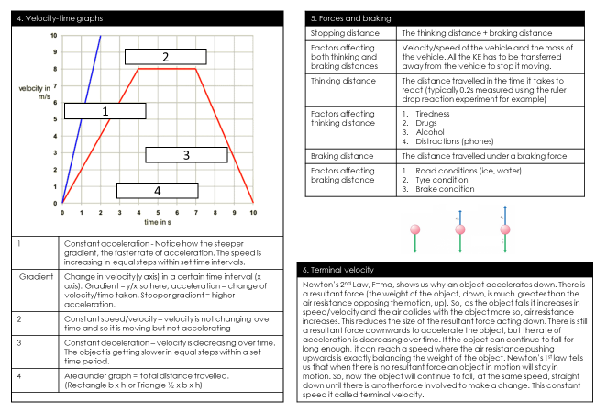
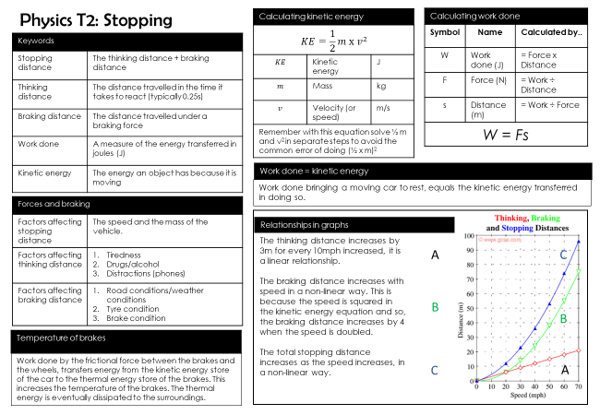
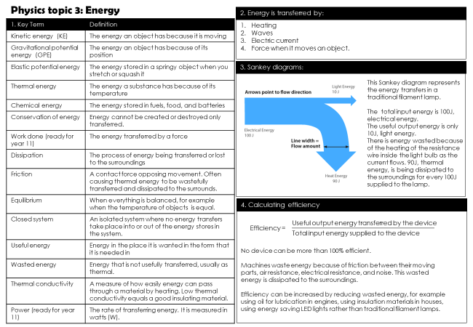
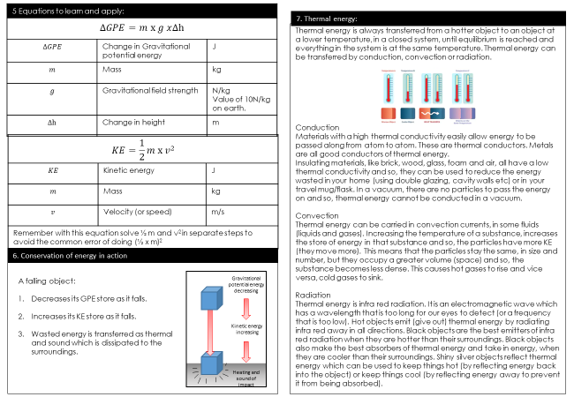
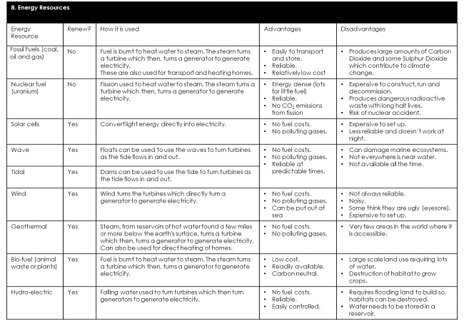
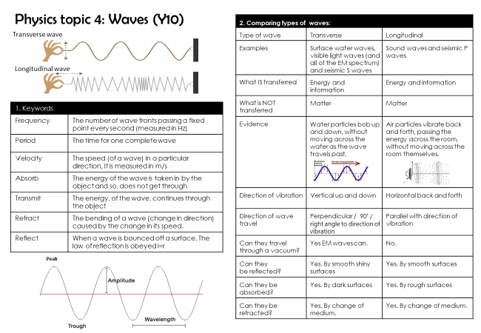

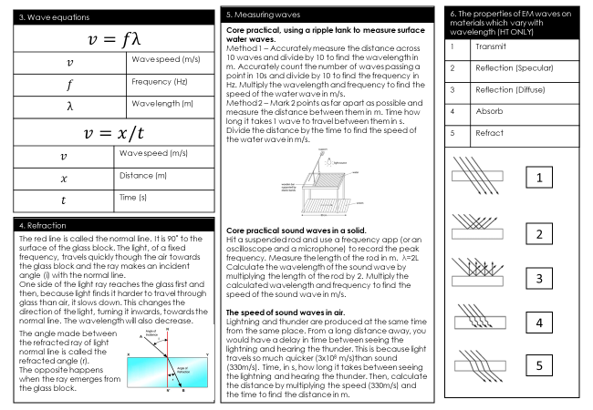
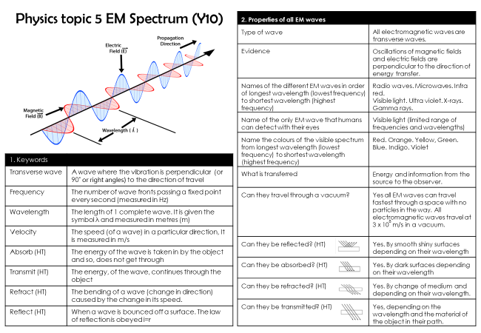
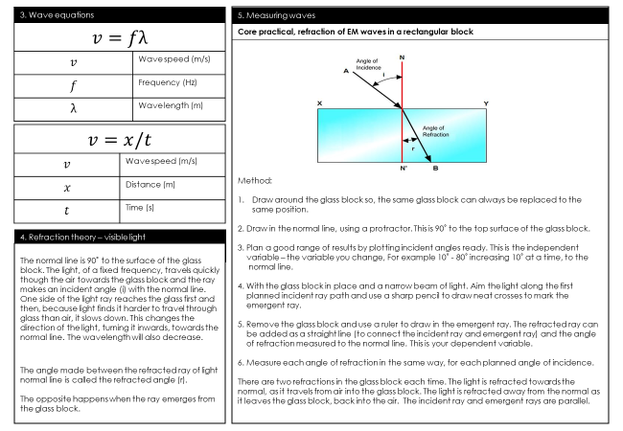
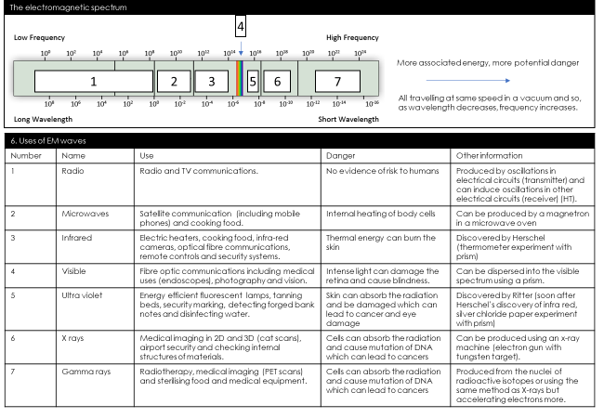
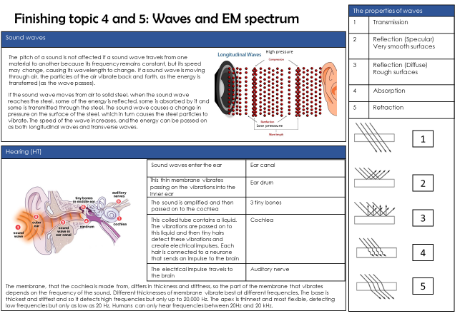
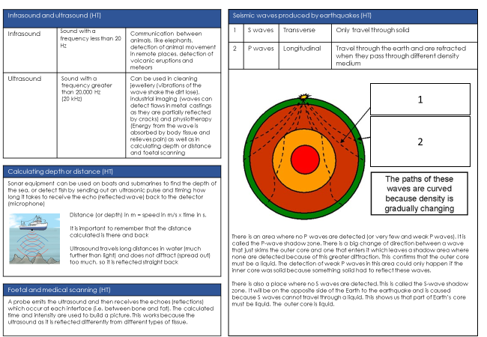
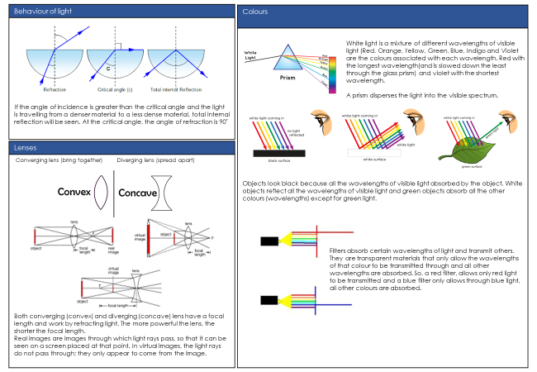
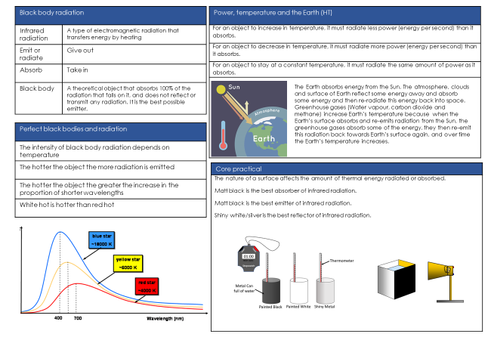
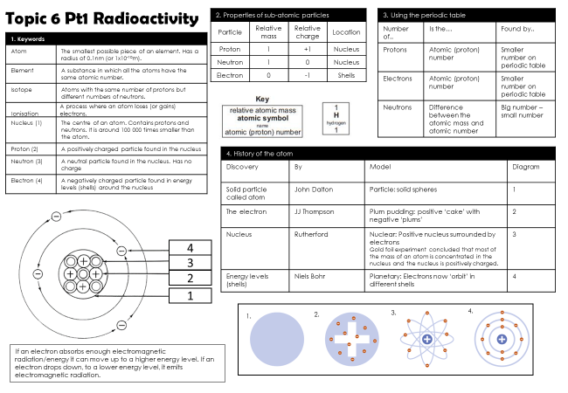
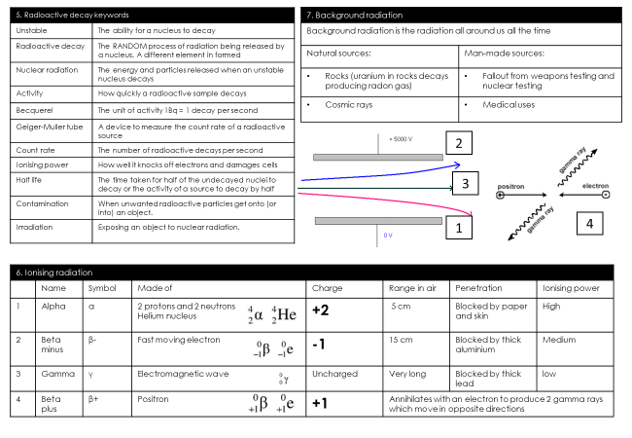
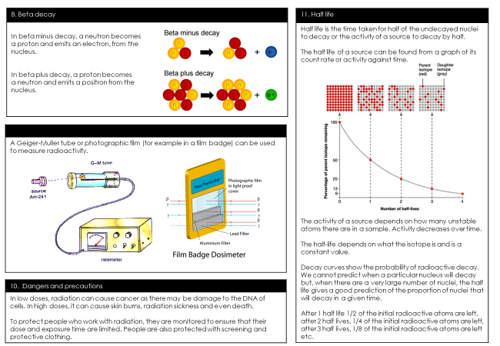

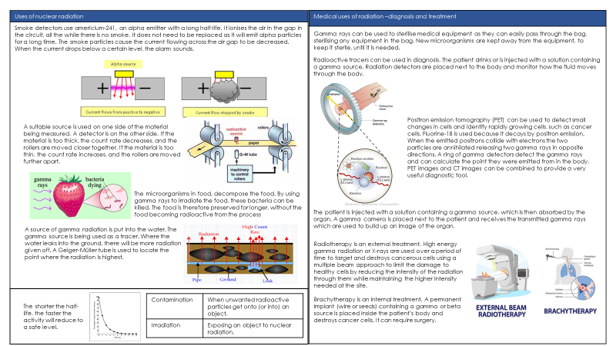
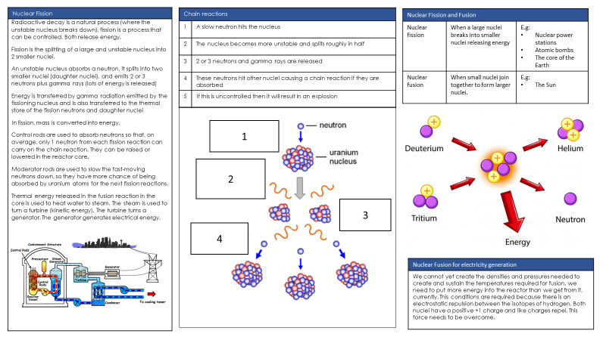
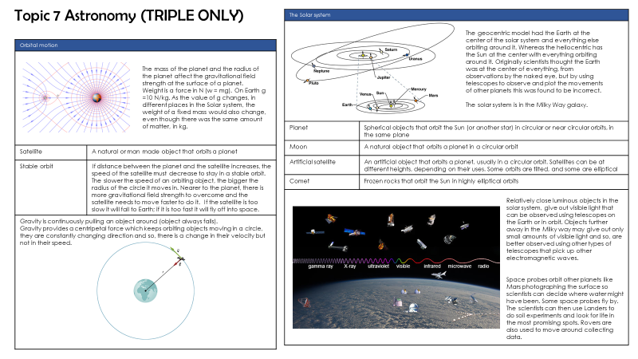
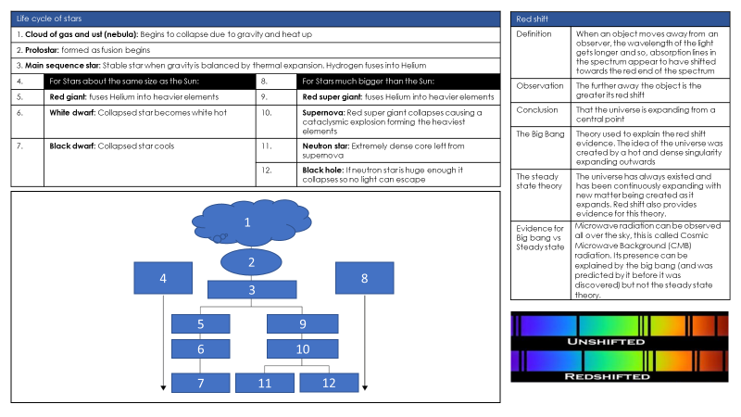
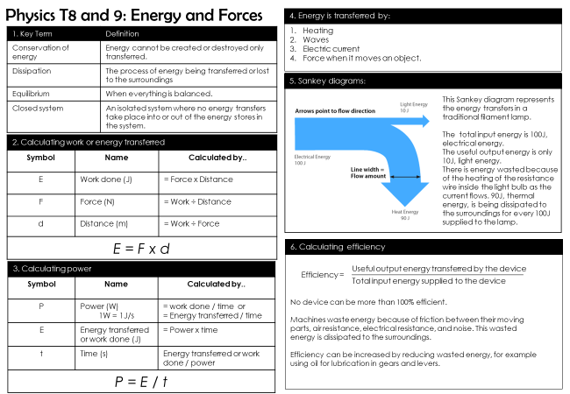
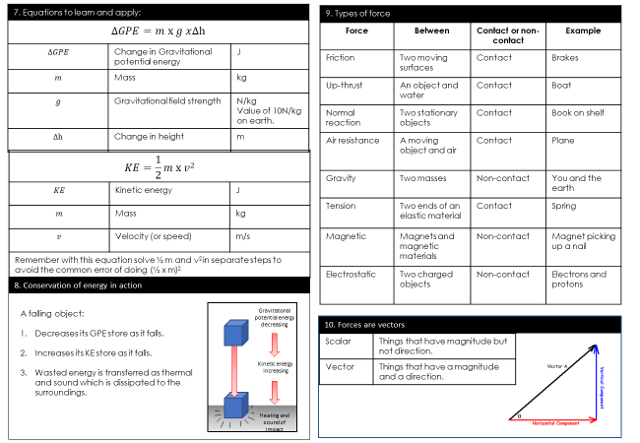
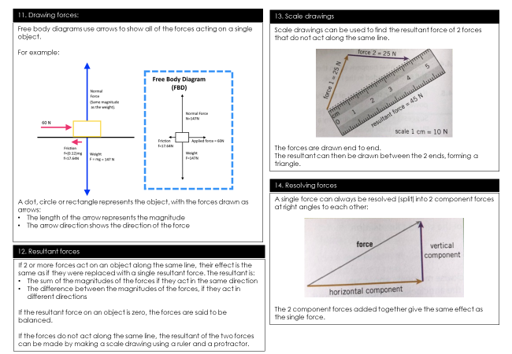
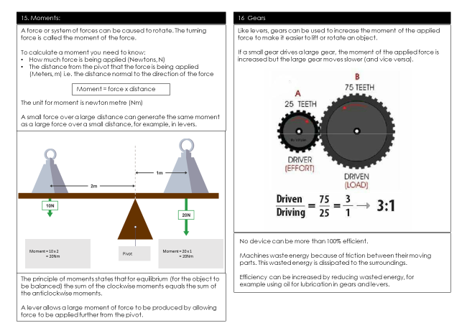
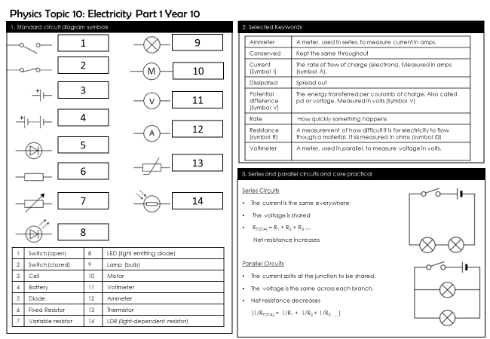
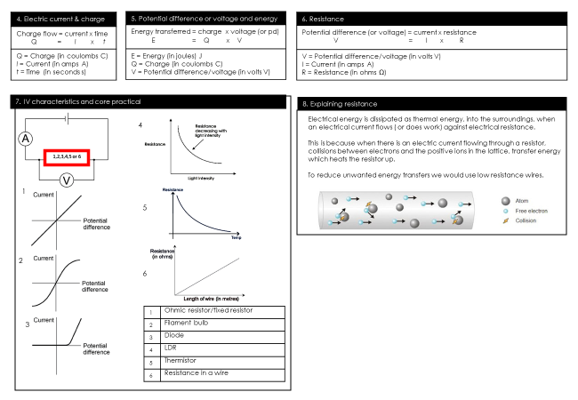
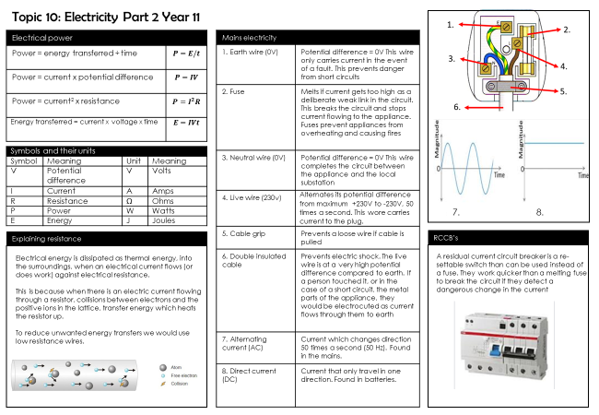
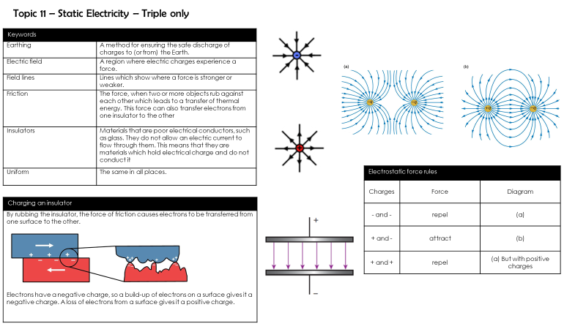
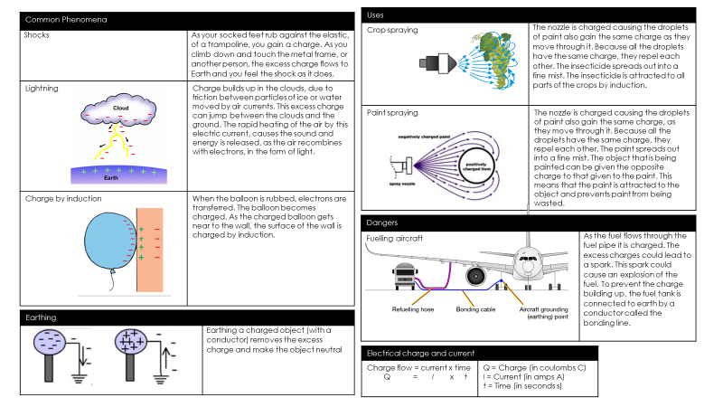
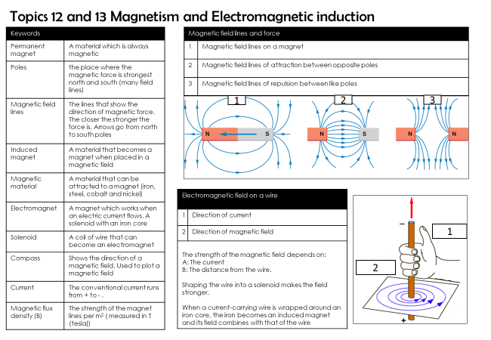
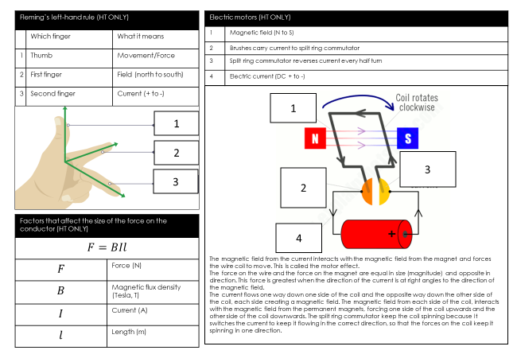
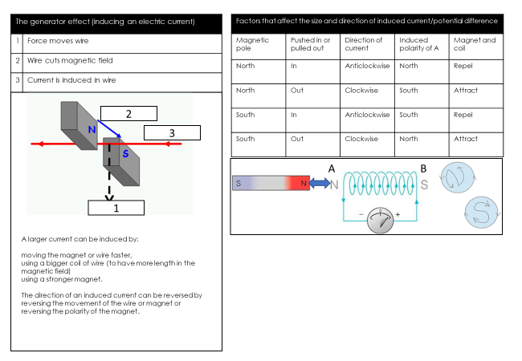

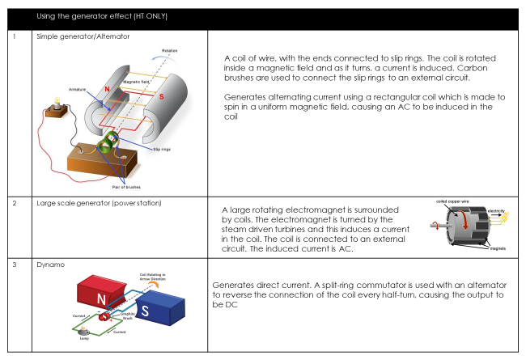
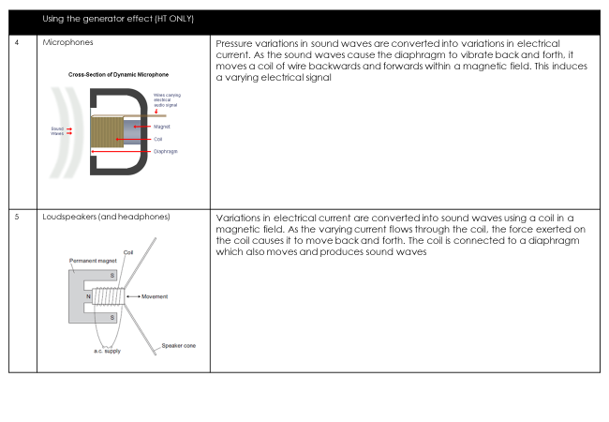
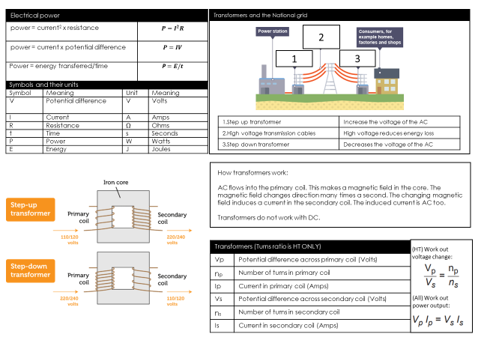
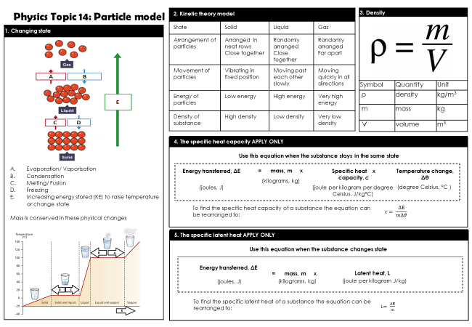

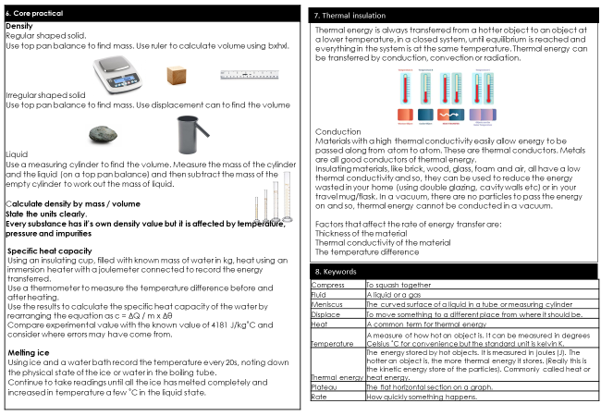
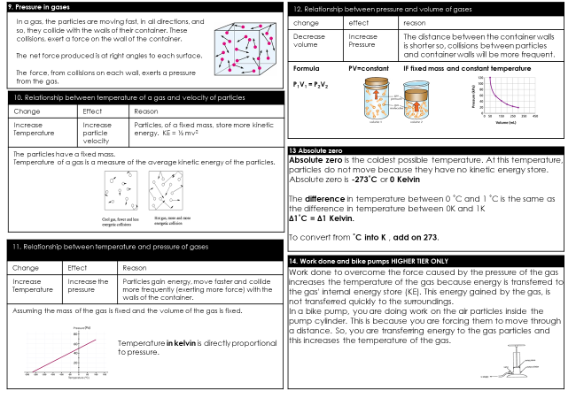
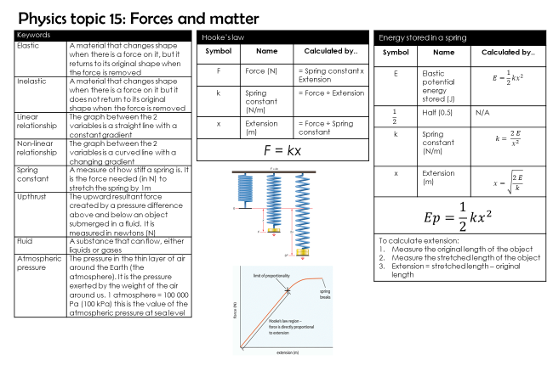
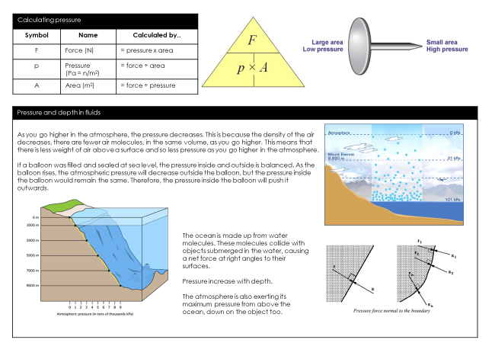
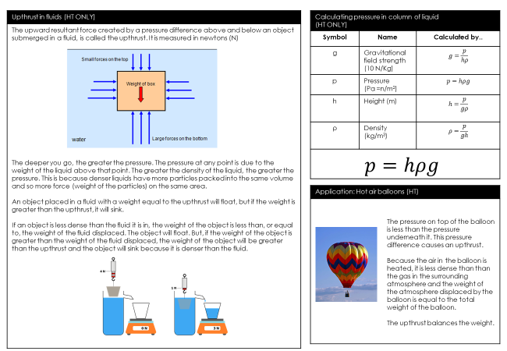
Full equation list:
