Geography Department
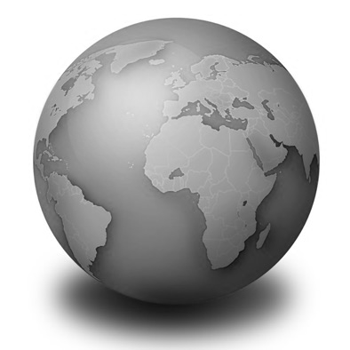
Year 8

Core knowledge booklet

Name:
Class:
Teacher:

Guidance for accessing homework in geography
This will help to make sure you know how to find and complete the ‘Geography in the news’ homework that you will be set once per topic for most of the topics covered at key stage 3. This involves some geographical news that has some sort of link to the topic that you are studying
Your teacher will inform you when homework has been set and when the due date is. Paper copies will be available outside Room 30 if you have no way of accessing the internet
- Log in to RM Unify using your school email address and password (the link to RM Unify can be found via the school website under the quick links tab)
- Then go to Google Classroom, by clicking the image that looks like this, shown to the right ()

- Locate your geograhy class. With year 7 and 8, this will be the class which has your class code followed by ‘Gg’ (for example, 7AGg, or 8HGg). For year 9 this will appear as Op__EB__g, where the blanked bits will have extra numbers and letters depending on your class group (e.g. Op1AEB1g or Op2aEB3g)
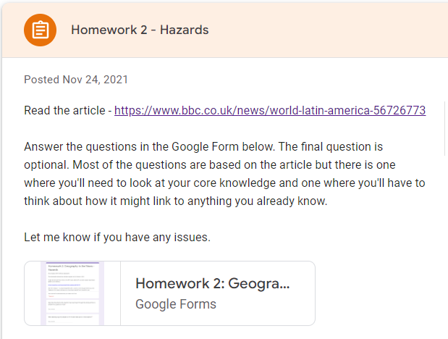
- Then find the topic that you are working on where you will see the homework that has been set for the topic. Click on that homework and you will see a link to both the article and to the Google Form where there are questions for you to answer.

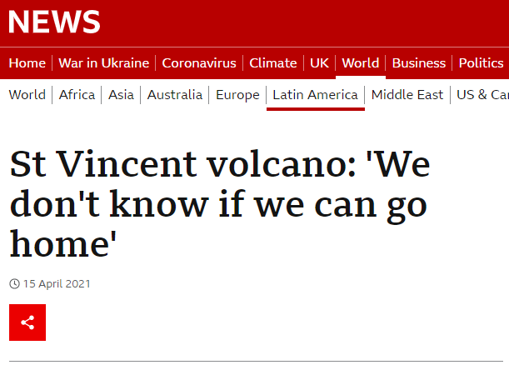
- If you are using a laptop or computer, it is handy to have the article and questions open side by side so that you can see the questions that you are trying to find answers for while you read the article.
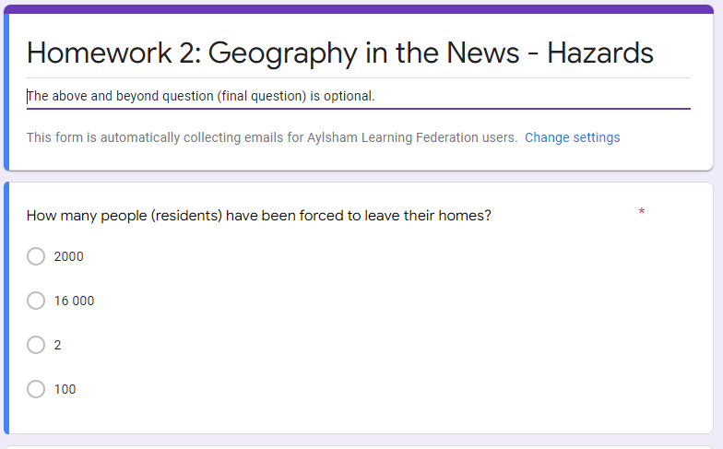

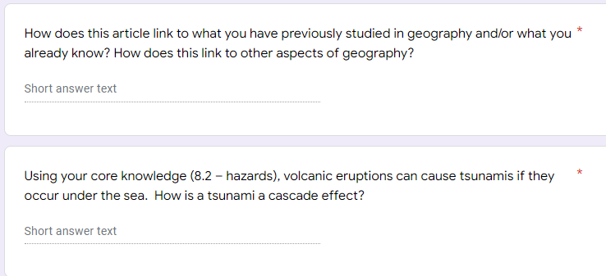
- The Google Form contains some multiple choice and some short answer questions. Most of the questions link to the article, but there will be a couple which are not possible to find answers to in the article. There will often be a question that needs you to think about how the article links to different parts of geography or anything that you’ve learnt in geography before. There is also usually a core knowledge one where you will need to refer to your core knowledge booklet to help you if you are unsure of the answer.

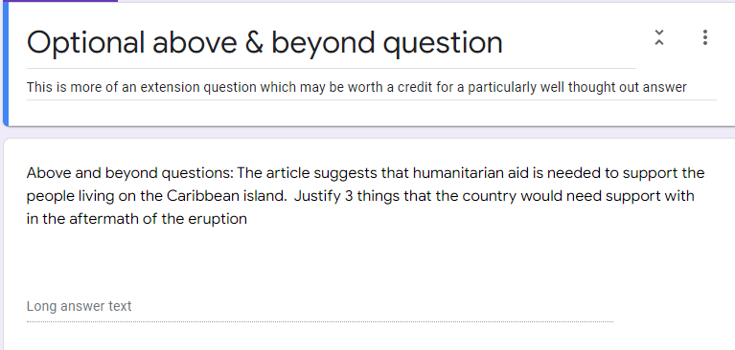
- There is also an above and beyond question which is optional, so it is not one that you have to do. This is an extension question that requires you to think a bit more deeply and often does not necessarily have an exact correct answer, but is more about your reasoning. A well thought out answer may be worth a credit.
- Make sure you click submit when you are finished with the Google Form, and wait for it to load and show confirmation before you close the page

- Also on Google Classroom you should click mark as done so that it shows your teacher that your work has been submitted

Don’t leave homework until the last minute and make sure you contact your teacher before the due date if you are having any issues

Core knowledge
These core questions cover key facts for each of the units you will study during year 8. It is an important revision skill to return to these throughout the year. You will be tested on these throughout the year and in your end of year exam.

The more confident you are with the terminology, the more confident you will be with the explanations in class.

The ones in the grey boxes may not feature in class, but they may form part of your assessment. This is to emphasise the importance of learning outside of the classroom.

Ways to revise:
Read through the questions and answers a number of times, cover the answers and write down or read aloud the answers

Use flashcards; write the question one side and the answer on the other side

Ask someone at home to test you on a regular basis

8.1 International Development
 | Question | Answer
1 | What does HIC stand for? | High Income Country
2 | What does LIC stand for? | Low Income Country
3 | Which development indicator measures how wealthy people are on average in a country? | GDP per capita
4 | Which development indicator measures the % of people over the age of 15 who can read and write? | Adult literacy rate
5 | Which development indicator takes into account both social & economic factors? | Human Development Index (HDI)
6 | How is a social indicator different from an economic one? | Economic takes into account money/wealth and social takes into account how the people benefit in terms of education, health or access to basic resources
7 | State the 4 industrial sectors | Primary, Secondary, Tertiary, Quaternary
8 | What is primary industry? | Extraction of raw materials from the ground or sea (e.g. farming, fishing, forestry and mining)
9 | What is secondary industry? | Manufacturing of goods using raw materials (e.g. car manufacturing)
10 | What is tertiary industry? | Providing a service (e.g. teacher, lawyer, shop assistant and cleaner)
11 | What is quaternary industry? | Research & development to improve knowledge and advances in technology
12 | What sort of industry tends to be most dominant in HICs? | Tertiary & quaternary
13 | What is meant by the UK north-south divide? | The social and economic differences between the north and south of the UK
14 | What is infrastructure? | Facilities that support everyday economic activity
15 | Give an example of infrastructure | Roads, rail, phone lines, gas pipes, electricity cables, ports etc
16 | Which transnational corporation operates in Nigeria? | Shell oil
17 | What was HS2? | A high speed rail network connecting London to the northern cities of Birmingham, Manchester, Liverpool and Newcastle
18 | What was the objective of HS2? | Reduce journey times and to help businesses function better, to help address the UK north south divide
19 | What is globalisation? | Businesses becoming more connected across the world, having international influence or operating on a global scale
20 | What does the Clark-Fisher model show? | Changes in the UK economy over time

8.2 Hazards
# | Question | Answer
1 | Name the scale earthquakes are measured on | The Richter Scale
2 | What was the landmass called when all of the continents were joined in one ‘supercontinent’? | Pangaea
3 | State which plate boundary involves two different density plate boundaries moving towards each other, causing one to subduct | Destructive
4 | In which country was the largest ever earthquake recorded? | Chile
5 | What is the name for the point underground where an earthquake begins? | Focus
6 | What is the name of the point at the surface, directly above the focus of an earthquake? | Epicentre
7 | What are the waves of energy called given off by an earthquake? | Seismic waves
8 | What is the thickest layer of the earth’s structure? | Mantle
9 | What is the hottest layer of the earth’s structure? | Inner Core
10 | What is the difference between magma and lava? | Magma is liquid rock that is underground whereas lava is above ground
11 | What is the cloud of ash, dust and rock which rushes down the slope of a volcano called? | Pyroclastic Flow
12 | What do primary effects of hazards involve? | The impacts that happen straight away as a direct result of the hazard (e.g. buildings collapsing or injury)
13 | What are the 3 names used for tropical storms? | Hurricane, typhoon, cyclone
14 | What temperature of ocean water is needed for tropical storms to form? | 27°C or higher
15 | What does a Met Office red weather warning mean? | Widespread damage, travel and power disruption and risk to life is likely
16 | What is a cascade effect? | An chain of events that happen as a knock-on effect due to a natural disaster (e.g. tsunami starting due to an earthquakes)

8.3 Urban Environments
# | Question | Answer
1 | What is a settlement? | A place where people live (e.g. village, town, city)
2 | What three things cause a settlement to change in size? | Birth rate, death rate and migration
3 | What is migration? | Movement of people from one place to another to stay permanently
4 | What is the birth rate? | The number of people born each year per 1000 of the population
5 | What is the death rate? | The number of people who die each year per 1000 of the population
6 | What is urbanisation? | Increasing percentage of people living in towns and cities (urban areas)
7 | What is meant by opportunities of living in urban areas? | Positives that improve peoples’ lives, the economy or the environment
8 | What is meant by challenges of living in urban areas? | Problems that limit the economy or the environment and have a negative effect on peoples’ lives
9 | What is urban greening? | Increasing the amount of green spaces in a city
10 | What is urban decline? | The worsening of a town/city caused by lack of investment or maintenance
11 | What is urban deprivation? | A lower standard of living than most people in an area
12 | What is the difference between greenfield and brownfield sites? | Greenfield are areas of land that have not been built on before  Brownfield are areas of land that have been built on before but now disused
13 | State the 3 settlement shapes | Nucleated, linear and dispersed
14 | Define a megacity | A city with more than 10 million inhabitants
15 | What are favelas? | Low quality slum buildings in Brazil
16 | In which type of countries do you usually find slums? | LIC’s and NEE’s
17 | What is meant by an integrated transport system? | All of the different forms of transport in an area link together
18 | What is multiculturalism? | Where more than one culture lives together in close proximity
19 | What is an asylum seeker? | Person who has left their home country (e.g. due to war) to look for somewhere safer to live
20 | What is a refugee? | Someone who is accepted in a different country after being forced to escape their own for safety
8.4 Coasts
# | Question | Answer
1 | What do destructive waves do to a coastline? | Erode – remove material from the beach
2 | What do constructive waves do to a coastline? | Build up the beach by depositing material
3 | What do you call the movement of a wave up a beach? | Swash
4 | What is fetch? | The distance of ocean water over which the wind blows
5 | What will be a characteristic of a wave that has been formed with a large fetch? | Destructive wave that is more powerful with more energy
6 | What type of beach do constructive waves create? | Gentle / shallow sloping
7 | What type of beach do destructive waves create? | Steep
8 | What type of erosion involves material being dissolved? | Solution / corrosion
9 | What is the difference between erosion and weathering? | Erosion involves material being worn away by waves whereas weathering weakens & breaks down rock above the waves
10 | Material is transported along a coastline. What is this process called? | Longshore drift (LSD)
11 | What is the name for the landform of deposited material that is attached to the mainland at one end but sticks out to sea? | A spit
12 | What landforms are created when coastlines have alternating bands of hard and soft rock? | Headlands and bays
13 | What is a stack? | Column of rock separated from the mainland
14 | What is hard engineering? | Artificial structures as sea defences against coastal erosion
15 | Give two disadvantages of hard engineering | Expensive, doesn’t look nice, not very natural
16 | State 2 types of hard engineering | Sea wall, revetment, rip rap, groyne, gabion, offshore reef
17 | What is soft engineering? | Enhancing natural processes as a natural defence against erosion
18 | State 2 types of soft engineering | Dune regeneration, cliff regrading, beach nourishment, managed retreat
19 | Which UK coastline is most rapidly eroding? | The Holderness coast
20 | Why are towns like Sheringham & Cromer heavily defended against coastal erosion? | They have a greater economic value which outweighs the cost of defences
Wider reading list
These are some suggestions of useful books (both fiction and non-fiction) to read to further your understanding of the topics you are studying this year. They vary in complexity and the ones with a * next to are the more difficult books to understand.
Please let your geography teacher know if you read any these or if you come across any other great geography books we can add to the list.
Urban environments:
Sarah Harper: How Population Change will Transform our World * (non-fiction)
Danny Dorling: Population 10 Billion * (non-fiction)
Michael Rosen and Annemarie Young: Who are Refugees and Migrants? What Makes People Leave their Homes? * (non-fiction)
Robert Neuwirth: Shadow Cities: A Billion Squatters * (non-fiction)
Lonely Book: The Cities Book (non-fiction)
Fabio Geda: In the Sea there are Crocodiles * (fiction)
Gillian Cross: After Tomorrow * (fiction)
Jon Walter: Close to the Wind * (fiction)
Sarah Crossan: The Weight of Water * (fiction)
Floella Benjamin: Coming to England * (non-fiction)

Natural hazards:
Horrible Geography series: Earth-shattering Earthquakes (non-fiction)
Horrible Geography series: Violent Volcanoes (non-fiction)
Horrible Geography series: Stormy Weather (non-fiction)
Iain Stewart: Plate Tectonics (A Ladybird Expert Book) (non-fiction)
Jim Eldridge: Survivor: Escape from Pompeii * (fiction)
DK Eyewitness: Volcano and Earthquake (non-fiction)
Sue Reid: Pompeii * (fiction)

International development:
United Nations Publications: Frieda Makes a Difference: The Sustainable Development Goals (non-fiction)
Donata Montari: Children Around the World (non-fiction)
Lonely Planet Kids: The Travel Book – A journey through every country of the world (non-fiction)
Andy Mulligan: Trash * (fiction)
Scott Westerfeld: Uglies (fiction)
Susin Nielsen: No Fixed Address * (fiction)
Polly Ho-Yen: Boy in the Tower * (fiction)
Gemma Malley: The Declaration * (fiction)

Coasts
Richard Girling: Sea Change: Britain’s coastal catastrophe * (non-fiction)
Nicholas Crane: Coast: Our Island Story * (non-fiction)
Horrible Geography series: Cracking Coasts (non-fiction)
James Nixon: Let’s Explore Britain: Coasts (non-fiction)
Michael Morpurgo: Why the Whales came (fiction)
Chris Vick: Storms: Every storm breaks in the end (fiction)

