Geography Department
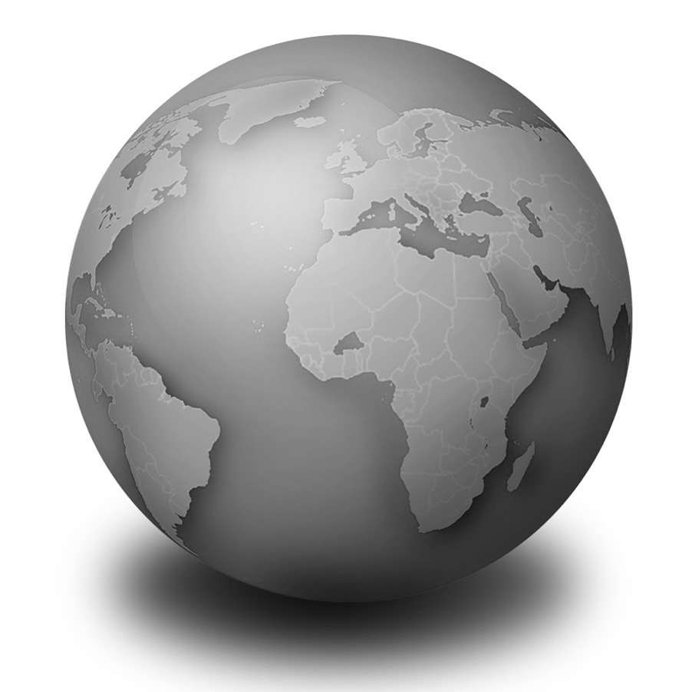
Year 7

Core knowledge booklet

Name:
Class:
Teacher:

Guidance for accessing homework in geography
This will help to make sure you know how to find and complete the ‘Geography in the news’ homework that you will be set once per topic for most of the topics covered at key stage 3. This involves some geographical news that has some sort of link to the topic that you are studying
Your teacher will inform you when homework has been set and when the due date is. Paper copies will be available outside Room 30 if you have no way of accessing the internet
- Log in to RM Unify using your school email address and password (the link to RM Unify can be found via the school website under the quick links tab)
- Then go to Google Classroom, by clicking the image that looks like this, shown to the right ()

- Locate your geograhy class. With year 7 and 8, this will be the class which has your class code followed by ‘Gg’ (for example, 7AGg, or 8HGg). For year 9 this will appear as Op__EB__g, where the blanked bits will have extra numbers and letters depending on your class group (e.g. Op1AEB1g or Op2aEB3g)
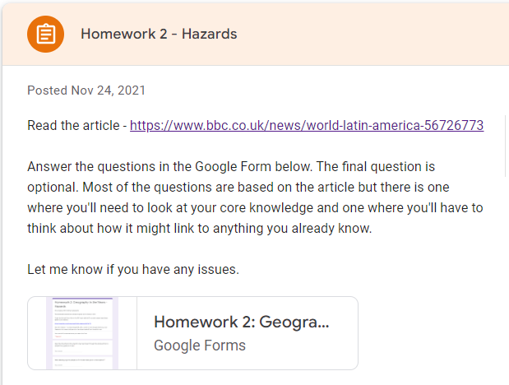
- Then find the topic that you are working on where you will see the homework that has been set for the topic. Click on that homework and you will see a link to both the article and to the Google Form where there are questions for you to answer.

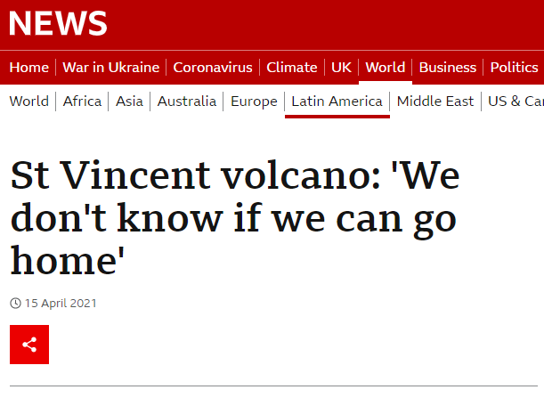
- If you are using a laptop or computer, it is handy to have the article and questions open side by side so that you can see the questions that you are trying to find answers for while you read the article.
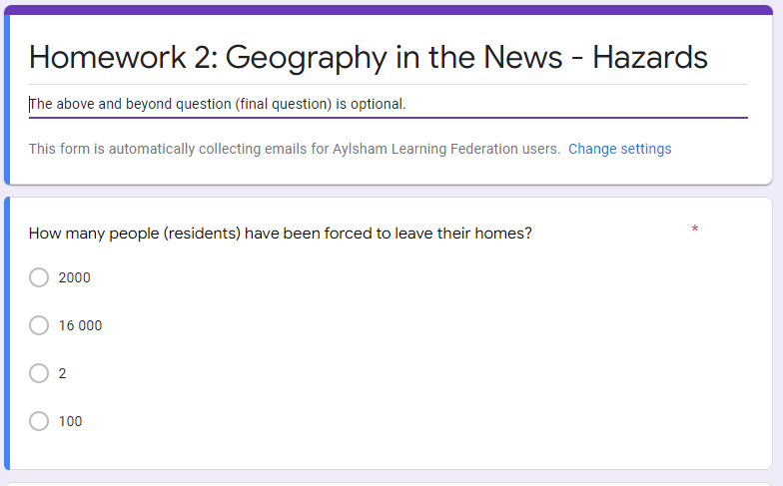

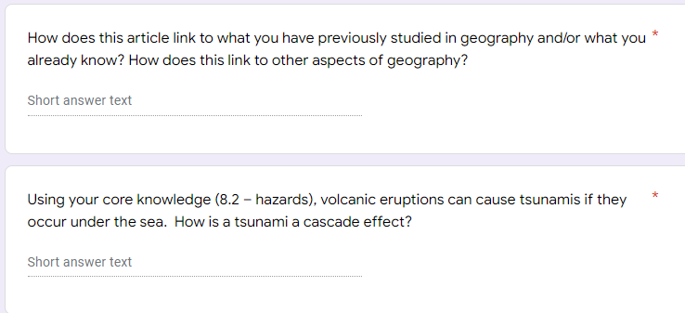
- The Google Form contains some multiple choice and some short answer questions. Most of the questions link to the article, but there will be a couple which are not possible to find answers to in the article. There will often be a question that needs you to think about how the article links to different parts of geography or anything that you’ve learnt in geography before. There is also usually a core knowledge one where you will need to refer to your core knowledge booklet to help you if you are unsure of the answer.

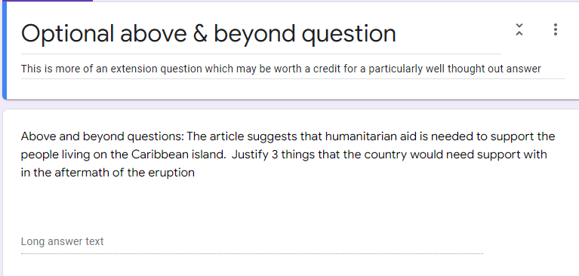
- There is also an above and beyond question which is optional, so it is not one that you have to do. This is an extension question that requires you to think a bit more deeply and often does not necessarily have an exact correct answer, but is more about your reasoning. A well thought out answer may be worth a credit.
- Make sure you click submit when you are finished with the Google Form, and wait for it to load and show confirmation before you close the page

- Also on Google Classroom you should click mark as done so that it shows your teacher that your work has been submitted

Don’t leave homework until the last minute and make sure you contact your teacher before the due date if you are having any issues

Core knowledge
These core questions cover key facts for each of the units you will study during year 7. It is an important revision skill to return to these throughout the year. You will be tested on these throughout the year and in your end of year exam.

The more confident you are with the terminology, the more confident you will be with the explanations in class.

The ones in the grey boxes may not feature in class, but they may form part of your assessment. This is to emphasise the importance of learning outside of the classroom.

Ways to revise:
Read through the questions and answers a number of times, cover the answers and write down or read aloud the answers

Use flashcards; write the question one side and the answer on the other side

Ask someone at home to test you on a regular basis

7.2 Ecosystems: Tropical Rainforest

# | Question | Answer
1 | What is an ecosystem? | A community of living things interacting with the non-living environment
2 | Give an example of a large scale ecosystem | Rainforest, Ocean, Desert, Savannah, Tundra etc
3 | Give an example of a small scale ecosystem | Tree, Hedgerow, Pond, Meadow, Puddle etc
4 | How would the climate be described in a tropical rainforest? | Hot, wet and humid
5 | What is a tropical rainforest? | Forest which grows in areas with high temperatures, high humidity and high rainfall all year round
6 | Name a tropical rainforest | Amazon, Central African Rainforest (Congo), South East Asian Rainforest (Indonesia), Madagascar, Papua New Guinea
7 | What are the layers of the rainforest called from the ground upwards? | Shrub layer / forest floor, Lower Canopy, Canopy, Emergent
8 | State one plant adaptation | Drip tips, Buttress roots, Epiphytes, Lianas, Waxy leaves
9 | Describe how sloths have adapted to live in the rainforest | Algae in hair to camouflage / strong claws to hang from branches / slow moving to avoid detection etc
10 | Describe how a tree frog has adapted to live in the rainforest | Has sticky pad’s on feet to cling to leaves and branches / green colour to camouflage with the leaves
11 | What is deforestation? | Large scale destruction of forest (over a big area)
12 | What is an indigenous person? | Person who is native to a particular area
13 | What causes deforestation in the Amazon rainforest? | Road building, subsistence farming, commercial farming, mineral extraction, population growth, logging
14 | What is the difference between subsistence and commercial farming? | Subsistence farmers grow food for themselves whereas commercial farming sell produce for profit
15 | What is the name of the Amazonian tribe who live on the border between Brazil & Venezuela? | The Yanomami
16 | What does it mean for a tribe to be nomadic? | They move from place to place to live off the land
17 | Why are roads especially threatening for rainforests? | They give better access for machinery which can make deforestation easier
18 | What is sustainable management? | Ensuring that resources are used in a controlled and careful way so that it doesn’t have a negative impact on the future
19 | Where is deforestation happening the most? | The Amazon, especially in Brazil
7.3 Ecosystems: Hot and cold environments
HOT Environments
# | Question | Answer
1 | What is the definition of a desert? | A place which receives less than 250mm of rainfall annually
2 | Where are hot deserts located? | Mainly near to the tropics (and near to 30°N or S of the equator)
3 | Name a hot desert | Mojave (Death Valley), Atacama, Sahara, Arabian, Namib/Kalahari, Outback
4 | Name a desert plant (just cactus on its own is not good enough) | Prickly pear cactus/ Saguaro cactus / Joshua tree / Aloe Vera etc
5 | Name a desert animal | Fennec Fox / Camel / Thorny Devil / Scorpion / Meerkat etc
6 | State one adaptation for a cactus | Thick waxy skin, Long & deep roots, wide & shallow roots, Fleshy stem, Spikes instead of leaves, small leaves
7 | State one adaptation for a camel | Long eyelashes, Fat stored in hump, Fur for insulation, Nostrils can close, Broad feet , thick leathery skin on their feet, 2 sets of eyelashes
8 | How do Bushmen of the Kalahari find water that they need in the desert? | From digging up and eating tubers
9 | Where is the Arabian Desert? | In the Middle East, along the Tropic of Cancer (in countries like Saudi Arabia and UAE)
10 | What encouraged rapid growth of cities in the Arabian Desert since the 1930s? | The discovery of oil and the wealth it created
11 | State one opportunity of developing the Arabian Desert | Renewable energy (e.g. solar), tourism, land availability for growth of new cities, mining for minerals, gas and oil
12 | State one challenge of developing the Arabian Desert | Conflict over oil, lack of natural water resources for farming, energy use for air conditioning in hotels / shops / homes
13 | What is the difference between subsistence and commercial farming? | Subsistence involves farming for themselves and their family, whereas commercial involves farming for profit (sell produce)
14 | Why are deserts spreading? | Climate change and human activities is causing desertification

COLD Environments
 | Question | Answer
1 | Name 1 animal that lives in the Arctic | Polar Bears, Reindeer, Arctic Fox, Arctic Hare, Orca, Walrus
2 | Where is tundra found? | Around the Arctic Circle (north of 66.5°N of the equator)
3 | Name a country in the Arctic | Canada, Russia, Greenland, Iceland, Norway, Sweden, Finland
4 | What is tundra? | A cold, treeless, barren landscape
5 | What is the climate like in the tundra? | Below 0°C for most of the year, with relatively little rain
6 | What is the biodiversity like in the tundra? | Low due to the harsh conditions
7 | Why do the Nenets need to migrate? | The climate is too extreme for them and their reindeers to survive in northern Siberia in winter
8 | The Nenet tribe live in ‘chums’ – what are these? | Their homes made of reindeer skins placed over a skeleton of long wooden poles.
9 | What is permafrost? | Ground that is nearly always frozen apart from the top layer in summer
10 | What is the difference between a food chain & food web? | Food chains show simple relationships (one species eats another), whereas food webs show complex links (as species have multiple food sources)
11 | What was the name of the ice sheet that last covered Britain? | The Anglian Ice sheet

7.4 Map skills
# | Question | Answer
1 | Name the 7 continents of the world | Antarctica, Oceania, Africa, Europe, Asia, South America, North America
2 | Name 5 oceans of the world | Pacific, Atlantic, Indian, Southern, Arctic
3 | What is physical geography? | The study of natural features of a landscape
4 | State a physical feature | Mountain, river, beach, woodland etc
5 | What is human geography? | The study of artificial (people made) features of a landscape
6 | State a human feature | School, building, car park, road etc
7 | What do we use grid references for? | To help locate somewhere or something
8 | What do 4 figure grid references help to locate on a map? | A 1km square – e.g. a village
9 | What do 6 figure grid references help to locate on a map? | A particular point on a map – e.g. a church
10 | How do we measure straight line distance on a map? | Measure using a ruler and convert using a scale
11 | What are contours? | Lines which join places of equal height on a map.
12 | What is a spot height? | A specific height shown on a map in metres above sea level (shown in black)
13 | Contour lines that are drawn closely together tell us what about the relief of the land? | It is steep
14 | Contour lines that are drawn far apart tell us what about the relief of the land? | It is flat/gentle
15 | Why do we use map symbols? | To show attractions/features (without them maps would become cluttered)
16 | What are the 8 points of a compass going clockwise? | North, North East, East, South East, South, South West, West, North West
17 | What is scale? | The relationship between the distance on the map and real life distance

7.5 Weather
# | Question | Answer
1 | What is the difference between weather and climate? | Weather is the day to day changes in atmosphere. Climate is the 30 year average weather over a larger area.
2 | What instrument do we use to measure temperature? | Thermometer
3 | What instrument do we use to measure wind speed? | Anemometer
4 | What instrument do we use to measure wind direction? | Compass/ Weather vane
5 | What instrument do we use to measure rainfall? | Rain gauge
6 | What is a microclimate? | Localised climate that is different to its surroundings
7 | Give one factor which influences a microclimate | Shelter, relief, trees, hills and water, buildings
8 | How do we measure microclimates? | Differences in wind speed, direction and temperatures in locations
9 | What does a climate graph show? | Rainfall and temperature data for a location over a year
10 | What weather is associated with rising air? | Low pressure, rain, wind and cloud
11 | Where on Earth experiences the most heating? | Near the equator
12 | What type of biome is found where air is sinking? | Deserts
13 | What is extreme weather? | Conditions that are very different from normal
14 | What instrument do we use to measure atmospheric pressure? | Barometer
15 | What is a convection cell? | Air moving from high to low pressure
16 | Name the largest convection cell | A Hadley cell
17 | What happens when air is heated by the sun? | It becomes less dense and rises, creating low pressure at the surface

# | Question | Answer
1 | What is the greenhouse effect? | Heat is trapped in Earth’s atmosphere by gases like carbon dioxide
2 | What has been the general pattern of global climate since the 1700s? | Temperatures have warmed
3 | What are greenhouse gases? | A gas which traps heat on Earth by reducing the loss of heat to space
4 | Give an example of a greenhouse gas | Carbon dioxide, methane, nitrous oxide
5 | How does the enhanced greenhouse effect differ from the natural greenhouse effect? | Humans have added more greenhouse gases so more heat energy is trapped in the atmosphere.
6 | What activities do humans do which cause climate change? | Deforestation, keeping cattle for meat & dairy production, burn fossil fuels for transport and electricity
7 | What factors can naturally lead to changes in climate? | Changes in solar energy, Earth’s tilt, Earth’s orbit and volcanic eruptions
8 | What type of countries have typically contributed to climate change most? | Higher income countries (HIC)
9 | State one current impact of climate change | Ice melting (sea ice and glaciers), sea level rise, drought, extreme weather
10 | What can be done to help solve issues with climate change? | Adapt to changes and try to reduce emissions to prevent climate change being more extreme.
11 | What is the difference between mitigation and adaptation? | Mitigation deals with causes of climate change whereas adaptation deals with the impacts
12 | Why might food supply be affected by climate change? | Changing rainfall patterns could mean crops don’t have enough water to grow  Different pests and diseases may lead to a loss of crops
13 | How can animals be threatened by climate change? | Habitats are changing that can harm the food web and risk extinctions
14 | How could rainforests be impacted in the future? | It could get drier and turn to savannah grasslands instead
15 | What is the Kyoto Protocol? | An international agreement to reduce carbon emissions
7.6 Climate change (once you go into year 8 at timetable rollover in June)

Wider reading list
These are some suggestions of useful books to read to further your understanding of the topics you are studying this year. They vary in complexity and the ones with a * next to are the more difficult books to understand.
Please let your geography teacher know if you read any these or if you come across any other great geography books we can add to the list.
What is geography? / Map skills
Simor Garfield: On the map: Why the world looks the way it does * (non-fiction)
Scot Ritchie: Follow that map: A first book of mapping skills (non-fiction)
Malcolm and Alexander Swanston: How to draw a map *(non-fiction)
James Doyle: Where on Earth? Geography without the boring bits (non-fiction)
Horrible Geography series: Horrible Geography of the World (non-fiction)
Tim Marshall: Prisoners of Geography: Our world explained in 12 simple maps * (non-fiction)

Ecosystems: Tropical rainforests
Horrible Geography series: Bloomin Rainforests (non-fiction)
Simon Chapman: Borneo Rainforest (Expedition diaries) (non-fiction)
Katherine Rundell: The Explorer (fiction)
Gerard Cheshire: The Tropical Rainforest (Nature unfolds) (non-fiction)
Richard Platt: The Vanishing Rainforest (non-fiction)
Eva Ibbotson: Journey to the River Sea (fiction)

Ecosystems: Hot and cold environments
Horrible Geography series: Desperate deserts (non-fiction)
Sara Wheeler: The Magnetic North: Travels in the Arctic * (non-fiction)
Ellen Labrecque: Arctic Tundra (Earth’s last frontiers) (non-fiction)
Professor Alex Woolf: Expedition to the Arctic (non-fiction)
Alan Parkinson: The Ice Man (fiction)
Mike Gould: The Race to the Pole (non-fiction)
Michael Palin: Pole to Pole * (non-fiction)
Michael Palin: Sahara * (non-fiction)
Louis Sachar: Holes * (fiction)

Weather
Jen Green: Weather patterns * (non-fiction)
Jen Green: Weather in 30 seconds (non-fiction)
Christiane Dorian and Beverley Young: How the weather works (non-fiction)
Virginia Bergin: The Rain * (fiction)

Climate change
Gail Herman: What is Climate change? (non-fiction)
Baby Professor: What every child should know about climate change? (non-fiction)
Marcus Sedgewick: Floodland (fiction)
Saci Lloyd: The Carbon Diaries * (fiction)
Lauren James: The Quiet at the End of the World * (fiction)

