Geography Department
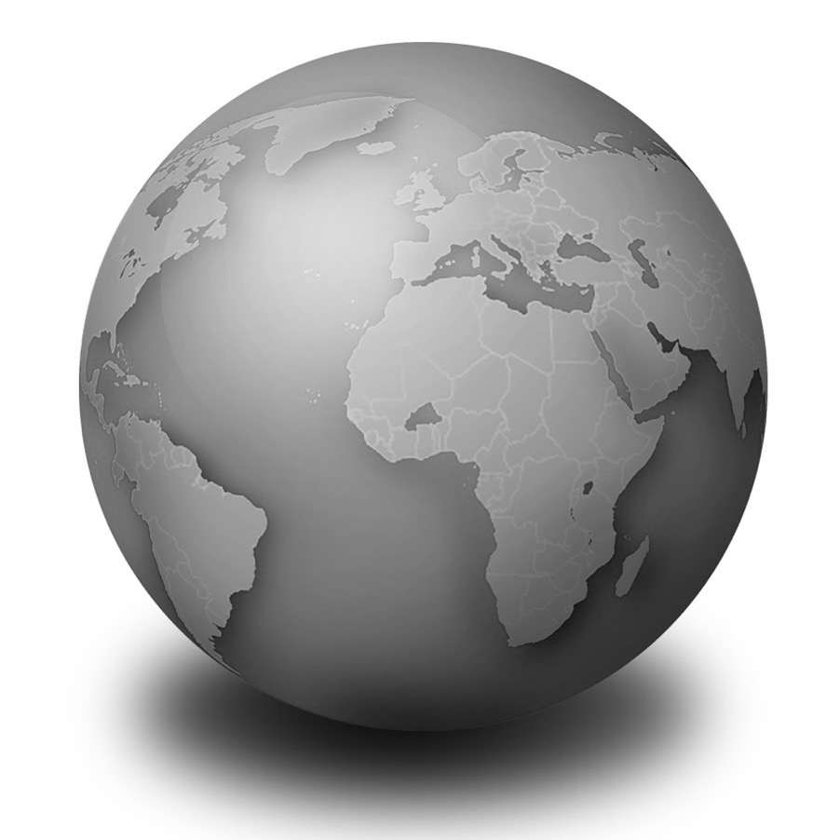
Year 9

Core knowledge

Name:
Class:
Teacher:

Guidance for accessing homework in geography
This will help to make sure you know how to find and complete the ‘Geography in the news’ homework that you will be set once per topic for most of the topics covered at key stage 3. This involves some geographical news that has some sort of link to the topic that you are studying
Your teacher will inform you when homework has been set and when the due date is. Paper copies will be available outside Room 30 if you have no way of accessing the internet
- Log in to RM Unify using your school email address and password (the link to RM Unify can be found via the school website under the quick links tab)
- Then go to Google Classroom, by clicking the image that looks like this, shown to the right ()

- Locate your geograhy class. With year 7 and 8, this will be the class which has your class code followed by ‘Gg’ (for example, 7AGg, or 8HGg). For year 9 this will appear as Op__EB__g, where the blanked bits will have extra numbers and letters depending on your class group (e.g. Op1AEB1g or Op2aEB3g)
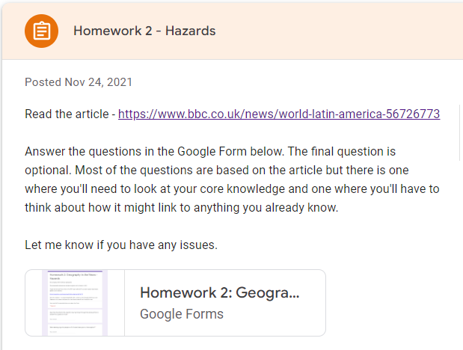
- Then find the topic that you are working on where you will see the homework that has been set for the topic. Click on that homework and you will see a link to both the article and to the Google Form where there are questions for you to answer.

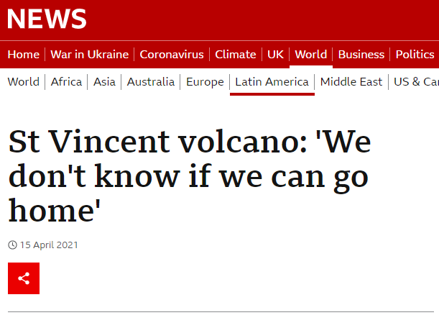
- If you are using a laptop or computer, it is handy to have the article and questions open side by side so that you can see the questions that you are trying to find answers for while you read the article.
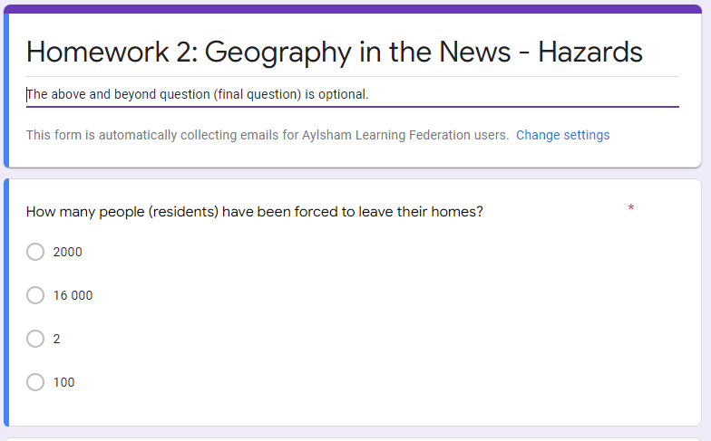

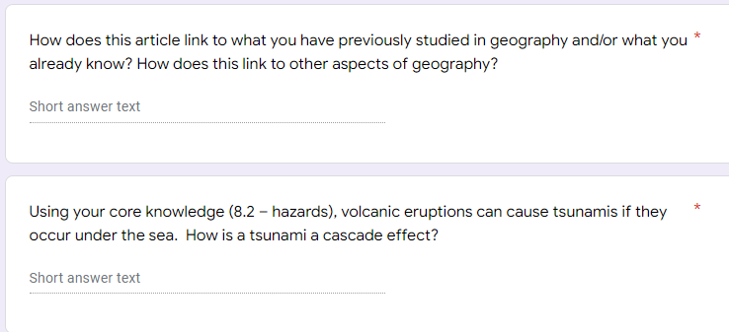
- The Google Form contains some multiple choice and some short answer questions. Most of the questions link to the article, but there will be a couple which are not possible to find answers to in the article. There will often be a question that needs you to think about how the article links to different parts of geography or anything that you’ve learnt in geography before. There is also usually a core knowledge one where you will need to refer to your core knowledge booklet to help you if you are unsure of the answer.

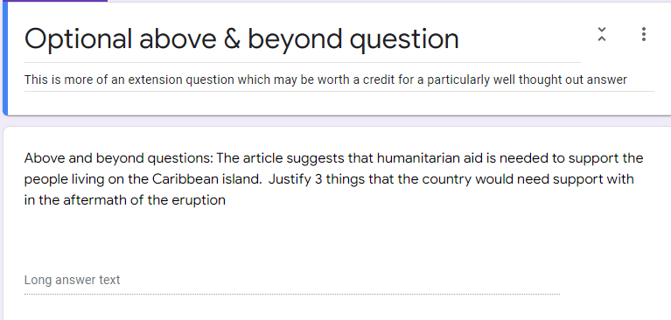
- There is also an above and beyond question which is optional, so it is not one that you have to do. This is an extension question that requires you to think a bit more deeply and often does not necessarily have an exact correct answer, but is more about your reasoning. A well thought out answer may be worth a credit.
- Make sure you click submit when you are finished with the Google Form, and wait for it to load and show confirmation before you close the page

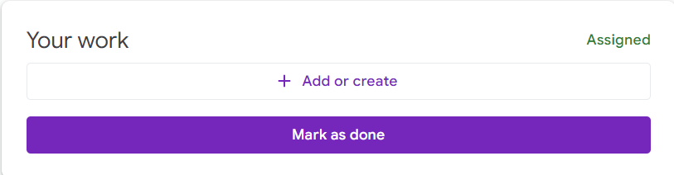
- Also on Google Classroom you should click mark as done so that it shows your teacher that your work has been submitted

Don’t leave homework until the last minute and make sure you contact your teacher before the due date if you are having any issues

Core knowledge
These core questions cover key facts for each of the units you will study during year 9. It is an important revision skill to return to these throughout the year. You will be tested on these throughout the year and in your end of year exam.

The more confident you are with the terminology, the more confident you will be with the explanations in class.

The ones in the grey boxes may not feature in class, but they may form part of your assessment. This is to emphasise the importance of learning outside of the classroom.

Ways to revise:
Read through the questions and answers a number of times, cover the answers and write down or read aloud the answers

Use flashcards; write the question one side and the answer on the other side

Ask someone at home to test you on a regular basis

9.1 Rivers
# | Question | Answer
1 | What is the hydrological cycle? | The continuous movement of water between the ocean, atmosphere, land and living organisms
2 | What is evaporation? | When water turns from liquid to gas (typically after being heated by the sun)
3 | What is condensation? | Water vapour cools and turns from gas to liquid
4 | Where is most freshwater stored on Earth? | Groundwater in aquifers
5 | What three processes happen in a river? | Erosion, transport and deposition
6 | What is the difference between erosion and deposition? | Erosion is wearing away of the land whereas deposition is the dropping of material
7 | Why does a river deposit material it is transporting? | Lack of energy as the flow decreases
8 | How many types of erosion are there? What are they? | 4 – attrition, abrasion, hydraulic action, solution
9 | What is a drainage basin? | An area of land drained by a river  OR more technically [The area of land where water has the potential to flow towards a given river]
10 | What are the names of the start and end of a river? | Start – source / End - mouth
11 | What happens at the confluence of a river? | Two rivers or streams meet / A tributary joins a main river
12 | What 4 landforms are found in the upper course of a river? | V shaped valley, interlocking spurs, waterfalls & gorges
13 | What 4 landforms are found in the lower course of a river? | Ox-bow lake, floodplains, levees and deltas
14 | What are flood hydrographs used for? | Measure a river’s discharge and how it changes in response to a storm
15 | What needs to happen for a waterfall to be created? | A river needs to cross a band of soft rock after flowing over hard rock
16 | What feature forms on the inside bend of a meander? | Slip off slope
17 | Why does more surface runoff promote flooding? | Water flows over the land to reach the river, so lots of water quickly reaches the river and can’t contain it all within it’s banks
18 | Why does the removal of vegetation increase the chances of flooding? | Less rainfall is intercepted, meaning that more water moves down towards rivers more quickly
19 | State one way humans influence drainage basins | Farming, building urban areas, taking water for our own uses, dams, deforestation
20 | How does the size of a drainage basin influence the amount of water at the mouth? | There will be more water in a bigger drainage basin as there will be a larger area for water to be drained over
21 | Which process occurs most in the upstream of a river? | Vertical (downwards) erosion
9.2 Sustainable development
# | Question | Answer
1 | What is sustainable development? | Meeting the needs of the present without harming the ability of future generations to meet their needs
2 | What are the three strands/pillars of sustainability? | Environment, social (people), economic (money)
3 | Where is Masdar City & ‘The Sustainable City’? | In the United Arab Emirates – Masdar near Abu Dhabi, The Sustainable City near Dubai
4 | Give an aim of Masdar & The Sustainable City | To minimise the impact cities have on the environment whilst helping to improve the lives of people and grow the wealth of the area
5 | Define renewable resource | A resource that can be used again and again, or replaced on short timescales (never is diminished)
6 | Define non-renewable resource | Is finite meaning it will eventually run out, so it is not sustainable in the long run.
7 | Give an example of a renewable resource | Solar, wind, geothermal, tidal, hydropower
8 | Give an example of a non-renewable resource | Coal, oil, natural gas
9 | What are food miles? | The distance food has travelled to get from where it was produced to where it is sold
10 | What is a carbon footprint? | Measure of how much carbon is emitted in the production and transportation of a product
11 | What does Fairtrade aim to do? | Help producers/farmers in poorer countries make better trading conditions, to receive a higher price for their products
12 | What is a throwaway society? | Buying new or latest goods regardless of whether it is already owned and in working order
13 | What is a consumer society? | Where buying and selling of goods and services is the most important activity
14 | State 3 main ways the UK disposes of waste | Landfill, incineration, recycling
15 | What percentage of ocean waste is plastic? | 90%
16 | What is an ecological footprint? | Measure of the human demand on earth's ecosystems and environment.
17 | What are the 2 problems of transport in cities? | Congestion  Air pollution
18 | Where in the world claims to have the most sustainable transport? | Hong Kong
19 | What does EfW stand for? | Energy from waste

# | Question | Answer
1 | What is gender equality? | When all genders are treated fairly and equally
2 | What does the gender inequality index measure? | Maternal mortality, empowerment and percentage of women in work
3 | How many global goals form the Sustainable Development Goals and when were they set up? | 17 in 2015
4 | What is a microfinance loan? | Very small loans which are given to people in LICs to start a small business.
5 | What is overpopulation? | The population size exceeds the capacity of the services & resources in an area
6 | State one negative impact of overpopulation | Pressure on food / increased carbon emissions / overcrowding / congestion / lack of jobs / pressure on services / decreasing green space / increased waste
7 | What is mass tourism? | Large numbers of people going on holiday to the same resort, usually at the same time of the year
8 | What is infrastructure? | The basic structures needed for an area to function
9 | State an example of infrastructure | Transport networks, communication networks
10 | What is ecotourism? | Responsible travel to natural areas that conserve the environment and sustains the well-being of the local people
11 | What does a carbon footprint measure? | The total carbon emissions caused by an organisation, process, event or person
12 | What is a transnational corporation? | Large businesses that sell products and services in different countries. They normally have their headquarters in a HIC
13 | What does an environmentalist seek to do? | Promotes the protection of the environment against destruction and pollution
14 | What is global warming? | A rise in the average temperature of the Earth’s surface
15 | What does a climate tipping point mean? | When the changes to our climate get past a critical point which leads to larger and irreversible changes
16 | What long term temperature limit was set at the Paris Agreement for limiting the effects of climate change? | To keep warming well below 2°C (preferably below 1.5°C ) above preindustrial times
17 | What is an example of a climate feedback loop? | Melting snow and ice leads to less solar heat energy being reflected back to space, which warms the planet, more ice melts and the process repeats
18 | What is the challenge with the global energy system? | It heavily relies on burning fossil fuels which releases greenhouse gas emissions
19 | By how much have global average temperatures already changed since pre-industrial times? | Increased by 1.1°C
20 | What is meant by the term ‘health’? | The state of complete physical, mental and social well-being not just the absence of disease.
21 | How much of the world is at risk from Malaria? | Approximately half
22 | Name one factor that can affect health across the world. | Location, gender, education, contraception, availability of resources, state and society (Government)
23 | Define the term ‘development gap’. | The difference in standard of living between the world's richest and poorest countries.
24 | ‘The state of being extremely poor’ defines what geographical term? | Poverty
9.3 Global Challenges
9.4 Geographical skills
# | Question | Answer
1 | What is the difference between latitude and longitude? | Latitude measures the distance north or south from the equator whereas longitude measures the distance east or west from the Meridian line
2 | What is found at 23.5°N on a map? | Tropic of Cancer
3 | What is found at 0° on a map? | The equator
4 | What is meant by hemisphere? | Half of the Earth
5 | What do 4 figure grid references help with? | Locating a square km on a map
6 | What do 6 figure grid references help with? | Pinpoints a specific feature on a map (an area of 100mx100m)
7 | What is the difference between a bar graph and histogram? | Bar graphs show categorical data whereas histograms show quantitative data
8 | How does a choropleth map help to show patterns? | Shading is used to show patterns (from dark to light to show quantity)
9 | What is a field sketch? | Simple outline drawing with annotated key points
10 | What do curved distances measure on a map? | Roads, railways and rivers
11 | What is relief on a map? | The shape of the land in terms of altitude and gradient
12 | How is relief shown on an OS map? | Contour lines (peach coloured lines) and spot heights (tiny black dots and black numbers)
13 | What is the relief like if contour lines are close together? | Steep
14 | What is a risk assessment? | Deciding what could go wrong with an activity and agreeing what needs to be done to prevent it from happening
15 | What is the difference between qualitative and quantitative data? | Qualitative is descriptive and is written in words whereas quantitative is numerical
16 | Why do geographers draw field sketches? | Support data collection  Can highlight information when doing fieldwork (e.g. where samples are taken)
17 | What is a sketch map? | Simplifies an image to only include the most important features
18 | What does a dispersion graph show? | The spread of data
9.5 Fieldwork skills
# | Question | Answer
1 | What is primary data? | Data that you have collected for the investigation
2 | What is secondary data? | Data that someone else has previously collected for their research
3 | What is the difference between population and sample? | Population is the entire dataset that could be measured. A sample is a limited number of measurements to represent the entire data set.
4 | Give one way to sample randomly | Roll a dice, draw from a hat, random number generator
5 | What is random sampling? | Each part of the population is equally likely to be included in a sample
6 | What is systematic sampling? | Measurements / data is taken at regular intervals
7 | What is stratified sampling? | The population is split into sub groups and samples are taken from each group.
8 | What are the benefits of sampling? | Quicker and easier than obtaining data from the whole population
9 | What is evaluation? | Studying the strengths and weaknesses of your work
10 | What is the purpose of a geographical investigation? | To learn about the environment  To find trends / patterns  To help with decision making  To help find solutions to problems
11 | What is a risk assessment? | Deciding what could go wrong with an activity and agreeing what needs to be done to prevent it from happening
12 | Where is Holt? | North Norfolk, 20 miles NW of Norwich
13 | What is an environmental quality survey? | Uses a person's judgement to assess how good the environment is against a range of factors
14 | What is a transect? | A line along which data is collected (e.g. a road)
15 | What is land use? | The main purpose of the land in a given area (e.g. retail, entertainment, housing)
16 | How is the width of a river measured? | Measuring from bank to bank
17 | Why is a river's depth measured at multiple points across its width? | To create an accurate cross profile
18 | What instrument is used to measure a river’s velocity? | A flow meter

Wider reading list
These are some suggestions of useful books to read to further your understanding of the topics you are studying this year. They vary in complexity and the ones with a * next to are the more difficult books to understand.
Please let your geography teacher know if you read any these or if you come across any other great geography books we can add to the list.
Rivers
Horrible Geography series: Raging Rivers (non-fiction)
Eva Ibbotson: Journey to the River Sea (fiction)
Grahame Baker-Smith: The Rhythm of the Rain (non-fiction)
Kingfisher Books: It’s all about Rushing Rivers (non-fiction)
Susie Brooks: The Where on Earth book of Rivers (non-fiction)
Lara Maikle: Mudlarking * (fiction)

Sustainable development:
Lucy Siegle: Turning the Tide on Plastic: how humanity (and you) can make our globe clean again * (non-fiction)
Martin Dorey: No More Plastic * (non-fiction)
Neal Layton: A Planet Full of Plastic (non-fiction)
Greta Thunberg: No One is too Small to Make a Difference * (non-fiction)
Horrible Geography series: Planet in Peril: Plastic Edition (non-fiction)
Mike Berners-Lee: There is No Planet B * (non-fiction)
Mike Berners-Lee: How Bad are Bananas? The carbon footprint of everything * (non-fiction)
Saci Lloyd: The Carbon Diaries * (fiction)
Jen Gale: The Sustainable(ish) Living Guide (non-fiction)
Sarah Crossan: Breathe * (fiction)
Lauren Bravo: How to Break Up with Fast Fashion (non-fiction)

Global challenges:
Lonely Planet Kids: Future Worlds (non-fiction)
Lonely Planet Kids: The Cities Book (non-fiction)
Gail Herman: What is Climate change? (non-fiction)
Neal Shusterman: Scythe (fiction)
Darren Simpson: Scavengers (fiction)
Marcus Sedgewick: Floodland (fiction)
Saci Lloyd: The Carbon Diaries * (fiction)
Lauren James: The Quiet at the End of the World * (fiction)
Baby Professor: What every child should know about climate change? (non-fiction)

Skills
Simor Garfield: On the map: Why the world looks the way it does * (non-fiction)
Scot Ritchie: Follow that map: A first book of mapping skills (non-fiction)
Malcolm and Alexander Swanston: How to draw a map * (non-fiction)
Horrible Geography series: Horrible Geography of the World (non-fiction)
Tim Marshall: Prisoners of Geography: Our world explained in 12 simple maps * (non-fiction)

