8B1 Cells and body systems
Question | Answer
Give two reasons why cells need food. | - Respiration (energy)  - To make new cells  - To repair themselves
Name three essential types of nutrient in a healthy diet | - Carbohydrates  - Proteins  - Lipids (fats and oils)  - Vitamins  - minerals
Name two other components of a healthy diet that aren’t nutrients. | Water and fibre
Name the unicellular organisms that live in the human digestive system and keep it healthy. | Bacteria
Name three organs of the digestive system | - Mouth  - Oesophagus  - Stomach  - Small intestine  - Large intestine  - Liver  - Pancreas  - Gall bladder
How can we test foods for sugar? | Benedict’s test. Green/yellow/brick red means sugar is present
How can we test for starch? | Iodine test. Blue/black means starch is present.
How can we test for protein? | Biuret test. Lilac/purple means protein is present
How can we test for fats/oils? | Ethanol emulsion test. Milky white means fat is present.
What is an enzyme? | A protein made in cells to help a chemical reaction to happen.
What do we call an enzyme that breaks bonds in large insoluble food molecules to give smaller soluble food molecules? | A digestive enzyme.
How is the small intestine adapted to absorb nutrients? | Lots of villi give it a large surface area, wall is only 1 cell thick, good blood supply
Name two jobs of the skeleton. | - Support  - Protection  - Movement  - Making blood cells
Name the organ system that we need for support and movement | The skeletomuscular system
What do we call a pair of muscles that control the movement of a joint? | Antagonistic muscles

8B2 Gas Exchange and Circulatory Systems
What are the characteristic processes of life? | Movement, respiration, sensitivity, nutrition, excretion, reproduction, growth
What are all living and previously living organisms made of? | Cells
What is respiration? | A cellular process that releases energy from food and oxygen
How do molecules move through cytoplasm? | Diffusion
Place the following in size order- molecule, cell and atom | Atom- molecule- cell
How can we describe the cell membrane? | As a semi-permeable membrane (some molecule are able to diffuse through it)
What are the key features of diffusion? | - All particles are in constant motion  - Diffusion involves the movement of particles  - It results from the random motion/collision of particles
What happens when a gas reaches equilibrium? | The particles continue to move but the net movement results in an equal amount of particles on each side of the membrane
What is the relationship between surface area of a membrane and the rate of diffusion? | As surface area increases the rate of diffusion increases too.
How are the alveoli adapted to maximise rates of diffusion? | Alveoli are adapted to provide a very large surface area for diffusion
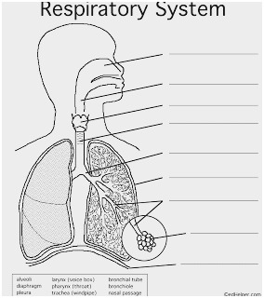  Label the structure of the respiratory system | 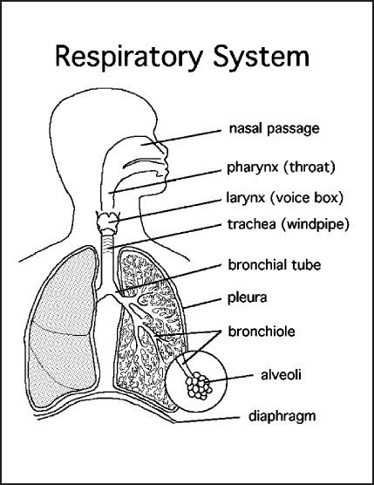
What is the composition of inhaled air? | 78% nitrogen, 21% oxygen, 0.04% carbon dioxide (as well as water vapour, other gases and particulates)
What is the composition of exhaled air? | 78% nitrogen, 17% oxygen, 4% carbon dioxide
How do we breathe in (ventilate)? | Our diaphragm is pulled down, anad the ribs are lifted up increasing the volume of the chest cavity. Air moves in to equalise the pressure.
How do we breathe out? | The muscles pulling on the diaphragm relax and this rises up, the ribs move in and the volume of the chest cavity decreases. Air moves out to balance the pressure.
What is the vital lung capacity? | The maximum amount of air you can breathe in and out

8C1 Atoms and the periodic table
Describe the structure of an atom. | A nucleus containing protons and neutrons, surrounded by electrons in shells.
What are the relative masses of the subatomic particles? | Protons- 1, neutron -1 Electrons – 1/1836
What are the charges of the subatomic particles? | Protons- +1, neutron -0 Electrons – -1
What is a chemical symbol? | A one or two universal letter code of each element
Where are chemical symbols of elements found? | In the periodic table
What are the physical properties of Group 1 metals compared to most metals? | Lower melting point, softer, low density ( Light for its size),
What are the chemical properties of Group 1 metals? | Very reactive
Where are the transition metals in the periodic table? | The middle block
What are the Group 1 metals called? | Alkali metals
What are the Group 7 elements called? | Halogens
What are Group 0 elements called? | Noble gases
State the number of bonds formed for groups 1, 2, 3,4 ,5, 6 and 7 on the periodic table | Group 1 =1  Group 2=2  Group 3=3  Group4 =4  Group 5=3  Group 6=2  Group 7=1
How are elements in the modern periodic table arranged? | In rows called periods and elements with similar properties are placed in the same vertical columns called groups.

8C2 Particles
Question | Answer
What is distillation? | Boiling then condensing to collect a pure liquid
What is the pure liquid collected during distillation called? | Distillate
What type of mixture is separated by distillation? | Substances with different boiling points
What type of substances are separated by filtration? | An insoluble solid and a solution or liquid.
What is the liquid called that passes through a filter paper during filtration? | Filtrate
What is the solid called that is left on the filter paper during filtration? | Residue
Describe crystallisation? | Heating a solution so the solvent boils off/evaporates, leaving the solute behind as a solid
What type of substances are separated by crystallisation? | Soluble substance in a solution
What type of substances are separated by paper chromatography? | Soluble substances of different colours
Why must the start line in paper chromatography be drawn in pencil and not pen? | So it is insoluble and won’t move or contaminate the sample.
What is a pure substance? | Something made from one type of substance
How can we identify a pure substance? | Fixed melting or boiling point, one spot on a chromatogram.

8P1 Forces and motion
Define friction. | Friction is a force that opposes the motion of one surface against another.
Describe the relationship between atmospheric pressure and height. | As height increases pressure decreases.
Why does gas pressure vary with height/depth? | Pressure increases as the force of the weight of fluid above increases. This itself depends on the height of the fluid column above the object. The density of the fluid and the gravitational field strength it experiences.
How does pressure vary with depth? | As depth increases so does pressure.
Define up thrust. | The resultant force on an object in a fluid created by a pressure gradient across it, due to its length.
Draw a free body diagram to show an object floating.
Draw a free body diagram to show an object starting to sink.
Recall the equation for pressure. | Force = Pressure / Area
State a unit for pressure. | Pascal, N/m² Any other Force over a given area.
State the units of force. | Newton’s (N)
How are forces represented on diagrams? | Using arrows.
What is Newton’s first law of motion? | An object remains in the same state of motion unless a resultant force acts on it.
What happens if the resultant force on an object is zero? | - a stationary object stays stationary  - a moving object continues to move at the same velocity (at the same speed and in the same direction)
What is Newton’s second law of motion? | When an unbalanced force acts on an object: the direction of the object's acceleration is the same as the direction of the unbalanced force
Which equation describes Newton’s second law of motion? (include the units in your answer) | Force (N) = mass (kg) x acceleration (m/s²)
What is relative motion? | The change in position with time of one object compared to another object.
How do you calculate relative motion if two objects are moving in the same direction? | Fastest speed- slowest speed
How do you calculate relative motion if two objects are moving in opposite directions? | Add the two speeds together

8P2 Energy
Name the three types of thermal energy transfer. | Conduction, Convection, Radiation
Define convection. | The transfer of thermal energy due to the cycling of particles created by a variation in density within a fluid.
Define thermal radiation | The transfer of thermal energy through electromagnetic waves.
Define conduction | The transfer of heat energy through the collisions between atoms.
In which sates of matter can convection take place. | Liquids and Gases
In which states of mater can conduction take place? | All but is not very effective in liquids and even less so in gases
State the term given to the material through which something may travel. | Medium.
Why do objects cool down? | Due to a net flow of energy away from the object.
What word is used to describe the spreading out a movement away if thermal energy? | Dissipates.
What instrument is used to measure temperature? | Thermometer
What are the units for temperature? | Degrees Celsius, degrees Fahrenheit or kelvin.

